

**TECHNICAL DOCUMENT**

**Topic**: Installation of Microsoft Project Server 2010 in a Windows Server 2008 R2 Environment





Version: 1

Date: 1/18/2013

Office of Primary Responsibility: Service Division

|  |  |  |  |
| --- | --- | --- | --- |
| **CHANGE CONTROL LOG** | | | |
| **Document Version Number** | **Brief Description of Change** | **Author(s)** | **Date** |
| Ver 1 | Initial Creation | Joe Brewer | 1/18/2013 |
| Choose an item. |  |  | Click here to enter a date. |
| Choose an item. |  |  | Click here to enter a date. |
| Choose an item. |  |  | Click here to enter a date. |
| Choose an item. |  |  | Click here to enter a date. |

# TABLE OF CONTENTS

TABLE OF CONTENTS 2

PRESUMPTIONS 4

PRE-REQUISITE INFORMATION NEEDED AND ACQUISITION LOCATION 5

INSTALLATION STEPS 10

Initial Setup of Primary Computers 10

Server Domain Setup & Configuration 10

Active Directory User Accounts & Updates 17

Install Microsoft SQL Server 2008 / 2012 24

Install Microsoft SQL Server 2008 / 2012 Native Client 35

Install the Microsoft SQL Server Analysis Services Analysis Management Objects (AMO) Client Software 38

Install Microsoft SharePoint Server 2010 41

Install Microsoft Project Server 2010 48

Install SharePoint Server 2010 SP1 51

Configure the SQL Server SharePoint Farm Account 52

Prepare SQL Server Analysis Services for Project Server 60

Run The SharePoint Server 2010 Configuration Wizard 65

Start SharePoint for the First Time-Run the Wizard 71

SHAREPOINT POST-INSTALLATION CONFIGURATION 74

Security Group Configurations 74

Setting INitial Read Permission on Site 80

Provision First Instance of Project Server 81

Add Admin users to Project Server 86

Internet Explorer Enhanced Security Control 92

Create a Performance Point Application 94

Configure Excel Services 97

Configuring the Secure Store Service Application 109

Configure OLAP CUBE Building Services 116

Setting Server performance Enhancements 117

Final Verification of Project Server Functionality 118

GENERAL FUNCTIONAL SETUP FOR YOUR SERVERS 119

Windows Firewall 119

Windows Shutdown Event Tracker 120

# PRESUMPTIONS

This document assumes that you have some technical experience in installing software and configuring software. In addition the fields of information collected herein are designed to create a SharePoint and ProjectServer deployment that utilizes Microsoft’s Best Practices of least privileged accounts.

Your feedback is encouraged and welcome. Please address all concerns to the Service Division of Advisicon, Inc.

### Labs & Demo Environment

In order to access these environments, you will need to use Microsoft Remote Desktop to access the server located at dev.advisicon.com. You will login with your NETWORK\username credentials to access your remote desktop to work with and build your labs/demo systems.

You will need to initiate an IT request to have the virtual machines setup and configured, along with your usernames and groups. Visit the Advisicon Intranet IT site for further information.

You may have been assigned a domain name address like <http://someone.myprojectserver.com> where someone is a changed variable assigned by IT. You can use this domain name to access your systems without using Remote Desktop; in the event you are in a client environment.

# PRE-REQUISITE INFORMATION NEEDED AND ACQUISITION LOCATION

|  |  |  |
| --- | --- | --- |
| **TABLE 1 - SITE ACCESS INFORMATION (Some or All May Be Required)** | | |
| **ITEM** | **PROVIDER** | **DETAILS/VALUE/VARIABLE** |
| VPN Login Address for Cisco Client | Client |  |
| Project Manager Login & Password | Client |  |
| Project Advisor Login & Password | Client |  |
| SharePoint Server Architect Login & Password | Client |  |
| Project Server Architect Login & Password | Client |  |
| Business Intelligence Architect Login & Password | Client |  |
| Technical Advisor #1 Login & Password | Client |  |
| Technical Advisor #2 Login & Password | Client |  |
| Technical Advisor #3 Login & Password | Client |  |
|  |  |  |

|  |  |  |
| --- | --- | --- |
| **TABLE 2 - SOFTWARE INSTALLATION INFORMATION** | | |
| **ITEM** | **PROVIDER** | **DETAILS/VALUE/VARIABLE** |
| SQL Server Software Medium | Client |  |
| SQL Server Install Key PROD | Client |  |
| SQL Server Install Key DEV | Client |  |
| SharePoint Server Software Medium | Client |  |
| SharePoint Server Install Key PROD | Client |  |
| SharePoint Server Install Key DEV | Client |  |
| Project Server Software Medium | Client |  |
| Project Server Install Key PROD | Client |  |
| Project Server Install Key DEV | Client |  |
|  |  |  |

|  |  |  |
| --- | --- | --- |
| **TABLE 3 - SYSTEM URLS/IPs/COMPUTER NAMES** | | |
| **ITEM** | **PROVIDER** | **DETAILS/VALUE/VARIABLE** |
| DEV-Project Server Web Server | Client |  |
| PROD-Project Server Web Server | Client |  |
| DEV-Project Server Application Server | Client |  |
| PROD- Project Server Application Server | Client |  |
| DEV-Project Server Database Server | Client |  |
| PROD-Project Server Database Server | Client |  |
| PROD-SharePoint Server Application Server | Client |  |
| DEV-SharePoint Server Application Server | Client |  |
| PROD-SharePoint Server Database Server | Client |  |
| DEV-SharePoint Server Database Server | Client |  |
|  |  |  |

|  |  |  |  |
| --- | --- | --- | --- |
| **TABLE 4 - ACTIVE DIRECTORY & CLIENT SITE LOGINS** | | | |
| **ITEM** | **PROVIDER** | **DETAILS/SUGGESTIONS** | **PURPOSE** |
| SQL Server Administrator**\***  **BEST PRACTICE**: Do not use your own account | Client | SQL_Admin | Initial installation of SQL, to set FIRST Administrator Account on instance of SQL; after, other Administrators can be added |
| SQL Server Service Account  **BEST PRACTICE**: Use a Domain User Account (If SQL on a server other than the SharePoint Server, it is **REQUIRED** to use a Domain User Account) | Client | SQL_Service | Used as the identity for MSSQLSERVER and SQLSERVERAGENT services |
| SharePoint Administrator and Setup User Account**\*\***  **BEST PRACTICE**: Use a Domain User Account (In SQL it is **REQUIRED** that this user be assigned the *dbcreator* and *securityadmin* roles) | Client | SP_Admin | Used by a Human to install and configure SharePoint  **NOTE**: Only account for which a SQL Login must be manually created and for which SQL roles must be assigned) |
| SharePoint Farm Service Account  **BEST PRACTICE**: Use a Domain User Account (It is **REQUIRED** to be a Domain User Account) | Client | SP_Farm | Used by Central Administration Site’s application pool and as the Timer Identity |
| SharePoint Web Application Pool Account  **BEST PRACTICE**: Use a Domain User Account (It is **REQUIRED** to be a Domain User Account) | Client | SP_WebApps | Runs the application pool for Web |
| SharePoint Service Application Pool Account  **BEST PRACTICE**: Use a Domain User Account (It is **REQUIRED** to be a Domain User Account) | Client | SP_ServiceApps | Runs the application pool for Service |
| SharePoint Search Indexer Account  **BEST PRACTICE**: Use a Domain User Account (It is **SUGGESTED** to be a Domain User Account) | Client | SP_Crawl | Indexes Content on SharePoint |
| SharePoint User Profile Synchronization Account  **BEST PRACTICE**: Use a Domain User Account (It is **SUGGESTED** to be a Domain User Account) | Client | SP_Synch | Synchronizes Profile Attributes between SharePoint and Active Directory |
| SharePoint User Profile OLAP Account  **BEST PRACTICE**: Use a Domain User Account (It is **SUGGESTED** to be a Domain User Account) | Client | SP_OLAP | Synchronizes Profile Attributes between SharePoint and Active Directory |
| GROUP-ProjectServer Report Authors | Client | grp_PS_RptAuthors | Used by Excel/ProjectServer |
| GROUP-ProjectServer Report Viewers | Client | grp_PS_RptViewers | Used by Excel/ProjectServer |

|  |  |  |  |  |
| --- | --- | --- | --- | --- |
| User Account | Domain Users | Domain Admins | Local Admin**\*** | DnsAdmins**\*** |
| SQL_Admin | X |  | X |  |
| SQL_Service | X |  |  |  |
| SP_Admin | X |  | X | X |
| SP_Farm | X |  |  |  |
| SP_WebApps | X |  |  |  |
| SP_ServiceApps | X |  |  |  |
| SP_Crawl | X |  |  |  |
| SP_Synch | x |  |  |  |

|  |  |  |
| --- | --- | --- |
| **TABLE 5 - SHAREPOINT ACCOUNTS (Managed Domain Accounts-Optional For Least Privileged Install)** | | |
| **ITEM** | **PROVIDER** | **DETAILS/SUGGESTIONS** |
| Application Pool Account | Client/Advisicon | spAppPoolAcc |
| Application Pool Account for Secure Store Target Application | Client/Advisicon | spAppPoolSSTAcc |
| Application Pool Account for  BDC Service Applications | Client/Advisicon | spAppPoolBDCAcc |
| Application Pool Account for  Excel Service Application | Client/Advisicon | spAppPoolEXCELAcc |
| Application Pool Account for  PowerPoint Service Application | Client/Advisicon | spAppPoolPPTAcc |
| Application Pool Account for  Word Service Application | Client/Advisicon | spAppPoolWORDAcc |
| Application Pool Account for  Project Server Application | Client/Advisicon | spAppPoolPSAcc |
| Application Pool Account for  PerformancePoint Service Application | Client/Advisicon | spAppPerfPointAcc |
| SharePoint Foundation  Search Service Account | Client/Advisicon | spfSearchSvcAcc |
| SharePoint Foundation  Search Content Access Account | Client/Advisicon | spfSearchCAAcc |

Why all of these different accounts? As your applications begin working together, and the servers start integrating with each other there may be times when things do not go as planned. Reflecting back to the server logs will yield clues as to the source of the problem, and the different logins allow you to further track it backwards to the problem. If a user only has one account, then the cause of a failure may not be easy to locate.

|  |  |  |
| --- | --- | --- |
| **TABLE 6 – MISCELLANEOUS SHAREPOINT INFORMATION** | | |
| **ITEM** | **PROVIDER** | **DETAILS/SUGGESTIONS** |
| SharePoint Farm Password Phrase | Client/Advisicon | Something Long, difficult to hack |
| SQL Database SharePoint Configuration File Name | Client | SharePoint_Config is Deafult |
| IP Port Number to be used for SharePoint Central Administration | Client | Any valid IP Port Number |
| SharePoint Top Level Site Title | Client |  |
| SharePoint Top Level Web Site Address URL ( / is the default) | Client |  |
| List of Users who be added to the SharePoint Farm Administrators Group (or an Active Directory Group) | Client |  |
| SharePoint Secure Store Application Key Pass Phrase | Client |  |

|  |  |
| --- | --- |
| **TABLE 7 – SHAREPOINT GROUPS** | **PERMISSION LEVEL** |
| SharePoint for Project Server Owners | Full Control |
| SharePoint for Project Server Members | Contribute |
| SharePoint for Project Server Visitors | Read |
| Add Other Groups or Client Groups Here | Level? |
| Add Other Groups or Client Groups Here | Level? |
| Add Other Groups or Client Groups Here | Level? |
| Add Other Groups or Client Groups Here | Level? |

|  |  |
| --- | --- |
| **TABLE 8 – PROJECT SERVER GROUPS** | **ACTIVE DIRECTORY GROUP (Or Users)** |
| Project Server Administrators | PS Admins |
| Project Server Executives | PS Execs |
| Project Server Portfolio Managers | PS Portfolio Mgrs |
| Project Server Project Managers | PS Project Mgrs |
| Project Server Resource Managers | PS Resource Mgrs |
| Project Server Team Leads | PS Leads |
| Project Server Team Members | PS Members |
| Project Server Other (Name: ) |  |
| Project Server Other (Name: ) |  |
| Project Server Other (Name: ) |  |

# INSTALLATION STEPS

## Initial Setup of Primary Computers

This installation instruction assumes that you have the following computers setup in order to proceed:

|  |  |  |
| --- | --- | --- |
| **BEST CASE SCENARIO** | **SECOND BEST CASE SCENARIO** | **LEAST CASE SCENARIO** |
| * Virtual or Physical (Lab/Demo see separate specification requirements for actual customer site installations) * Three separate machines * Machine #1-Domain Controller * Machine #2-SQL Server * Machine #3-SharePoint and Project Server | * Virtual or Physical (Lab/Demo see separate specification requirements for actual customer site installations) * Two separate machines * Machine #1-Domain Controller & SQL Server * Machine #2-SharePoint and Project Server | * Virtual or Physical (Lab/Demo see separate specification requirements for actual customer site installations) * One machine containing all three applications: Domain Controller, SQL Server and SharePoint / Project Server |

## Server Domain Setup & Configuration

This section assumes you have three basic Windows Servers (or two/one as indicated above) yet they are only configured in the standard Workgroup and not joined together in a Domain. This section will show you how to promote one server to a domain controller, and then join the others to that domain, and the second section shows you how to simply join the computer to an existing domain. If your servers are already in a domain environment, and do not need to be further configured, simply skip to the next section.

### Promoting a Domain COntroller

Every computer in a network has a computer name, and an IP address. The difficulty with IP addresses is that we cannot always remember them, and cannot always route to them in a variety of different networks. Imagine always having to type 192.198.164.158 every time you wanted to reach intel.com. Not easy. In addition to the domain name being easy to remember it also allows for computers to be managed, locations changed, etc., without having tom completely re-route traffic on the internet. Computers “resolve” to IP addresses through their domain names, by using DNS (domain name services) servers, whose function it is to resolve the name to an IP address, and then route the user to the correct server address. If you want to see more about domain names visit: <http://en.wikipedia.org/wiki/List_of_Internet_top-level_domains> .

In a work environment like Advisicon.com we have servers whose function it is to control the domain name Advisicon.com. These domain controllers serve to authenticate security using a variety of different methods, allowing only authorized users and computers to partnership in a domain and function as a collective group. For your lab/demo computers we will use our hosted environment of myprojectserver.com. You may receive domain names like tye.myprojcetserver.com or danielle.myprojectserver.com etc. In your lab/demo environments it WILL NOT be necessary for you to upgrade a server to a domain controller, as one already exists within the environment. Upgrading a second domain controller only allows you to either compete with the existing domain controller (a bad thing) or to augment and become a secondary domain controller (you will not need to do this in our lab environment, however if you create your own, you will need a domain controller.)

Domain names are registered to individuals who own that name, and the top-level domain names like .com, .net, .org etc. are managed by the Internet Assigned Numbers Authority (IANA.) You should not use a domain name registered to someone else for you lab environments, nor use a domain extension that is a top level domain name that is also not registered to you. You may create a domain name like joes.demo or joes.lab as a domain name, and the domain controller will function to control that domain.

For clients, they will already have a domain name established, and if we are using a sub-domain name, we will need to obtain that during the requirements gathering phase of the installation.

For this example, we are going to use the Advisicon.demo domain name to create a domain controller. If you want to see if a computer is already assigned to a domain or is merely a member of a workgroup, click the start button, Right click Computer and select Properties.

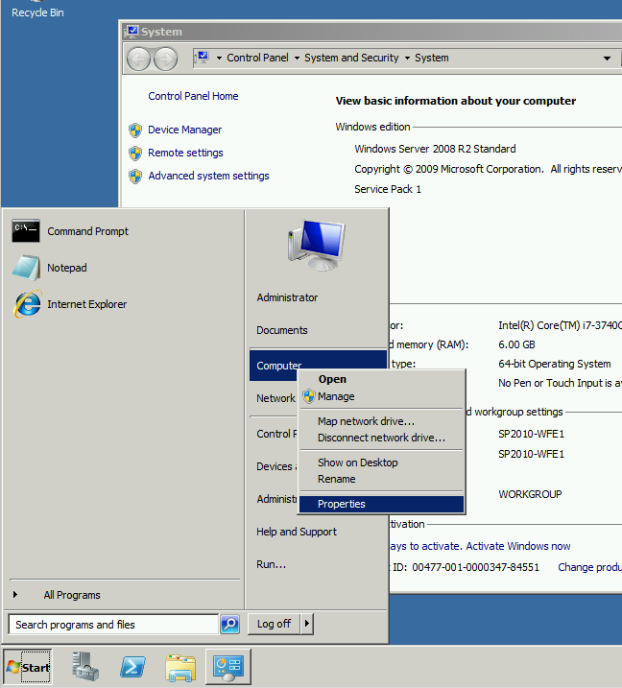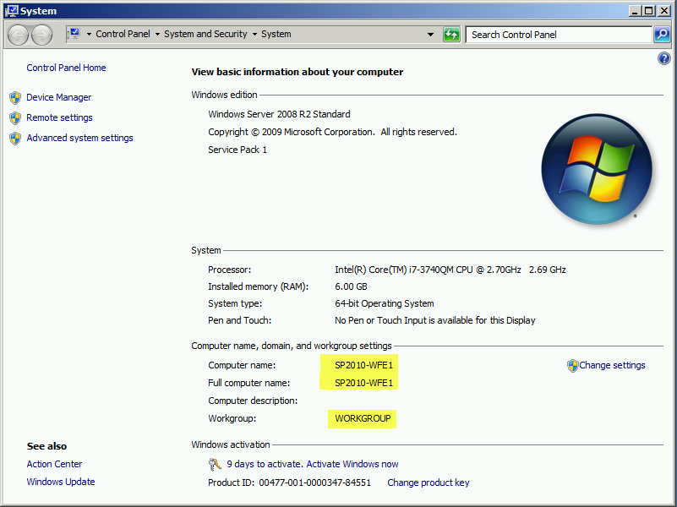

The computer name, domain, and workgroup settings will show you if the computer is already joined to a domain, the name of that domain, and the name of the computer. In table 3 above, you captured what will be the computer name on the domain, its IP address and the full computer name on the domain. For the purposes of this exercise of promoting a domain controller, we are going to name our Domain Controller DC. The full name of this computer will end up being dc.advisicon.demo when we have finished this process, and the domain controller will have managerial responsibility over the Advisicon.demo domain when we are finished.

1. To begin, log into the computer you have designated as your domain controller, using an Administrator login. Once logged in, click on Start, then Run and type dcpromo and click OK.

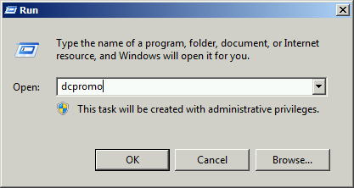

1. The Active Directory Domain Services Installation Wizard will begin. It will check to confirm this server is not already a domain controller.

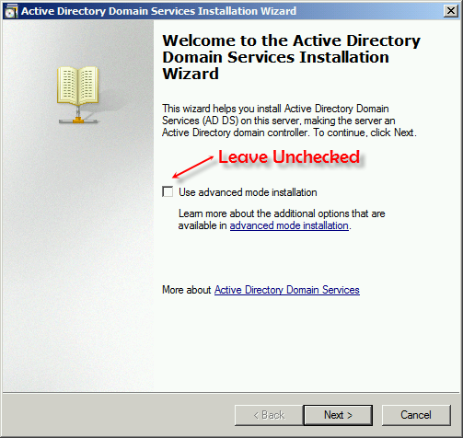

1. Click Next on the Operating System Compatibility Warning Screen
2. On the next screen you need to determine if you are creating the FIRST domain controller in a forest (Forest is described in detail on Wikipedia <http://en.wikipedia.org/wiki/Active_Directory> )

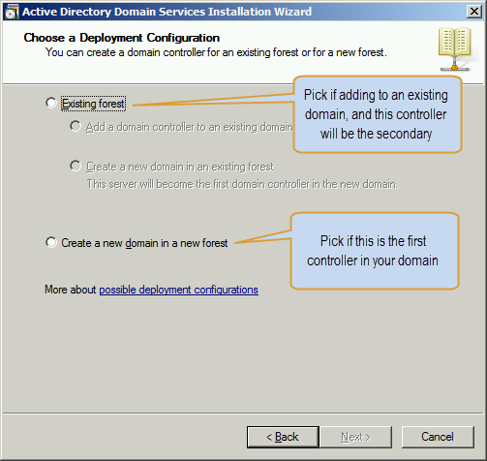

1. For this demonstration, we are creating the domain Advisicon.demo and we do not have a domain controller already in the domain forest, so we are going to pick the second option “Create a new domain in a new forest.” If this was a client site and you were asked to add a domain controller, you most likely would pick the top choice. Make your selection and press next.
2. Type the name of the domain that you are installing this controller for. In this example we chose Advisicon.demo so that name is typed into the FQDN space. Click next to continue.

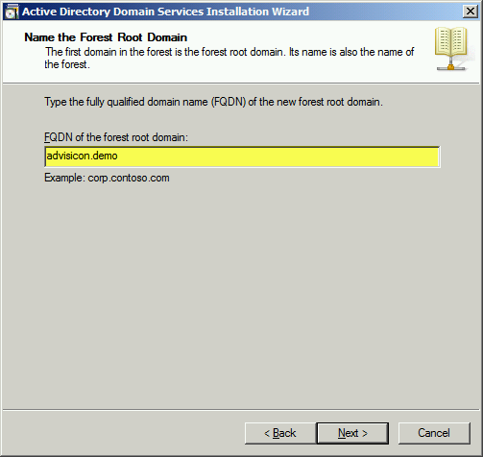

1. The system will check and see if the domain name is already in use before continuing. Once it is confirmed the domain name is not in use. You will then be asked to se the forest functional level. If you want to know more about the choices, read up on TechNet about the levels: <http://technet.microsoft.com/en-us/library/understanding-active-directory-functional-levels(v=ws.10).aspx>

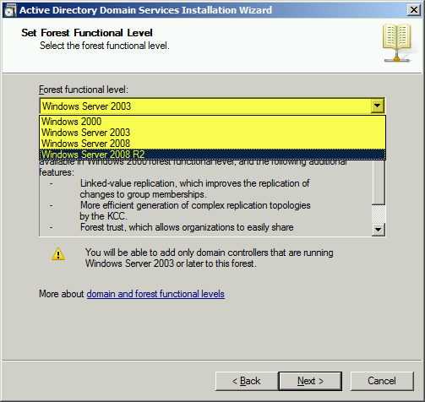

Select Windows Server 2008 R2 for most instances we will be involved in and/or for your lab or demo environments. Click Next to continue. The computer will examine if a DNS (Domain Name Service) controller already exists and if none is located will ask you to select this option. Ensure that DNS server is checked if you do not have a DNS server and click Next to continue.

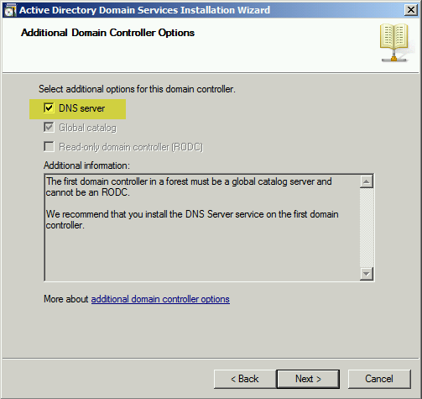

1. The wizard will now do a final check. If you see this screen click Yes to continue. The server has determined that a parent domain name server doesn’t exist for advisicon.demo (appropriate since .demo is not a top level domain name). For the lab/demo environments this is ok to continue with. If it were a client location install, then research is needed to determine why the parent DNS server cannot be located; a potential routing or network problem exists.

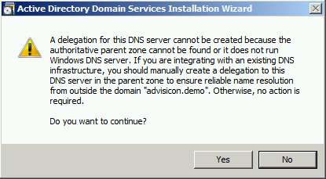

1. On the next screen you can change the location for the files (default locations are usually adequate). Click Next to continue.

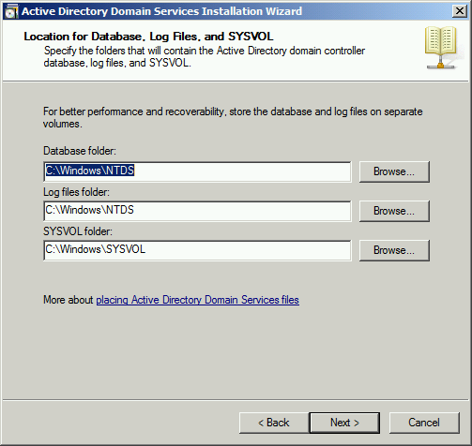

1. On the next screen, type a password that is DIFFERENT than your Administrator Login Password (for security reasons) and click Next to continue.

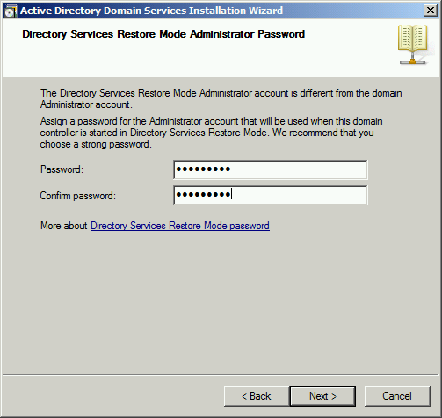

1. The next screen displays the summary. You can Export these settings if you want to be able to re-use them on other computers. Here you review all the final settings before proceeding. Once you proceed, the wizard will promote the server to a domain controller.

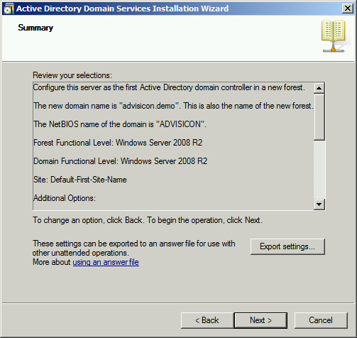

1. The computer finishes the installation of Active Directory, DNS if selected and converts this computer to a domain controller.

Congratulations. You now have a domain controller, and on the next boot you will need to login with a domain and user account that looks something like: ADVISICON\Administrator for this example, as it was the Advisicon.demo domain, and Administrator was our user account. Next, you will add users to this domain that are authorized to perform functions within the domain. If I now go back to check the name of this computer like we did when we started, it shows a different setup as a domain computer, instead of a workgroup computer. If this is a lab or demo environment, recommend you create a Domain Admin account for yourself as well.

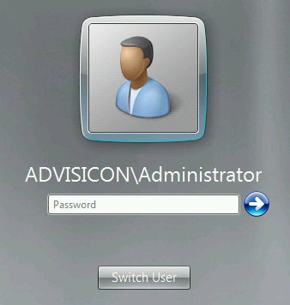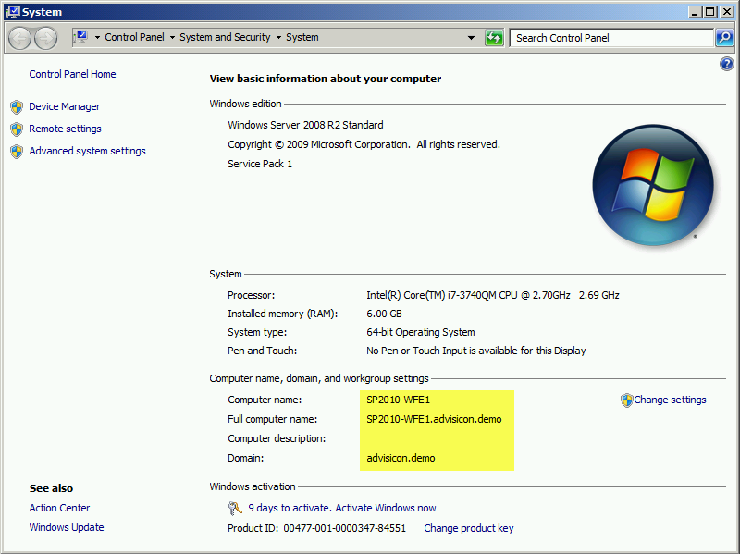

***This is a good place to take a Snapshot if you are using a Hyper-V or VMWare machine in your test lab or demo environment.***

## Active Directory User Accounts & Updates

On the client computer domain controller managing active directory, log in as a Domain Administrator and create the user accounts shown in Table 4 above. On some installations for clients, we will not have this access and must ask them to create the logins. If you have access, follow these steps to accomplish this:

1. Login to the Domain Controller Server with a Domain Administrator level account and password
2. Click Start > All Programs > Administrative Tools > Active Directory Users and Groups

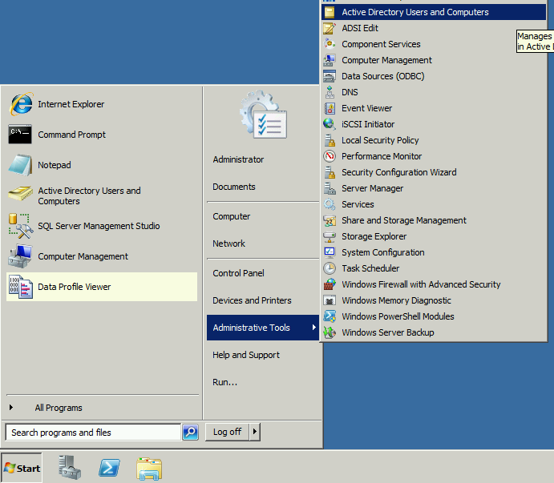

1. The first Step in creating a best practice and professional installation is to create an organizational unit for which you will place the user accounts. In a client environment this is helpful to understand which accounts have been created as part of the implementation. Right click on the Domain name and select > New > Organizational Unit

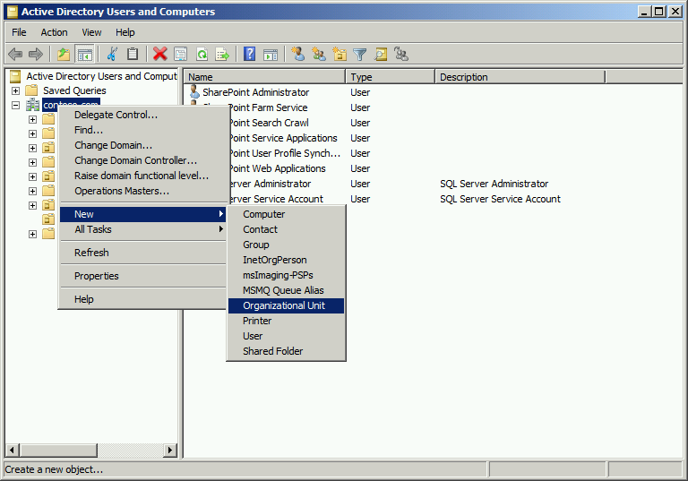

1. Name this Organizational Unit (OU) something along the lines of Service Accounts or SharePoint Service Accounts so that it has meaning and explains the contained user accounts.
2. Once you have created the OU, then you need to begin adding the user accounts to the Domain/OU. To add user accounts, right click the OU and click New > User

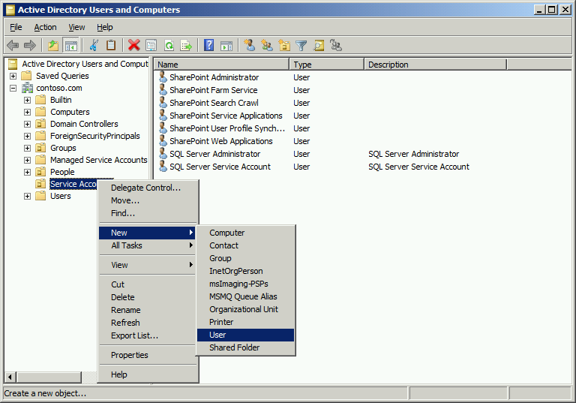

1. Fill in the details for the user account

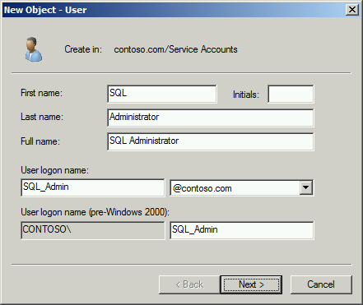

1. Click next and complete the password screen. Make sure to uncheck User must change password at next login, and check the Password never expires box. Document the password for this user on your user accounts sheet as you will refer to the account later during setups for SQL and SharePoint.

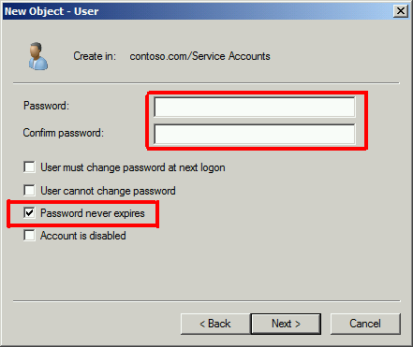

1. Click next and repeat that cycle for each user account you need to create. Once you have finished creating the user accounts, close down Active Directory Users and Computers.
2. Finally add SP_Admin to the DnsAdmins group. Highlight the Service Accounts folder, right click on the SharePoint Administrator account, and select Add to a Group.

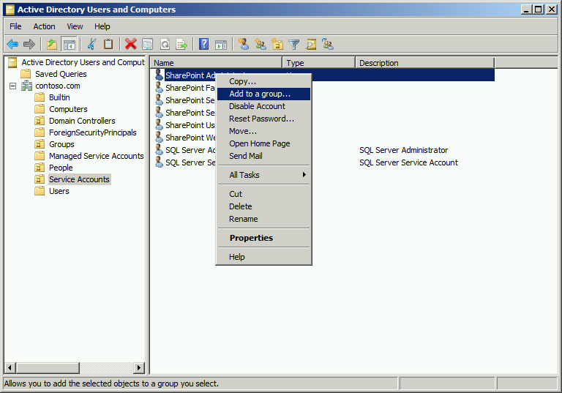

1. In the dialog window that opens, type DNS in the Enter the object names to select box. Make sure that from this location will search your domain and not the local machine name, and then click on Check names. 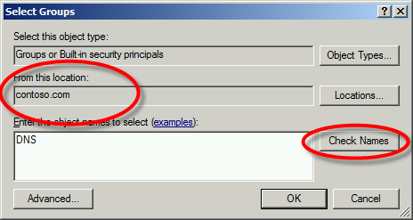 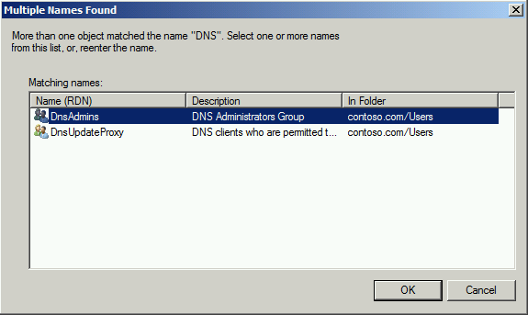
2. Multiple DNS named groups will appear (at least two built in, others dependent on the network.) Select the DnsAdmins group and click on ok, then ok again and you should see the window below appear. 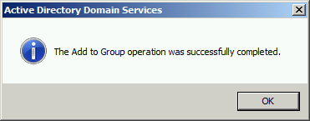
3. Click OK and close down the Active Directory Users and Groups application.
4. The final steps prior to installation that involve user accounts and rights is to add the SQL_Admin account to the local administrators account of the computer you intend to install SQL onto, and then to add the SP_Admin account to the computer you intend to install SharePoint Server onto. The next steps will show you how to add these accounts.
5. ON YOUR SQL SERVER MACHINE:
   1. Log on as a Domain Administrator (i.e. ADVISICON\Administrator from our earlier example)
   2. Click Start, Administrative Tools, Computer Management

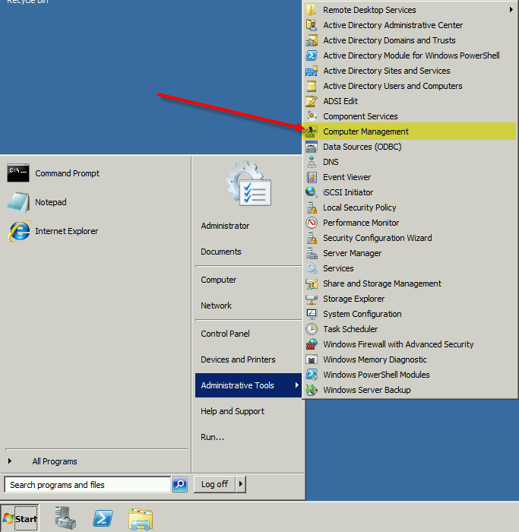

* 1. In the left Computer Management Tree, click the plus next to Local Users and Groups to expand its contents. Then select the Groups Folder. Once selected, double click the Administrators Group in the right window pane.

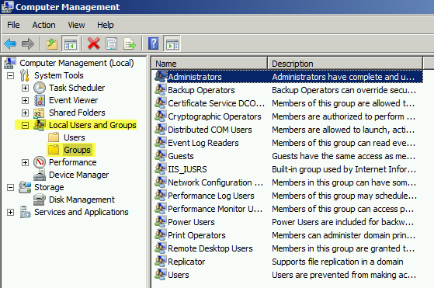

* 1. Click the Add button located almost to the bottom left of the dialog window

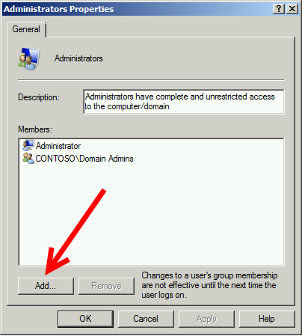

* 1. You will already see your Domain Admins added to this group, a standard windows server performs when adding the server to the domain.

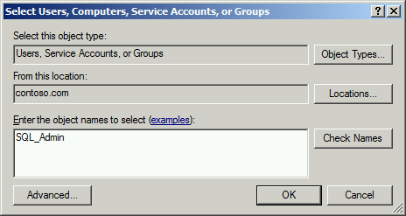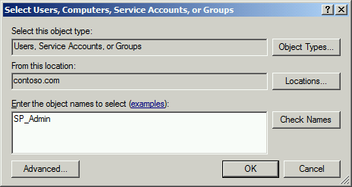

* 1. Ensure that you are searching in your domain in the From this location window, and then click on Check Names. The server should locate your desired name and complete the details in the object window. Select OK
  2. You should now see your SQL_Admin or SP_Admin account appear in the Members window.

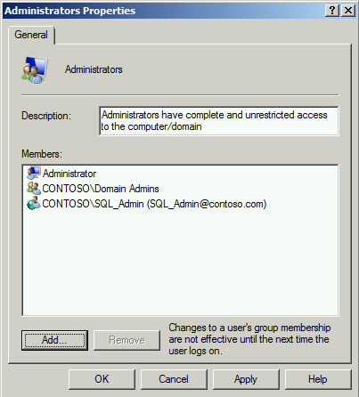

* 1. Click OK to close the window.

1. You are now ready to proceed with installing the software necessary to run SharePoint and ProjectServer.

***This is a good place to take a Snapshot if you are using a Hyper-V or VMWare machine in your test lab or demo environment.***

## Install Microsoft SQL Server 2008 / 2012

These steps assume that you already have connectivity to the Client’s network and that their network has an Active Duty Directory with all user accounts established.

In order to install Microsoft SQL 2008/2012, you need to have the appropriate installation media and serial numbers to continue. These were captured during the requirements gathering or are also located in Table 2 above.



In order to install SQL, you must be logged onto the computer you are going to install SQL into, as the SQL_Admin account that you created earlier. You also need to ensure that this account is a member of the local administrator group before proceeding.

The SQL installation files are .iso files, which are CD image files. In order to install them, you need to either be running Windows 8/Server 2012 or install an application called MagicISO which allows you to Mount the image as a CD drive. You can then access this CD drive from your virtual machines. If you are in a client environment, you may need to install MagicISO to continue. You can download it at <http://www.magiciso.com/> .

If you are running Windows 8/Server 2012, open Windows Explorer (Windows-E key) and browse to the location of the image file folder. Right click on the .iso file and select Mount. Note the drive letter that the system assigns to this image file.

If you are using MagicISO, browse to the file and right click on the image file, select MagicISO Mount xxxxx.iso where xxxxx is the name of the image file.

**Quick Pre-Requisite Check**

* Installation Media Available or Mounted
* Installation Key Available if in a Client Environment
* SQL Computer has been joined to the domain
* SQL_Admin has been added to the local administrators group of the computer you are installing SQL onto
* You are logged in as the SQL_Admin domain account on the computer you are going to install SQL

1. On the installation drive or media you mounted, locate the setup.exe file in the root folder of that media.

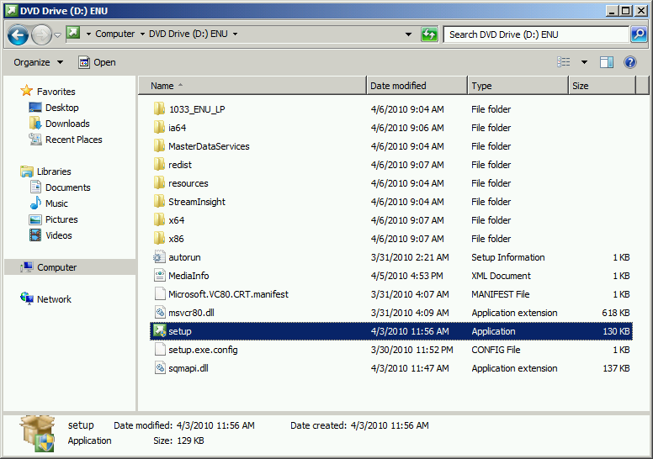

1. Double click setup.exe to begin the SQL installation. After a moment, SQL will display the following screen

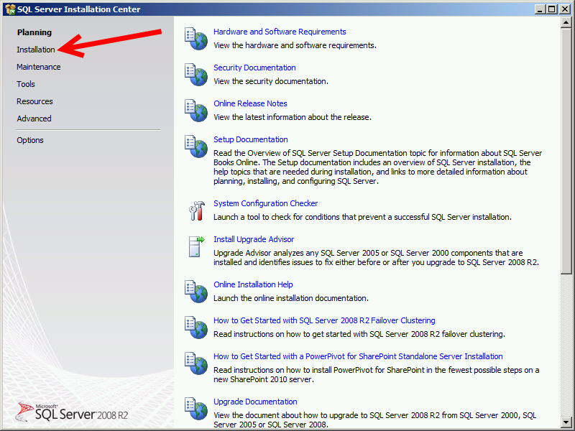

1. Click on Installation in the upper left corner to begin.
2. On the following screen, select New Installation or add features to an existing installation option at the top

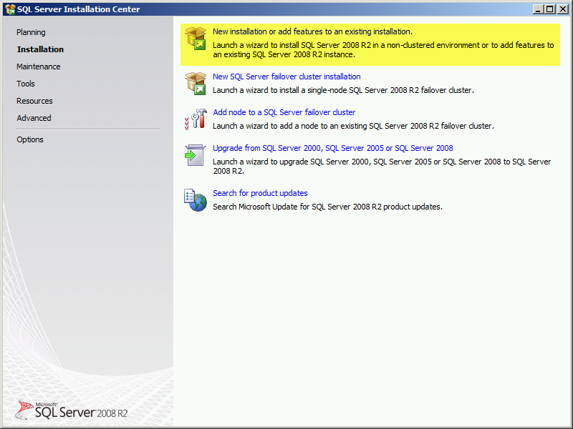

1. SQL will open a Setup Support Rules window and runs some compatibility checks. Once completed it will yield a report at the top of this window; pay attention to any errors and address them prior to continuing. If no errors are found, click OK to continue.

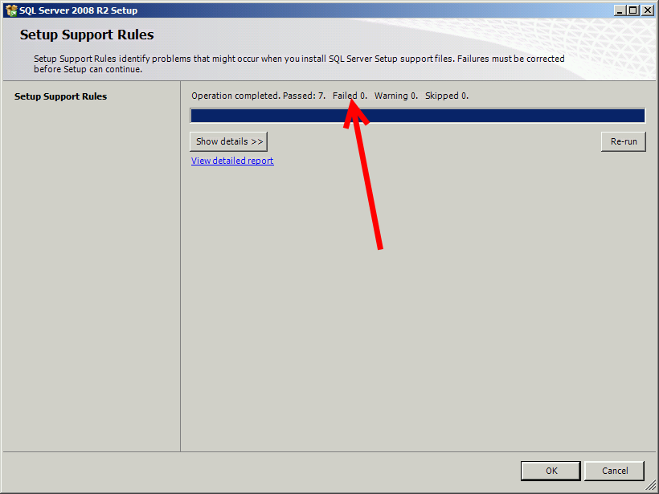

1. SQL will process the installation wizard and it may have up to a minute delay on the screen while it checks remaining options before displaying the Product Key Window. If installing in a customer environment, you will enter their product key in this window. If you are installing in your lab or demo environment, select the Specify a free edition option. Click next to continue.

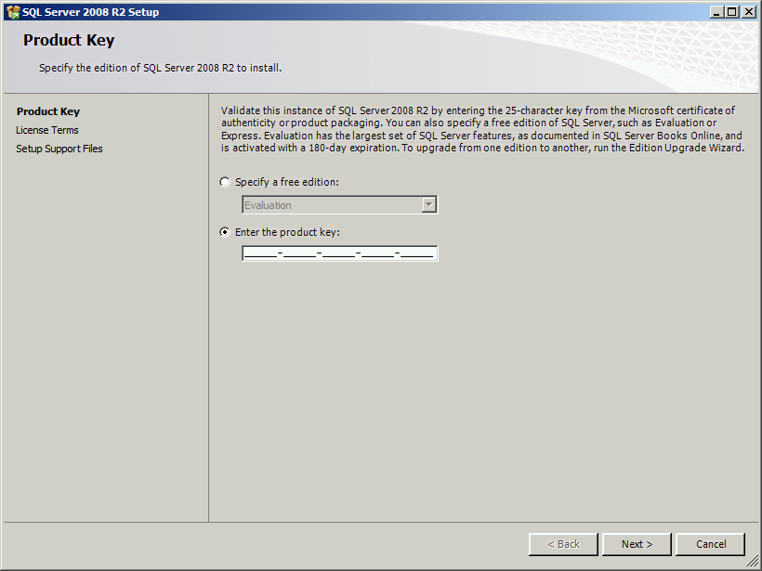

1. On the next screen click the box “I accept the license terms” and optionally select if you want to send feature data usage to Microsoft. Click Next to continue.

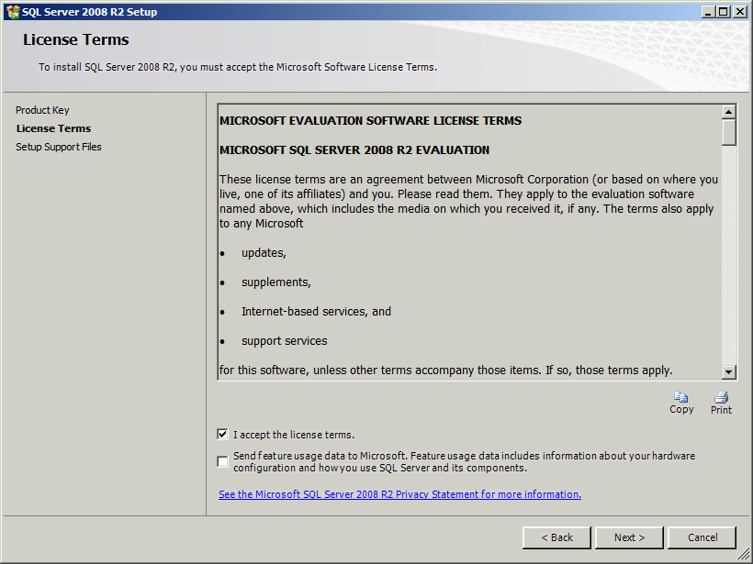

1. On the Setup Support Files screen (SQL 2008) click Install to install the setup support files. In SQL 2012 it will check for updates before displaying the Install Setup Files window.

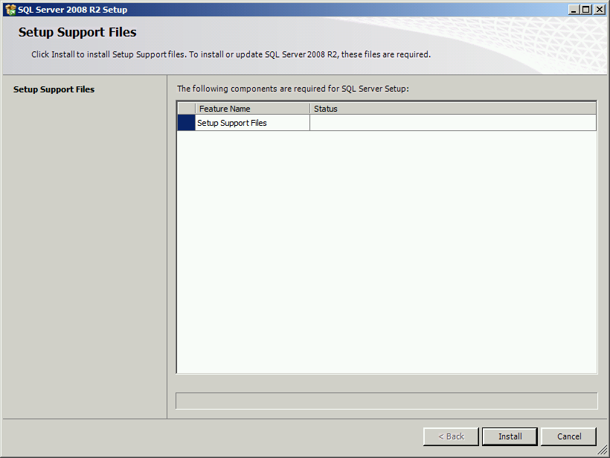

1. SQL will get to the final Setup Support Rules Screen. Note any validation errors (red X’s) that appear and respond to them prior to continuing. Once you have resolved any errors, click Next to continue.

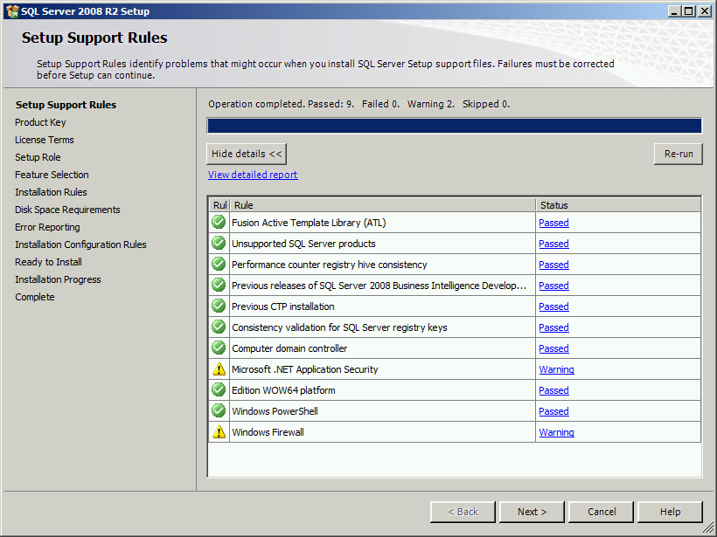

1. IF SQL displays the serial number and License term screen again, continue through them until you arrive at the Setup Role window. Select the All Features with Defaults option and click Next to continue.

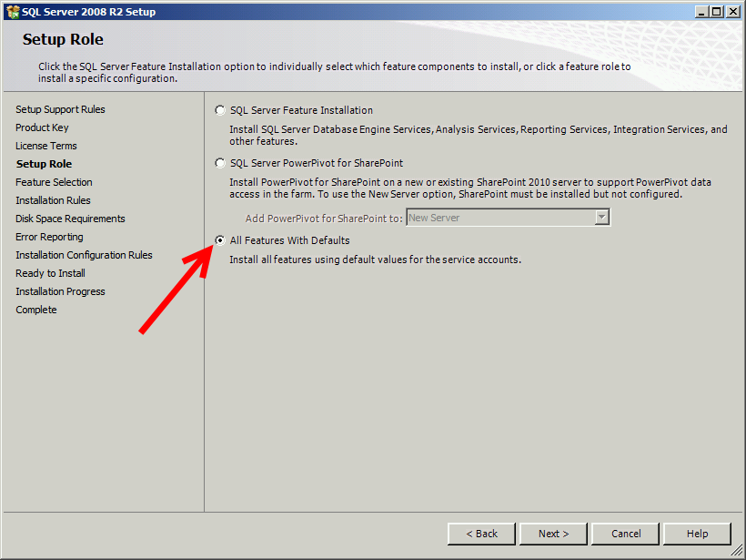

1. SQL displays a final feature selection screen. You can select/de-select options on this screen, however recommend you leave all items checked. You can also change the location of the Shared directory; however I also recommend you leave them as their defaults. Click Next to Continue

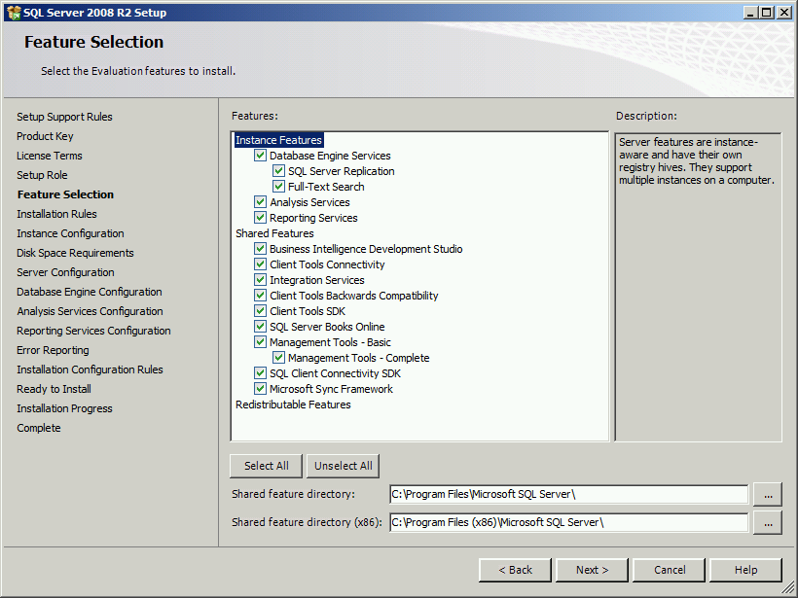

1. SQL Performs another Installation Rules check. Address any errors that may occur then press Next to continue.

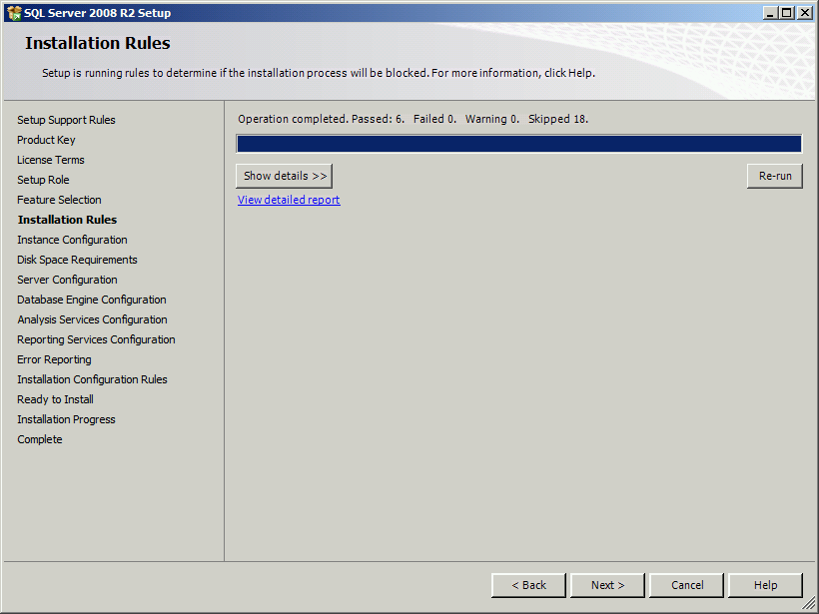

1. On the Instance Configuration Page you have the options to change the instance name, ID, root directory information for SQL. For lab/demo purposes there should be no reason to have to change these variables. In a custom environment, it may become necessary to change these dependent on their network configuration. Check with Technical Services if you have questions. Click Next to Continue.

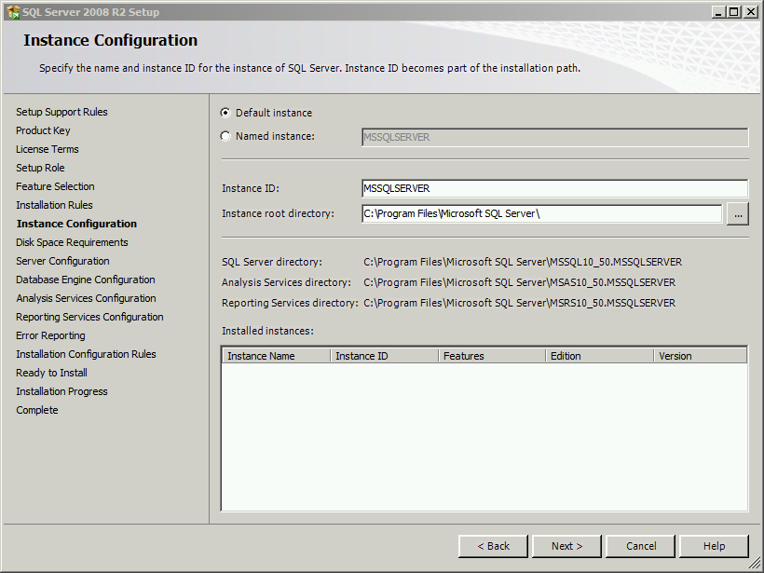

1. On the dis space requirements screen, SQL checks to determine if you have sufficient disk space remaining to continue installation. If you have a green check, click Next to Continue.

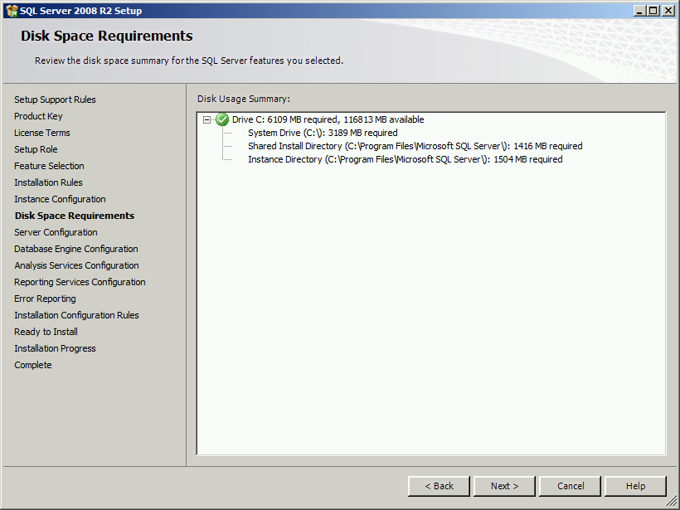

1. On the Server Configuration Screen, complete the Account Name and Password information using the SQL Server Service Account you identified in Table 4. The Account Name MUST be entered using the DOMAIN\Username format. Type the password for the account, and then press Next to continue.

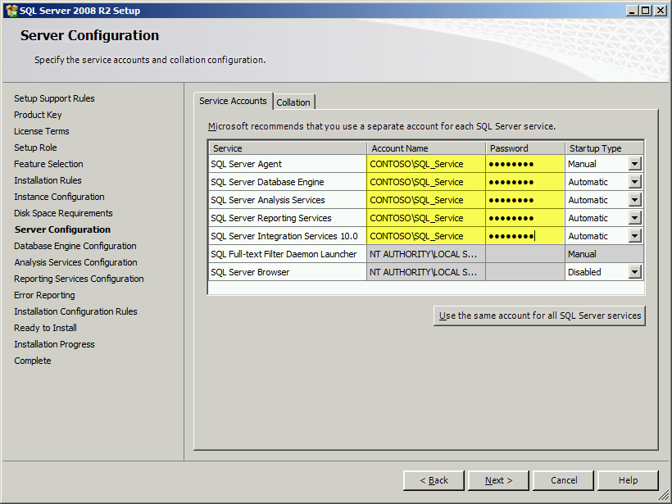

1. On the Database Engine Configuration screen, ensure that Windows Authentication mode is selected and then click Add… below to add another SQL Server administrator to the instance.

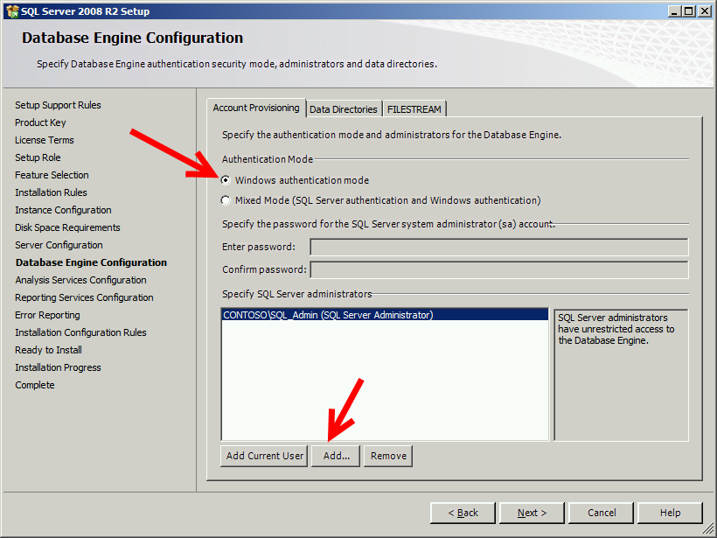

1. In the object names windows type Administrator and then click Check Names. IF an underline appears under the name Administrator, click OK to continue. If one does not, ensure that you are searching in Entire Directory for the locations.

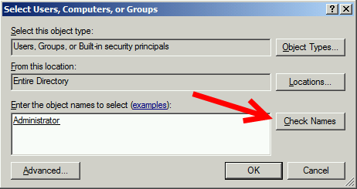

1. You have now added your Domain Administrator to the SQL Instance. Once added, click Next. On the Analysis Services Configuration Screen, there are no users listed with administrative permissions. First click on the Add Current User button to add the SQL_Admin. Second, click the Add… button and repeat the previous step to add the Administrator to the service. Your screen should have both users now listed. Click Next to continue.

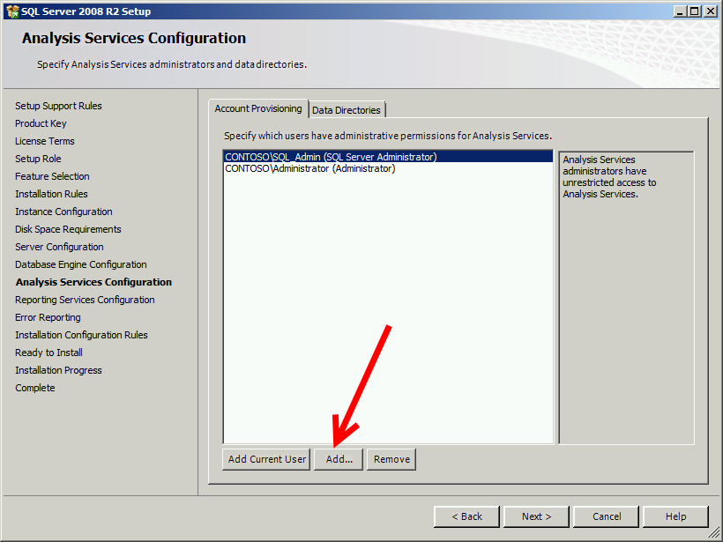

1. On the Reporting Services Configuration page select the middle choice “Install the SharePoint integrated mode default configuration” option and click next to continue.

CHANGES HERE FOR 2012 VERSION-EDIT

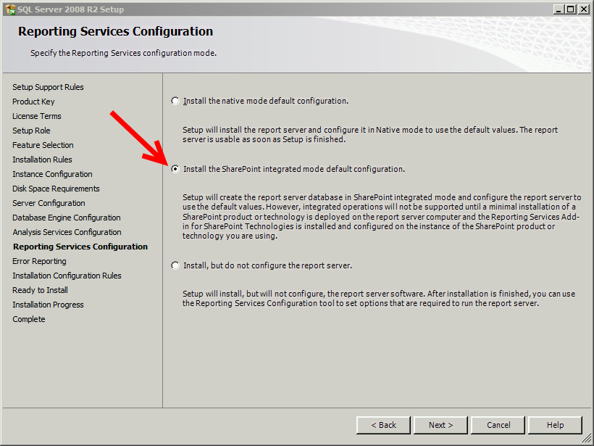

1. On the error reporting screen you can optionally select to send error report data. Click Next to continue.

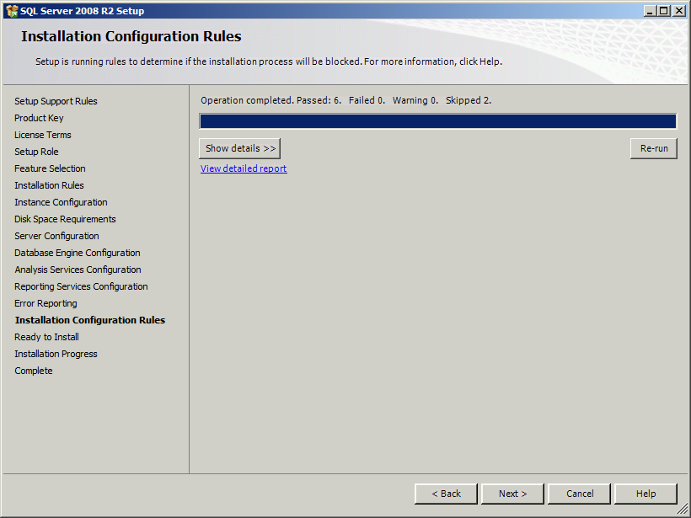

1. SQL performs a final configuration check. If there are any errors, respond to them before continuing. If no errors, click Next to continue. SQL displays the Ready to Install summary screen. You can scroll through and confirm your selections before clicking on Install to continue. SQL performs its installation.

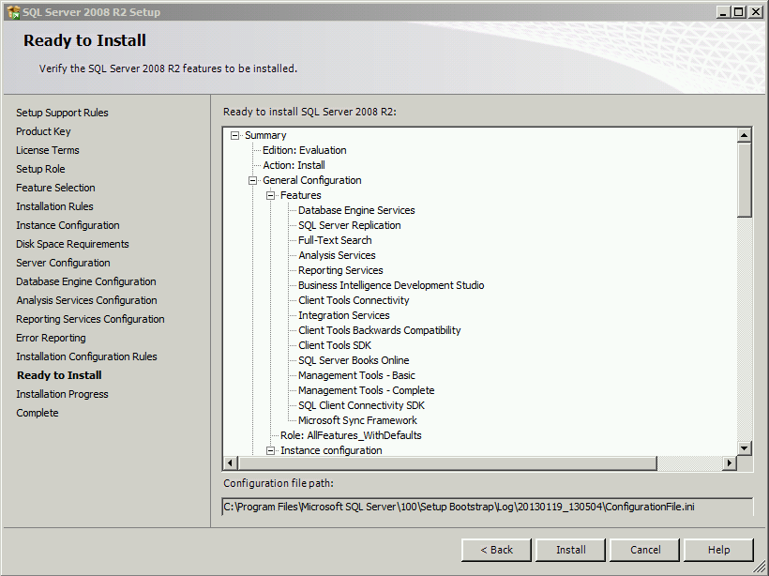

1. If everything installs correctly, SQL will give you a complete window with a summary screen. Click Close to continue.

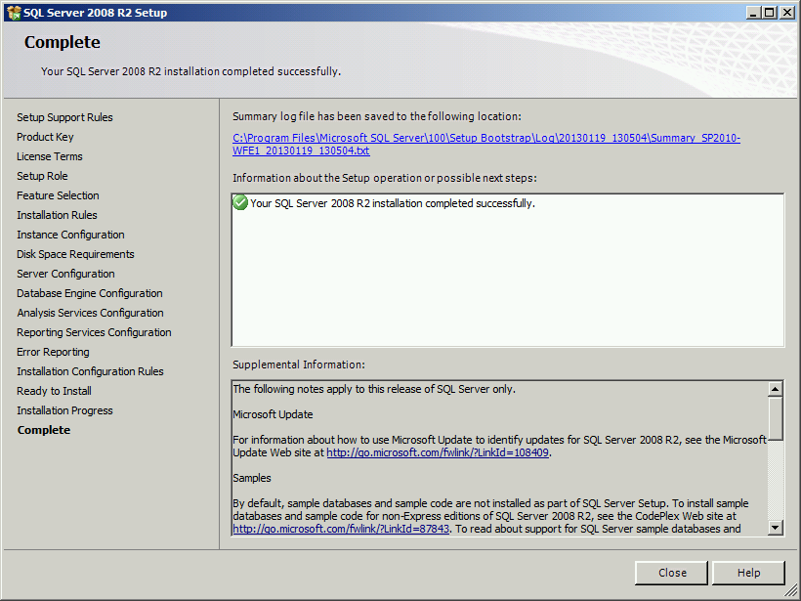

1. At this point I recommend a reboot on your lab/demo machines. This may not be possible or an option in a client environment.

Congratulations! At this stage, you have successfully installed SQL server. Remove the media and/or dismount any drives you used to install SQL.

***This is a good place to take a Snapshot if you are using a Hyper-V or VMWare machine in your test lab or demo environment.***

## Install Microsoft SQL Server 2008 / 2012 Native Client

If you are running SharePoint and ProjectServer on a Server ***OTHER*** than the one you are running Microsoft SQL on, you will need to install the SQL Server 2008 or 2012 Native Client. First step is to download them to prepare for installation:

SQL 2008 R2 Client: <http://www.microsoft.com/en-us/download/confirmation.aspx?id=16978>

SQL 2012 Client: <http://www.microsoft.com/en-us/download/confirmation.aspx?id=29065>

1. Once the system downloads the appropriate .msi file, double-click it to run the program. Click Next to continue/

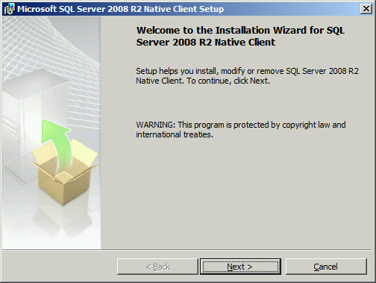

1. Click accept on the license agreement page and then click Next to continue.

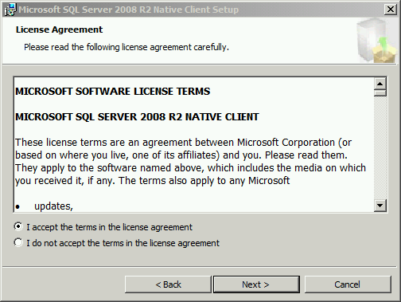

1. Enter your name and company information, then click Next to continue.

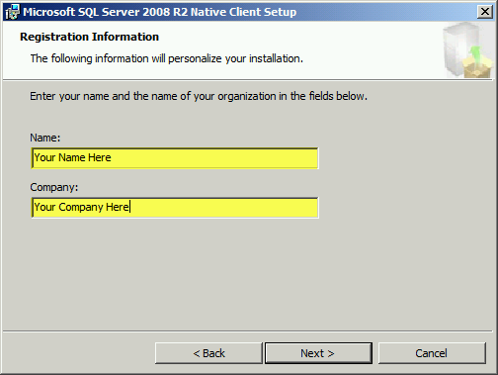

1. On the feature selection screen you can optionally install the SDK (Software Development Kit) but it is not necessary for most installations. Click Next to continue.

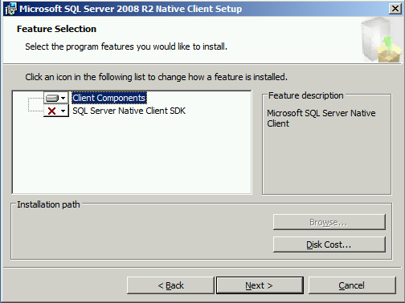

1. On the Ready to Install Program page click Install to continue.

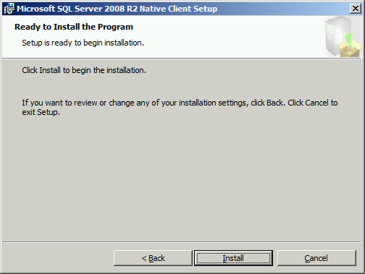

1. The system installs the SQL Client and gives you the completion screen; Click Finish to close down the installation. You have completed the SQL Client installation.

## Install the Microsoft SQL Server Analysis Services Analysis Management Objects (AMO) Client Software

If you are running SharePoint and ProjectServer on a Server ***OTHER*** than the one you are running Microsoft SQL on, you will need to install the SQL Server 2008 or 2012 Analysis Services Analysis Management Objects Client Software. First step is to download them to prepare for installation:

SQL 2008 R2 Client: <http://www.microsoft.com/en-us/download/confirmation.aspx?id=16978>

SQL 2012 Client: <http://www.microsoft.com/en-us/download/confirmation.aspx?id=29065>

1. Locate the downloaded file and double-click it to initiate the installation. On the welcome screen click Next to continue.

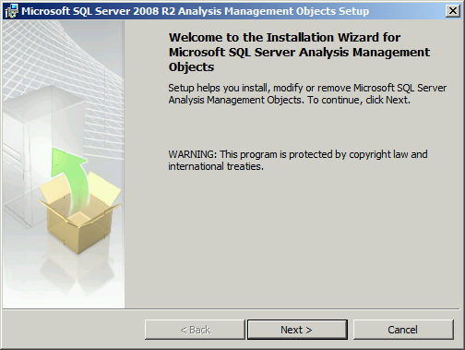

1. Click to accept the license agreement and then click Next to continue

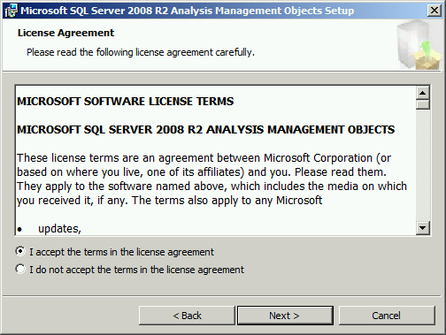

1. Type your name and company and then click Next to continue.

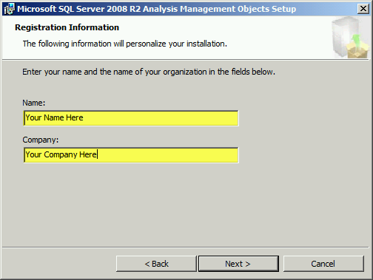

1. On the ready to install page, click Install to continue.

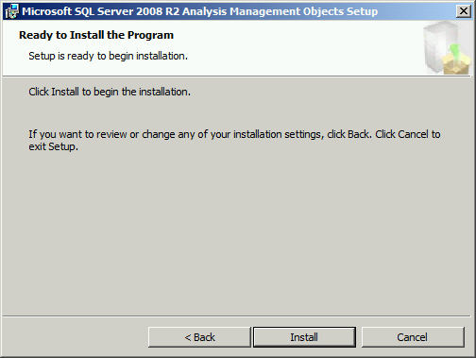

1. On the completion screen click Finish to complete the installation.

## Install Microsoft SharePoint Server 2010

**Quick Pre-Requisite Check**

* Installation Media Available or Mounted
* Installation Key Available
* SharePoint Computer has been joined to the domain
* SP_Admin has been added to the local administrators group of the computer you are installing SharePoint onto
* You are logged in as the SP_Admin domain account on the computer you are going to install SharePoint
* Your Server has Internet access for an online installation
* You will need the SQL Server Name and instance name from the previous installation
* You will be prompted for a Database Configuration name (usually SharePoint_Config) which is ok for your lab environment, however needs to be identified with the client in order to conduct the installation. Their naming convention needs to be employed
* You will be prompted for a port on which to install the Central Administration. Ports are usually not opened by IT departments unless necessary, so you need to know which port the client would like to use. For your lab environments you can usually name any ports as your servers are not on distanced networks
* You will be prompted for the Pass Phrase identified in Table 5

There are two methods to installing SharePoint, and offline method and an online method. The online method requires access to the Internet to download and install pre-requisite files necessary to install SharePoint Server. If you do not have access to the internet, you are going to have to download these files yourself and prepare a Pre-requisite Script File. Here is a list of the pre-requisite files you need:

* + Web Server (IIS) role
  + Application Server role
  + Microsoft .NET Framework version 4.5
  + SQL Server 2008 R2 SP1 Native Client
  + Microsoft WCF Data Services 5.0
  + Microsoft Information Protection and Control Client (MSIPC)
  + Microsoft Sync Framework Runtime v1.0 SP1 (x64)
  + Windows Management Framework 3.0 which includes Windows PowerShell 3.0
  + Windows Identity Foundation (WIF) 1.0 and Microsoft Identity Extensions (previously named WIF 1.1)
  + Windows Server AppFabric
  + Cumulative Update Package 1 for Microsoft AppFabric 1.1 for Windows Server (KB 2671763)

|  |  |
| --- | --- |
| **SAMPLE SCRIPT FILE FOR PRE-REQUISITE DOWNLOAD INSTALL:**  **This sample uses a script from the constoso.com SharePoint Server Shared folder and should not be copied verbatim to use. It is only for example purposes. This technical document does not cover this method of installation.**  /SQLNCli:\\SP2010-WFE1.contoso.com\SP2010Prereqs\sqlncli.msi /ChartControl:\\SP2010-WFE1.contoso.com\SP2010Prereqs\MSChart.exe /KB976462:\\SP2010-WFE1.contoso.com\SP2010Prereqs\Windows6.1-KB976462-v2-x64.msu /IDFXR2:\\SP2010-WFE1\SP2010Prereqs\Windows6.1-KB974405-x64.msu /Sync:\\SP2010-WFE1.contoso.com\SP2010Prereqs\Synchronization.msi /FilterPack:\\SP2010-WFE1.contoso.com\SP2010Prereqs\FilterPack64bit.exe /ADOMD:\\SP2010-WFE1\SP2010Prereqs\SQLSERVER2008_ASADOMD10.msi /ReportingServices:\\SP2010-WFE1.contoso.com\SP2010Prereqs\rsSharePoint.msi /Speech:\\SP2010-WFE1.contoso.com\SP2010Prereqs\SpeechPlatformRuntime.msi /SpeechLPK:\\SP2010-WFE1\SP2010Prereqs\MSSpeech_SR_en-US_TELE.msi |  |

Once you locate your SharePointServer.exe file, double-click it to open the installer. You will see:

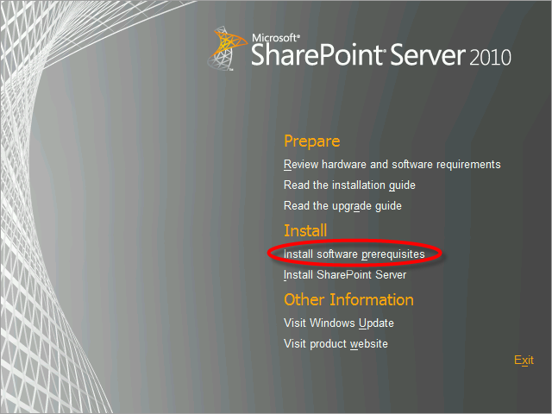

1. Click the Install Software Prerequisites Option which begins the installer wizard

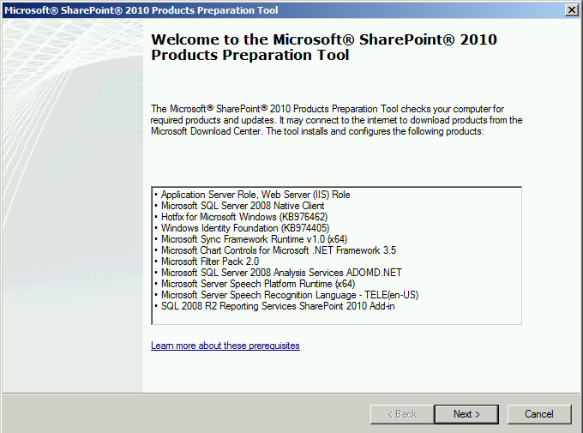

1. Click Next to continue. On the License Terms page click to accept the license agreements and then click Next to continue

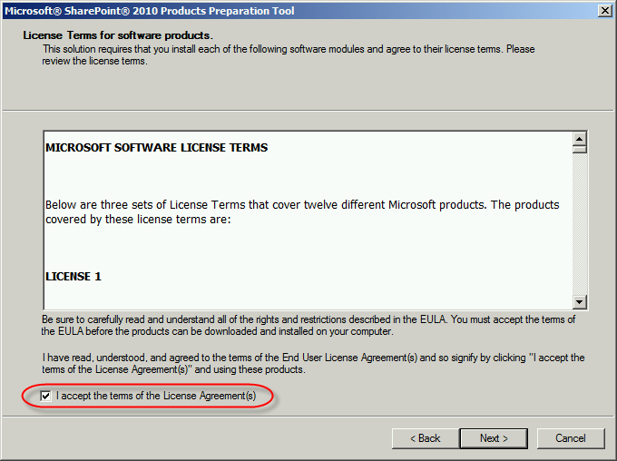

1. SharePoint downloads and installs all the required prerequisite files. Remember this will fail after the IIS installation if you are not connected to the internet. Once the wizard completes, click Finish to continue.

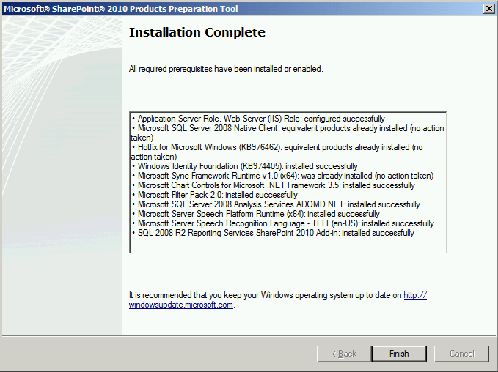

1. Click on the Install SharePoint Server option in the splash screen.

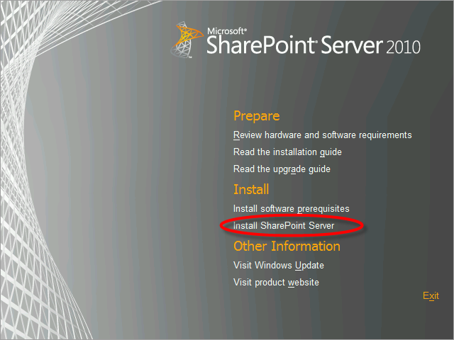

1. Enter the customer’s installation key (or the demo key which is displayed in the image). Click continue.

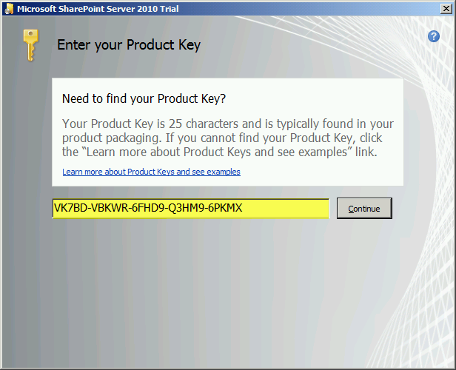

1. Click the check box to accept the license terms then click continue.

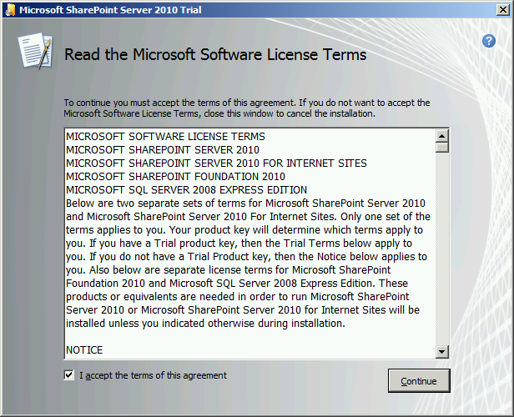

1. On the next screen select your choice of deployment. Recommend Server Farm for 99% of installations we will be involved in.

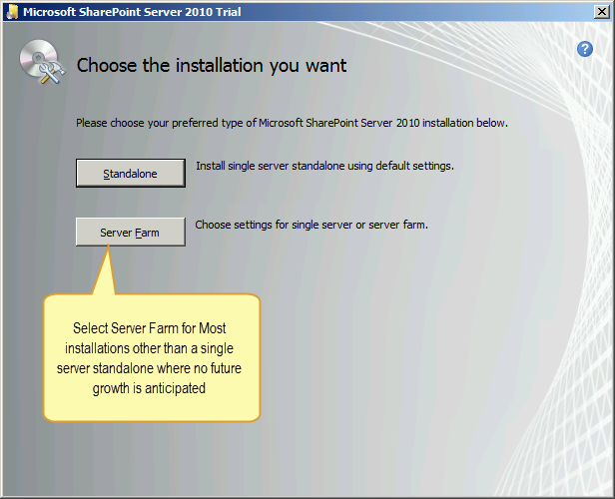

1. On the next screen select Complete – Install all Components. Choosing the other option restricts your ability to later add addition servers to the SharePoint Farm. You can also click the File Location tab and change the location where files will be installed. Once finished click on Install Now. The installation wizard will install all the necessary files.

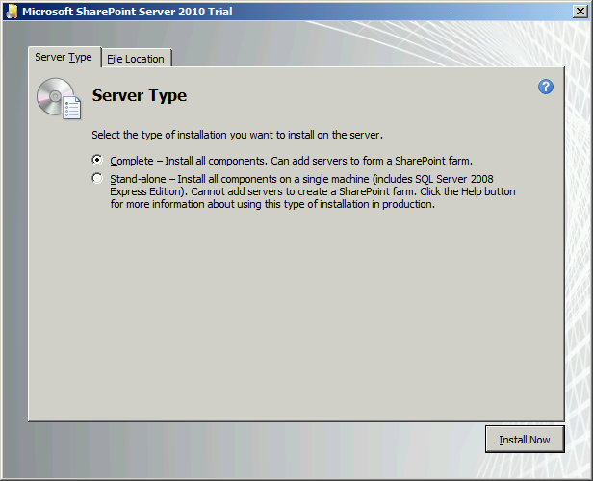

1. SharePoint does include four config.xml files which can be edited and modified to complete a silent or unattended installation of SharePoint. For more information see <http://technet.microsoft.com/en-us/library/cc261668.aspx> to read up on modifying and adjusting the installations using these files. On the completion screen uncheck the run configuration wizard option if you will be installing ProjectServer directly after SharePoint. You will run the configuration wizard after installing ProjectServer. SharePoint will not allow you to begin until you have run this wizard.

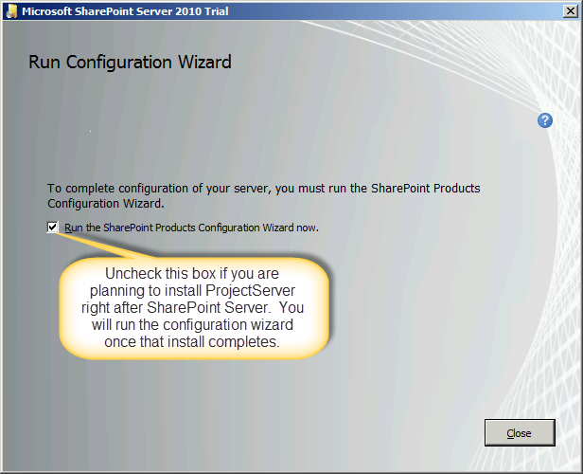

SharePoint is now installed and you can exit from the Installer Splash Screen. There is no need to re-boot after the installation of SharePoint. You can proceed directly to installing ProjectServer if you wish.

***This is a good place to take a Snapshot if you are using a Hyper-V or VMWare machine in your test lab or demo environment.***

## Install Microsoft Project Server 2010

**Quick Pre-Requisite Check**

* Installation Media Available or Mounted
* Installation Key Available if in a Client Environment
* SharePoint has been installed
* You are logged in as the SP_Admin domain account on the computer you are going to install ProjectServer (Same Computer as SharePoint is Installed)

1. Locate the ProjectServer2010.exe file and double click it to begin the installation wizard.

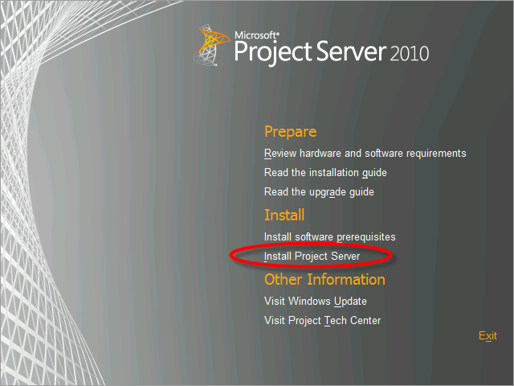

1. On this installation there is no need to install the software prerequisites like you did when you installed SharePoint Server. Enter your software installation key (the demo key is shown on the image). Click continue when ready.

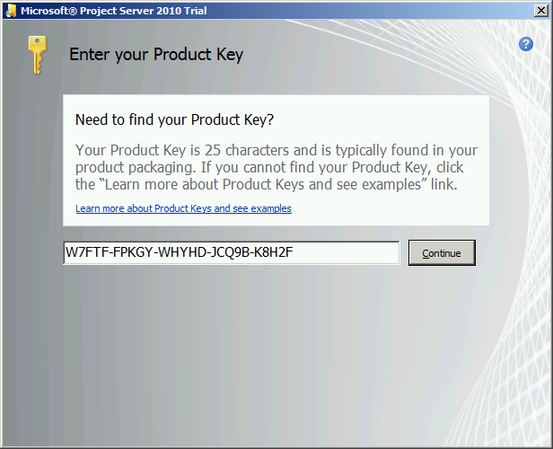

1. Check the box to accept Microsoft License Terms and then click continue.

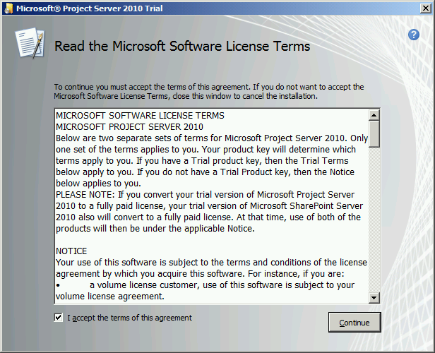

1. You will notice that the file locations on the next screen are greyed out, as we are installing ProjectServer as an application within SharePoint server, the system recognizes the folders to which the software needs to be installed. Click Install Now to continue.

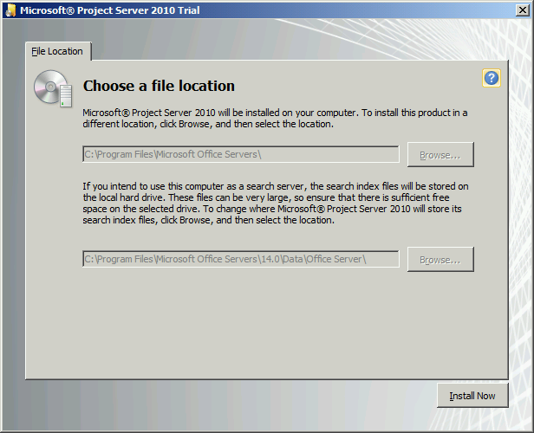

1. At the completion of the installation the system again asks if you want to run the SharePoint Configuration Wizard. You can run it later by clicking Start > All Programs > Microsoft SharePoint 2010 Products > SharePoint 2010 Products Configuration Wizard. For now, click Close and do not run the configuration wizard until we have installed Service Pack 1 for SharePoint, or the configuration wizard will fail, causing you to run it again after installing SP1.

## Install SharePoint Server 2010 SP1

1. Locate the downloaded SharePoint Server 2010 SP1 file and double click the executable to run it. The SP1 License Terms window appears. Click the box to accept the license terms and then click Continue.

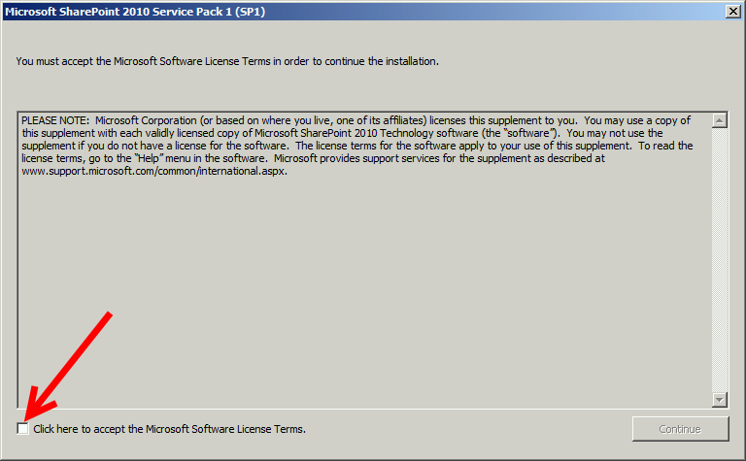

1. Windows installs the SP1 upgrade. At the completion of the upgrade you will see the complete screen:

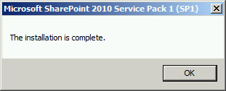

Service Pack 1 is installed.

***This is a good place to take a Snapshot if you are using a Hyper-V or VMWare machine in your test lab or demo environment.***

## Configure the SQL Server SharePoint Farm Account

**Quick Pre-Requisite Check**

* You are logged in as the SQL_Admin domain account on the SQL Server
* You have the name of the SharePoint Administrator Account from Table 4

Return to the SQL Server and login as the SQL Administrator Account that you created in Table 4.

There are two steps to configuring the SQL Server and SQL Databases before we can finalize the SharePoint installation.

1. Click Start > All Programs > Microsoft SQL Server 2008 R2 (or 2012) > Configuration Tools > SQL Server Configuration Manager

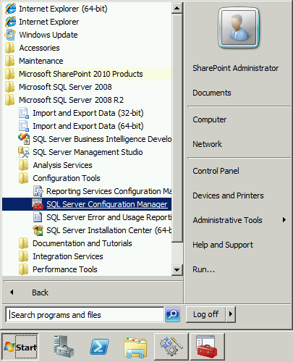

1. Click the Plus symbol next to SQL Server Network Configuration to expand the contents, then Select Protocols for MSSQLSERVER (Or the name of your server instance.) Once expanded check the TCP/IP setting on the right to ensure that it is Enabled. If it shows Disabled, right click it to change its setting before continuing. It should read Enabled when completed. You will receive a warning that the changes will not take effect until the Services are restarted. Click OK.

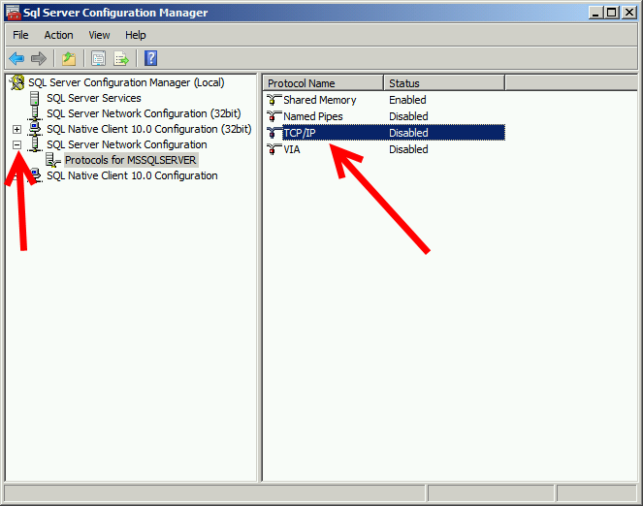

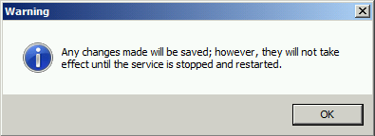

1. Click the Start > Microsoft SQL Server 2008 R2 / 2012 > SQL Server Management Studio

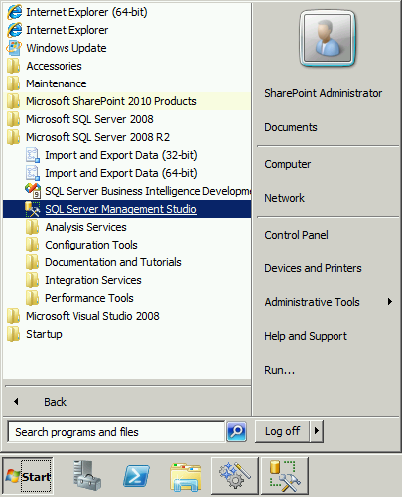

1. At the SQL Login Screen, make sure we are logging into the SQL Database Engine (top Choice), that the server name is correct, and that you are using Windows Authentication. Click Connect.

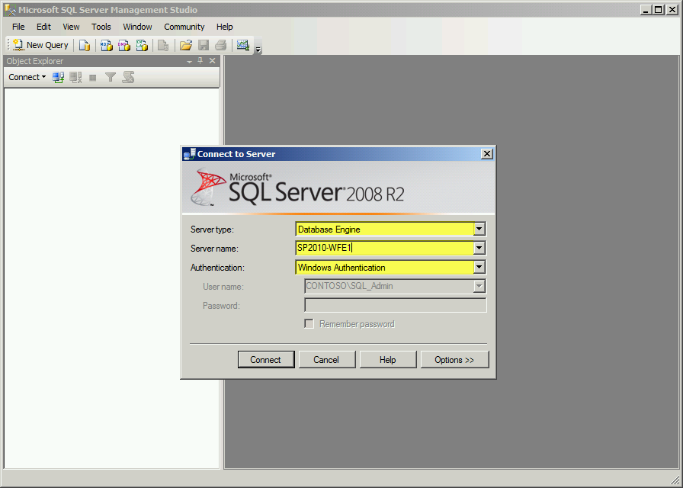

1. In the left Window pane, click the plus next to your server name if it is not already expanded, then the plus next to security and finally the plus next to Logins. Right click on the Title Logins and from the popup window, select New Login. We are about to give our SP_Admin login rights to the database server, and to ensure that it has rights to operate within SQL.

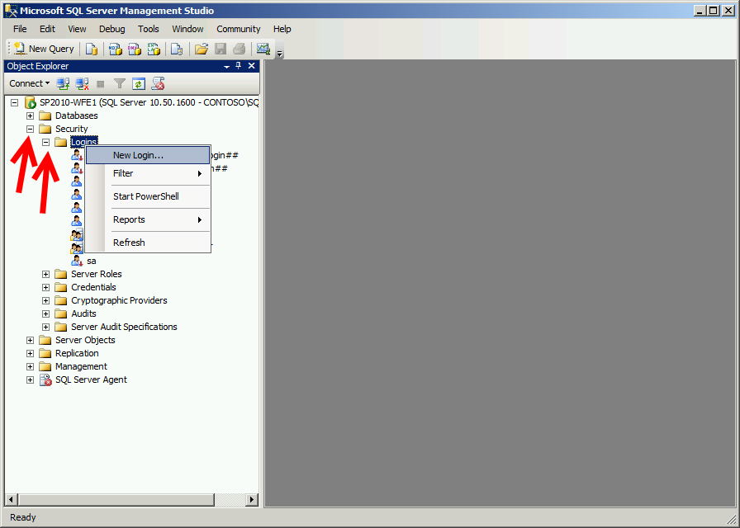

1. On the New Login Screen type in your SharePoint Admin login name from Table 4 then click the Search Button.

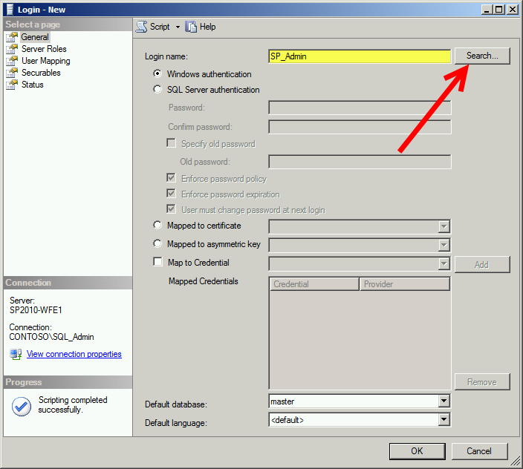

1. On the Search Screen first ensure that you are searching within the Domain and not the local machine.

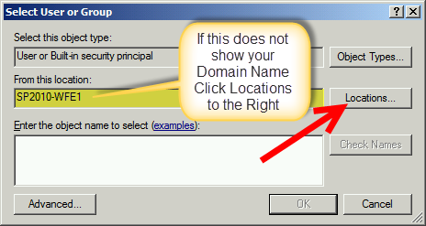

1. In the locations window, select the Entire Directory option and then click OK. This enables us to search in the entire Active Directory for the Domain, and not just user accounts setup on the local machine.

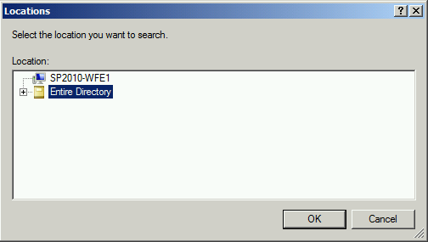

1. Type the name of your SharePoint Administrator Account in the Object Name window, and then click Check Names.

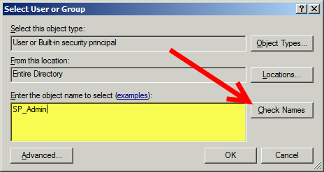

1. You should see the Domain resolve the Username and show it similar to below, if so, click OK to continue.

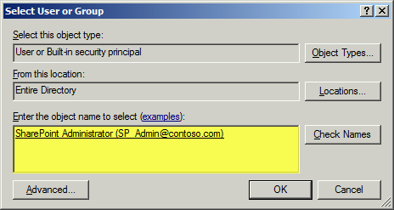

1. Optionally, in that Username Search window, you can type the complete Domain Name for the SharePoint Admin account like shown, and then continue without searching. Use this option only if you are confident you have the correct account.

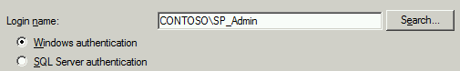

1. Returning back to the Login Screen, click the Server Roles option in the left window pane, and select the *dbcreator*, *public*, *securityadmin, setupadmin* and *sysadmin* roles. When you are finished, click OK to continue. You should now see your SharePoint Administrator account showing as a user in the SQL Database.

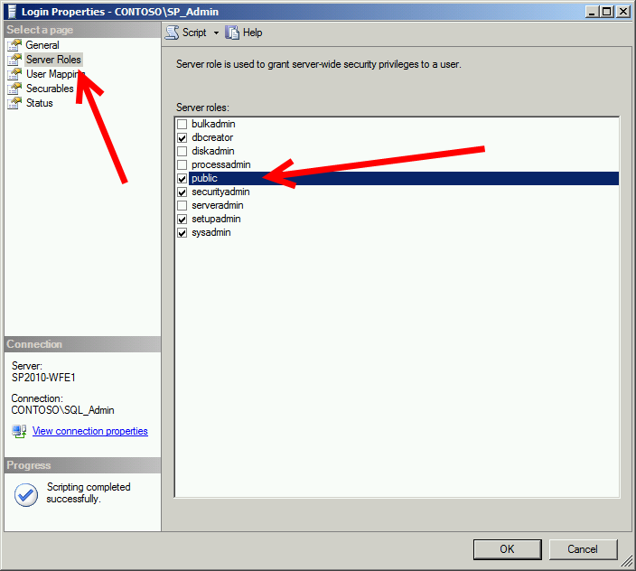

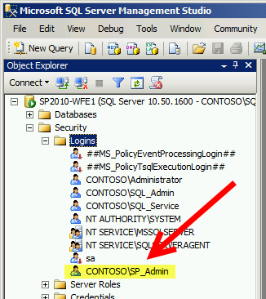T

1. The final configuration step for the SQL server is to run a setup Query to enable the common language runtime. Click the New Query button. In the middle window pane type this query exactly as you see it:

sp_configure ‘clr enabled’, 1;

go

reconfigure;

go

1. Click the Execute button in the toolbar

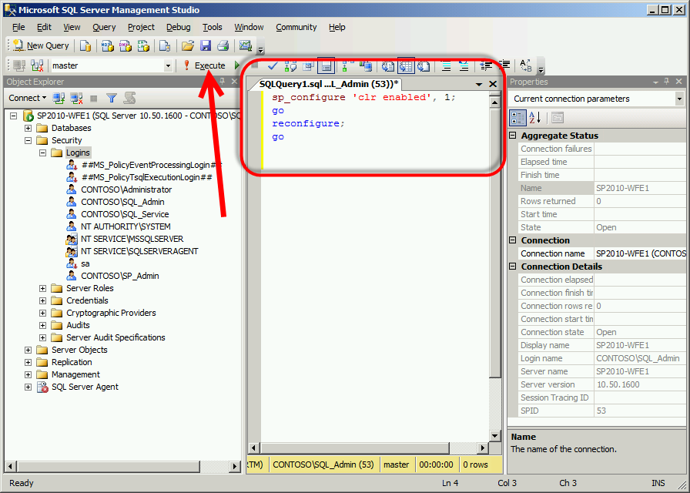

1. You should see a message response window appear at the bottom reporting that the change has been made. Once completed, close down the SQL Server Management Studio application. If asked to save the query, select no. If in your lab environment or demo environment, suggest you do a re-boot. Check with client on permission to re-boot, but advised.

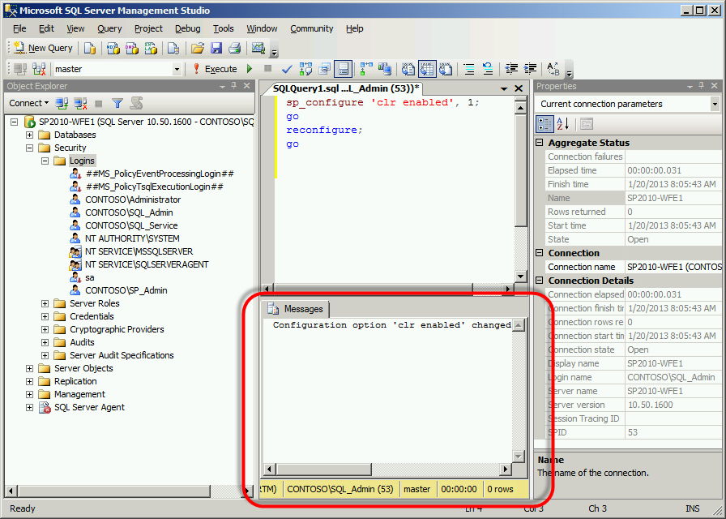

## Prepare SQL Server Analysis Services for Project Server

There are two steps to complete within SQL Server Analysis Services in order for ProjectServer to function. You will have to add the SharePoint Farm Administrator account to the OLAP Local Users Group on the SQL Server and then configure the SharePoint Farm Administrator account in Analysis Service.

1. Click Start > All Programs > Microsoft SQL Server 2008 R2 (or 2012) > SQL Server Management Studio

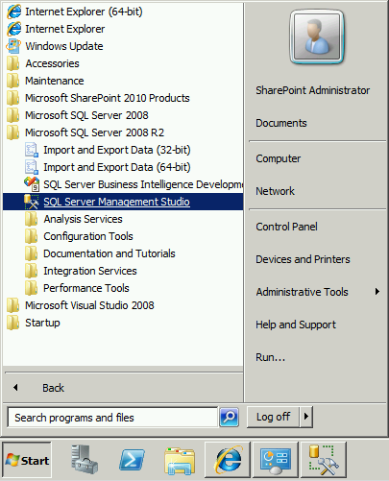

1. On the Connect to Server Dialog Window click the Server Type pull-down menu and select the Analysis Services Option

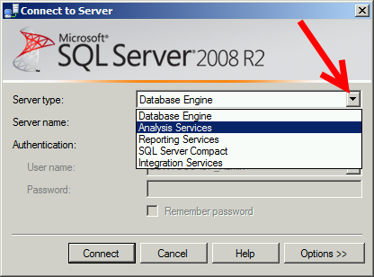

1. Make sure that your server instance is selected in the Server Name pull-down option then click Connect to continue

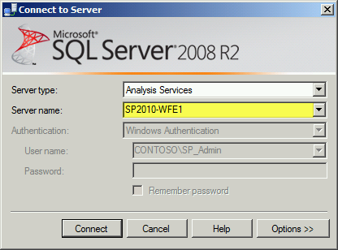

1. Right click on the Server name at the top, and then click Properties all the way at the bottom of the popup menu

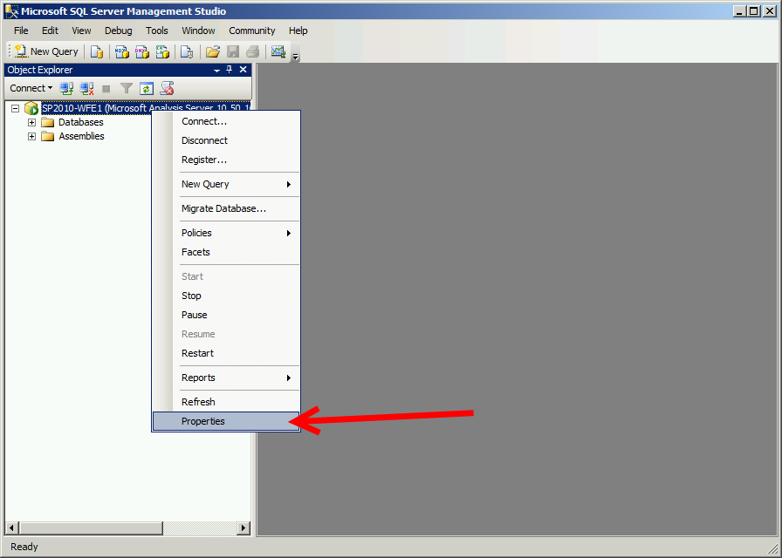

1. On the Analysis Server Properties dialog window, select the Security page in the left pane. Here you will see the current Administrators with security privileges. Click the Add button at the bottom.

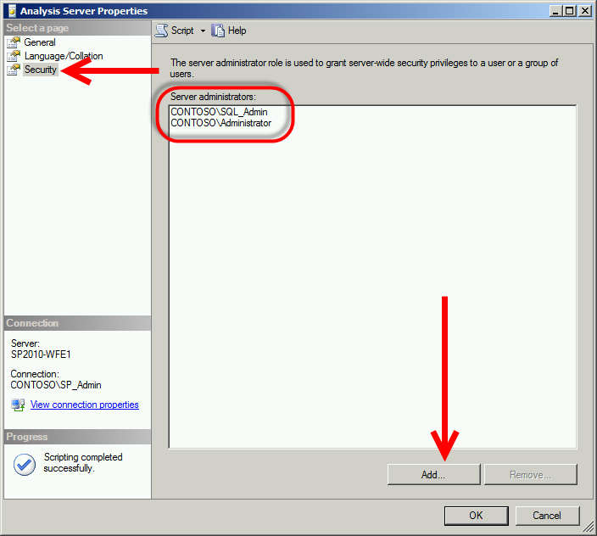

1. Type the name of your SharePoint Farm Administrator and then click Check Names. Ensure that you are checking in the Entire Directory Location, if another location shows, click Locations and choose Entire Directory. After checking names, you should see your SharePoint Farm Administrator account fully resolved with an underline.

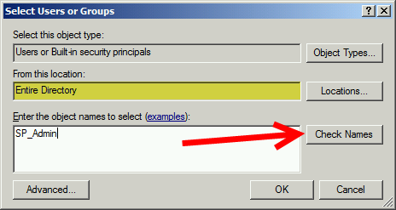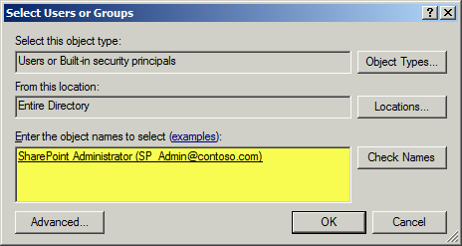

1. Click OK and you have completed adding the SharePoint Administrator. Close down Microsoft SQL Server Management Studio.
2. Click Start > Administrative Tools > Computer Management. Expand the plus sign next to Local Users and Groups. Select Groups. In the right pane look for a group that looks like SQLServerMSASUser$<SERVERNAME>$MSSQLSERVERINSTANCE or SQLServer2005MSOLAPUser$<SERVERNAME>$MSSQLSERVERINSTANCE. The key is MSASUser or MSOLAPUser in the name. Double click that group to open it up.

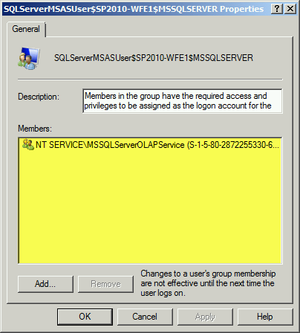

1. We are going to add the SharePoint Farm Administrator account to this group. Click Add at the bottom of the dialog window.

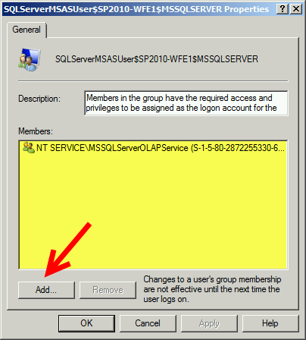

1. In the From this Location window, ensure you are searching the domain and not the local machine; click Locations to change if necessary. Type in the name of your SharePoint Administrator account in the names section, and click Check Names .

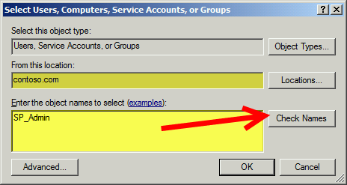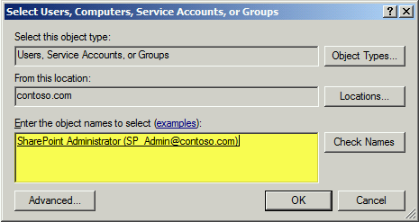

1. The name should resolve and leave you with an underlined Active Directory name. Click OK to continue. Click Apply on the next window then click OK. Close down Computer Management.

***This is a good place to take a Snapshot if you are using a Hyper-V or VMWare machine in your test lab or demo environment.***

## Run The SharePoint Server 2010 Configuration Wizard

**Quick Pre-Requisite Check**

* SharePoint has been installed
* You are logged in as the SP_Admin domain account on the SharePoint Server
* You have the name of the Database Server from Table 3
* You have the Username of the SharePoint Farm Administrator from Table 4
* You have the SQL Database SharePoint Configuration Database name from Table 6
* You have the Port Number the Client wishes to use for SharePoint Central Administration from Table 6

The SharePoint Configuration Wizard is the final setup in setting up SharePoint for the first use. The wizard is going to ask for the port number, the database location, the username and password to access the SQL server farm and the configure SharePoint to connect to the Server Farm.

1. From the Start Menu click All Programs, and then SharePoint 2010 Products Configuration Wizard

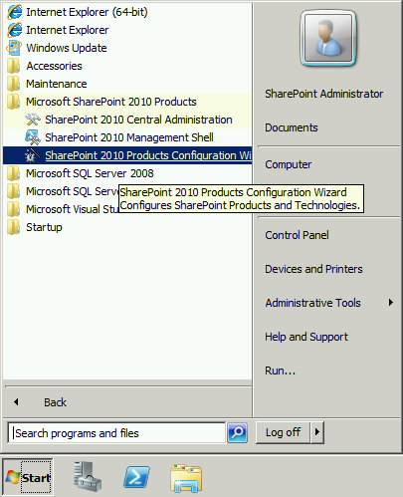

1. On the welcome screen click Next

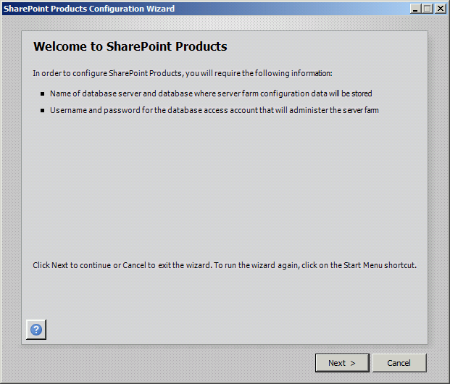

1. On the re-start warning screen click Yes if it will not disrupt the client environment

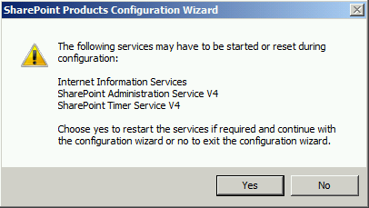

1. On the Connect to a Server Farm screen click Create a New Server Farm button for most installations. In some client environments you may be connecting SharePoint to an existing Farm for load balancing, etc. at which point you would select Connect to an Existing Farm.

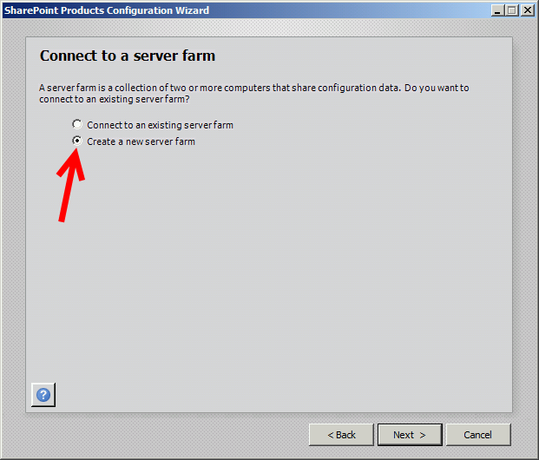

1. On the Specify Configuration Database Settings screen is where you are going to need to know the name of the SQL database server (i.e. sql.contoso.com or sql.advisicon.demo etc.) from Table 3. You will need to enter the default configuration database name from Table 6. On the specify database access information you will enter the SharePoint Farm administrator account and password from Table 4. This name needs to be entered in DOMAIN\username format. Click Next to continue.

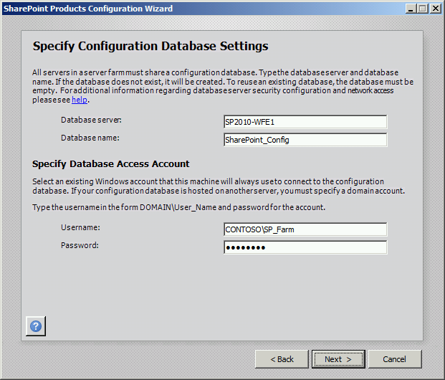

1. On the next screen you will enter the Farm Security Settings Passphrase that was identified in Table 6.

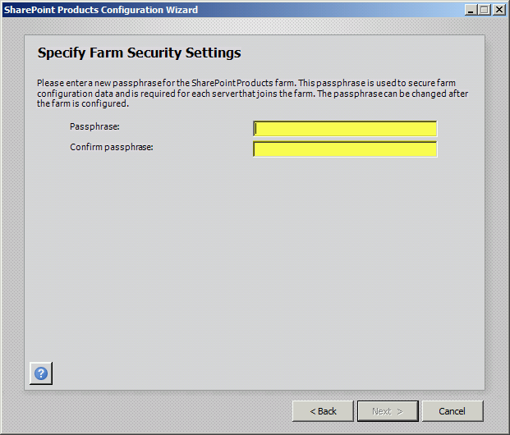

1. On the next configuration page, enter the Port number that was identified in Table 6 and ensure that NTLM security is checked unless you have a unique environment requiring otherwise. Click Next to continue.

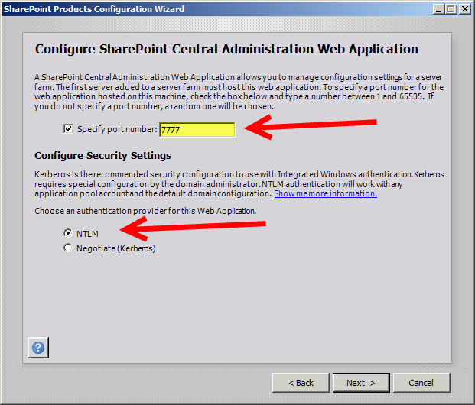

1. The final screen is a summary confirmation screen. Once you click Next, SharePoint will configure itself through a series of setups. Once completed, you should see the summary screen below.

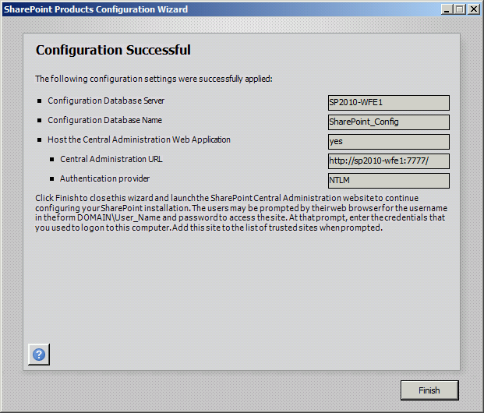

1. This completes the SharePoint Configuration Wizard setup.

***This is a good place to take a Snapshot if you are using a Hyper-V or VMWare machine in your test lab or demo environment.***

## Start SharePoint for the First Time-Run the Wizard

**Quick Pre-Requisite Check**

* You are logged in as the SP_Admin domain account on the SharePoint Server

1. Log into the SharePoint Server and click Start > SharePoint 2010 Central Administration or if not present, click Start > All Programs > Microsoft SharePoint 2010 Products > SharePoint 2010 Central Administration
2. Your system will open up Internet Explorer and reach out to your SharePoint Server name and the port you identified during installation. Once Connected you will see this screen, click Start the Wizard to Continue.

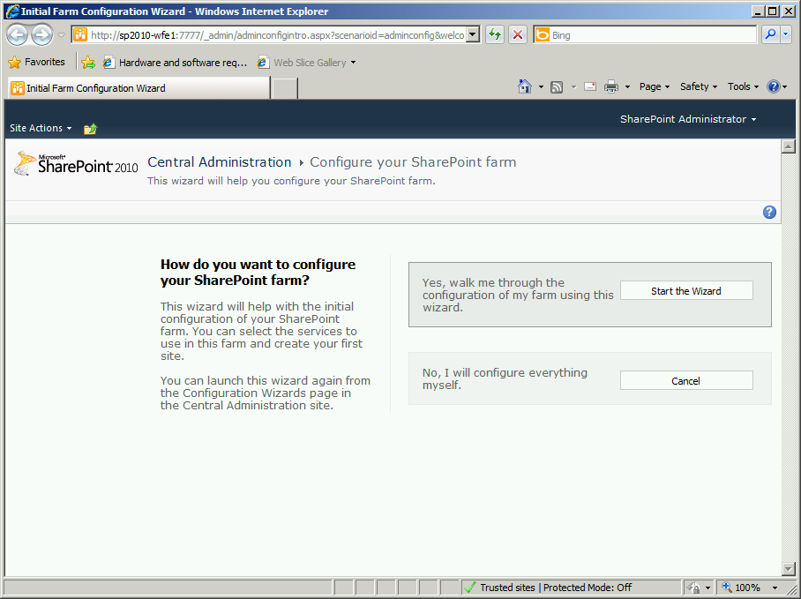

1. On the next screen, change the Service Account Username and Password to the SharePoint Services Account you created from Table 4. This establishes the correct account to perform Service functions for SharePoint and allows for better least privileged security and tracking if an issue arises. Optionally on this page you can turn off services that SharePoint runs, or activate the only non-installed Service, Lotus Notes Connector. The more services you run, the greater the load on the server. Once you have chosen your services, scroll down to the bottom of the screen and click Next to continue.

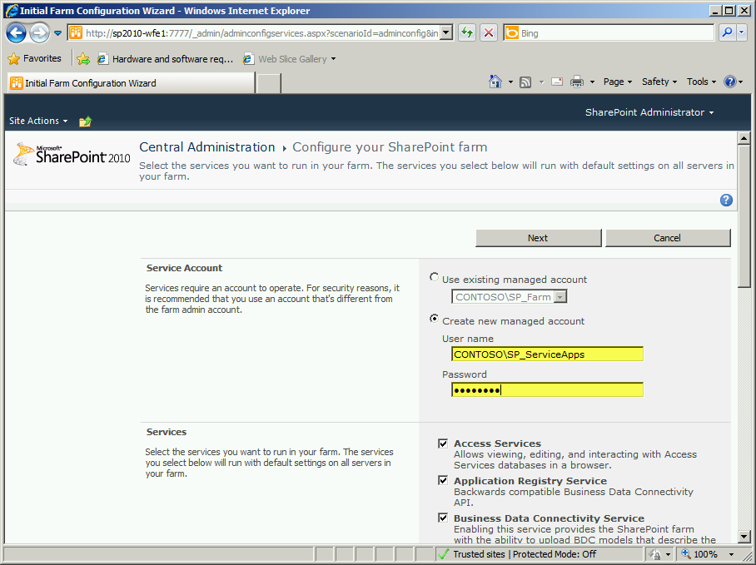

1. On the next Page you will need to enter the Title and URL the client desired from Table 6, or name it as you desire for your lab/demo site.

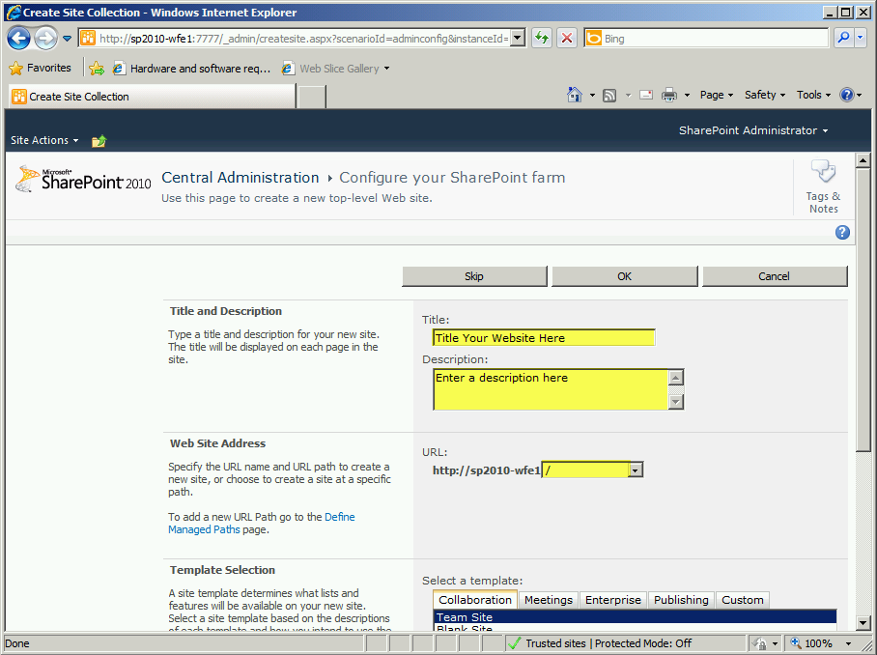

1. Scroll down the page and select the Site Template you are going to deploy for the top level site, then click OK to continue.

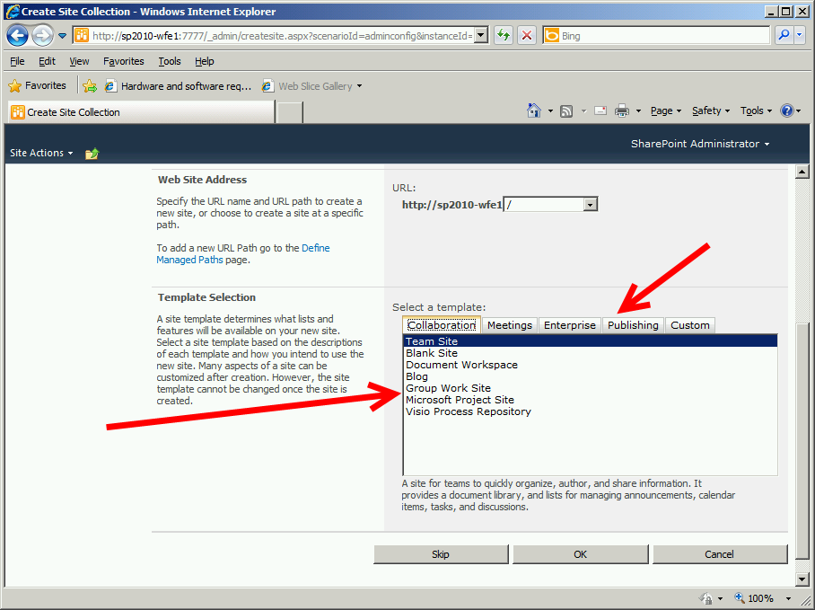

1. SharePoint will process your selections and completes the Configuration Wizard. Click Finish at the bottom of the page.

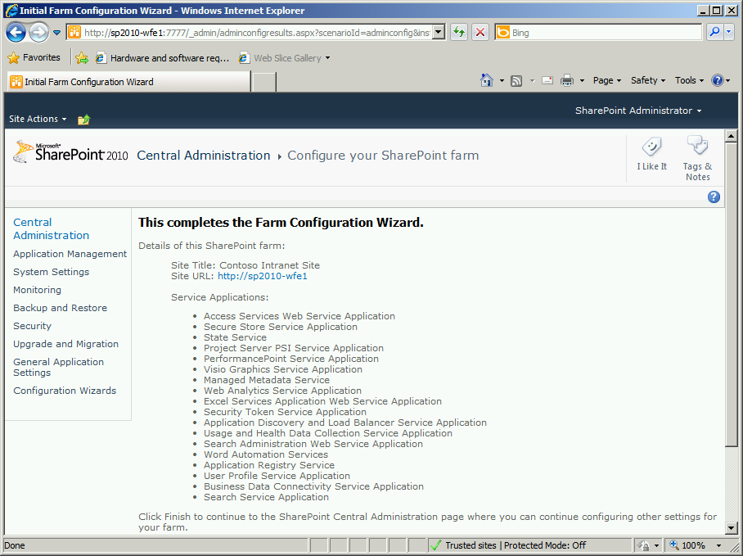

1. This completes the initial setup of SharePoint

***This is a good place to take a Snapshot if you are using a Hyper-V or VMWare machine in your test lab or demo environment.***

# SHAREPOINT POST-INSTALLATION CONFIGURATION

## Security Group Configurations

Once you have completed the initial setup of SharePoint we need to assign a few people to the Farm Administrators account, as well as create three groups for ProjectServer use.

1. Log into your SharePoint Server as the SharePoint Farm Administrator.
2. Click Start > All Programs > Microsoft SharePoint 2010 Products > SharePoint 2010 Central Administration to launch the Central Administration Page
3. In the left Sidebar menu, click Security

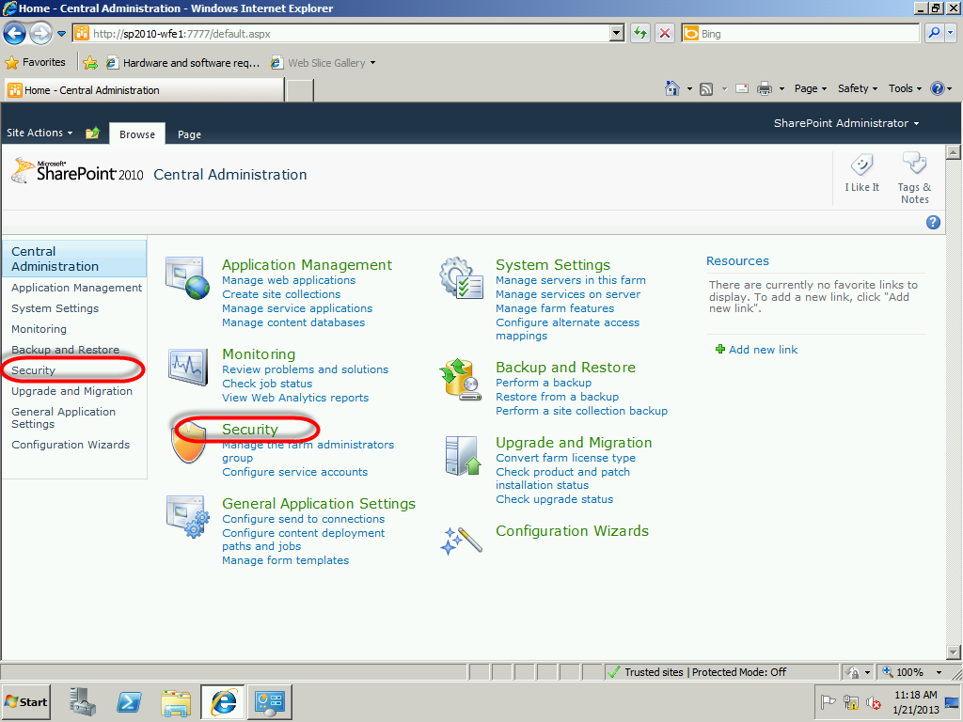

1. Click the Manage the farm administrator’s group link under Users. Optionally, from the Parent Central Administration Page, you could select this link directly.

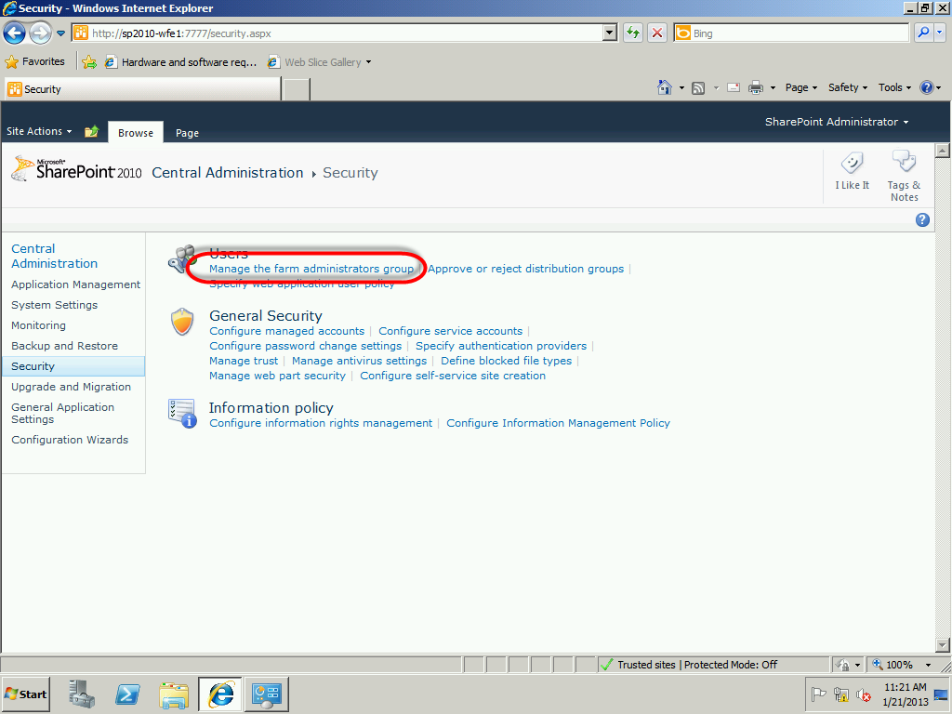

1. Click the New pull-down menu option and select Add Users to add to the Group

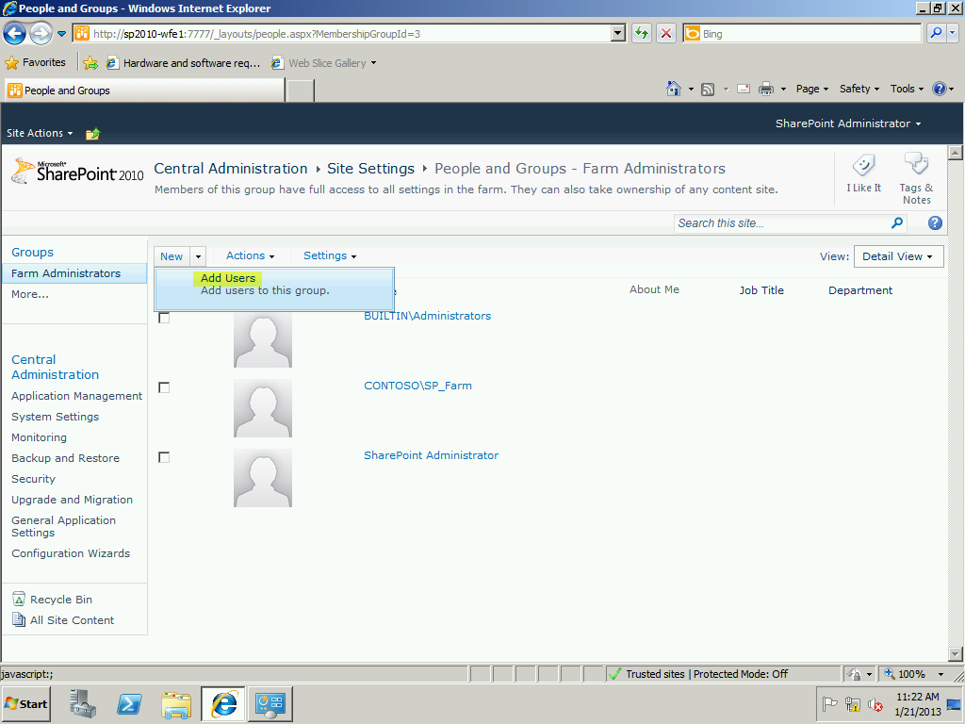

1. You will have a popup dialog window open asking you to enter user names, group names or email addresses. Notice the figure with a check mark and the book icons in the lower right. These are used to confirm a username from Active Directory, or to Browse Active directory. Type the usernames or groups you obtained from the client, or if this is your lab environment or demo system, type your name into the box and check to confirm it.

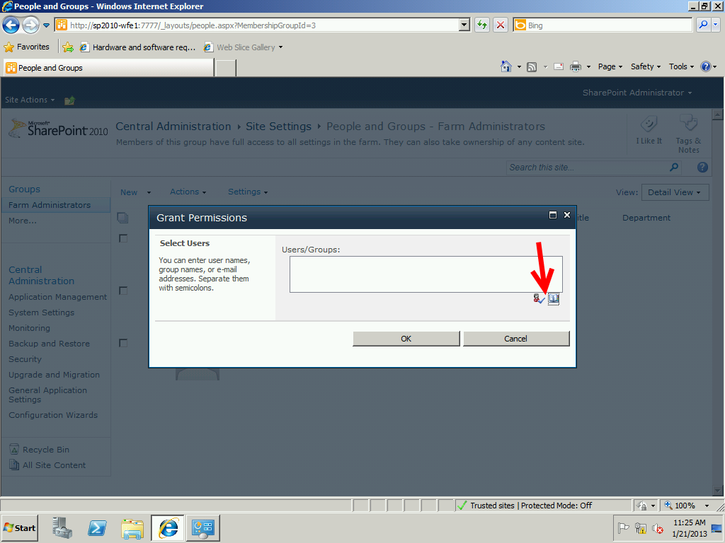

1. Once you enter a name or a group and confirm it, the name or group receives a solid underline to illustrate that this is an acceptable item in Active Directory. When you have finished, click OK to continue.

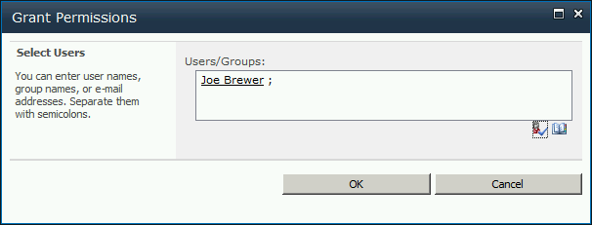

1. You are returned to the Central Administration > Site Settings > People and Groups-Farm Administrators page and should see your user accounts displayed on this page. Click the SharePoint 2010 logo to quickly go back to the Main Menu of Central Administration.
2. Now we will create the three groups ProjectServer will use.
3. On the Central Administration Page in the upper left corner, click on Site Actions and in the drop down menu, select Site Permissions

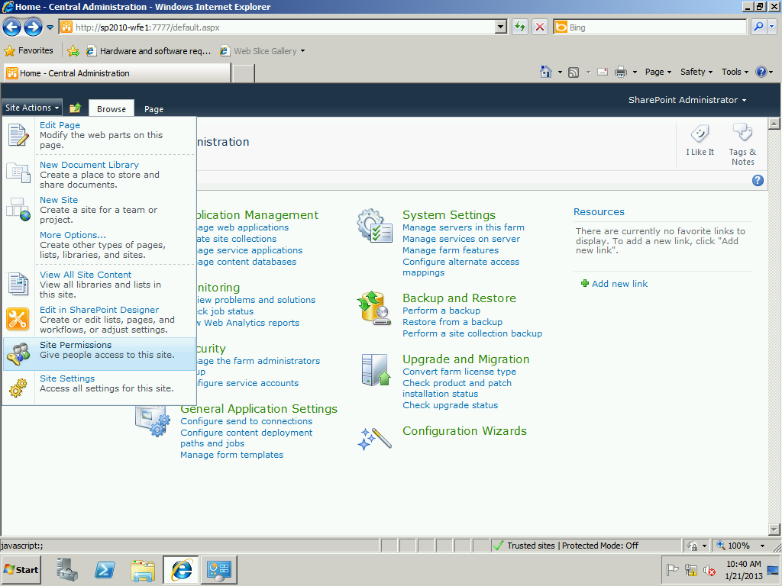

1. Notice the three existing Groups that SharePoint creates. Notice the permission levels in the far right column. We are going to create a total of three new groups with their own permission levels as follows:

|  |  |
| --- | --- |
| **Group** | **Permission Level** |
| SharePoint for Project Server Owners | Full Control |
| SharePoint for Project Server Members | Contribute |
| SharePoint for Project Server Visitors | Read |

**\*NOTE: On a client site, you will need to gather these as shown in Table 7-These three are the base levels suggested for a good practice installation**

1. Click the Create Group icon in the Ribbon

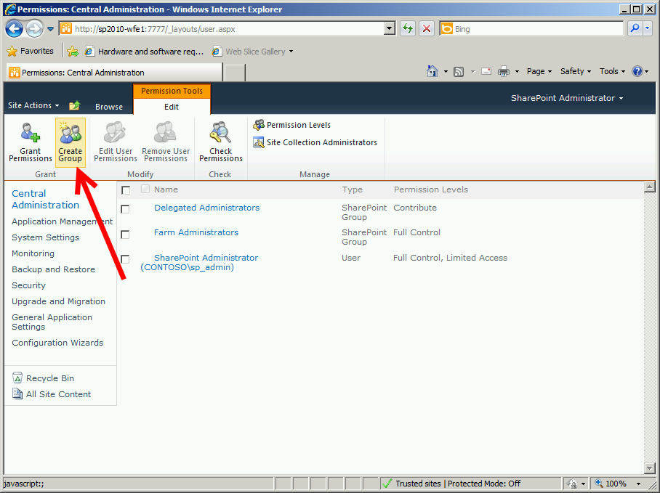

1. On this next screen you will type the parameters of these groups. Type the name from above and give it a description. If you want to change who the owner of this group is, you can select it in the Group Owner field, and confirm it with the Active Directory. You can alter group settings for view and edit (leave these three defaults set to the system default) and you can identify who receives emails if they want to join that particular group. Finally, choose the security level as designated in your preliminary work and in Table 7. Once you have finished, click Create to continue. Repeat this process as necessary for your groups.

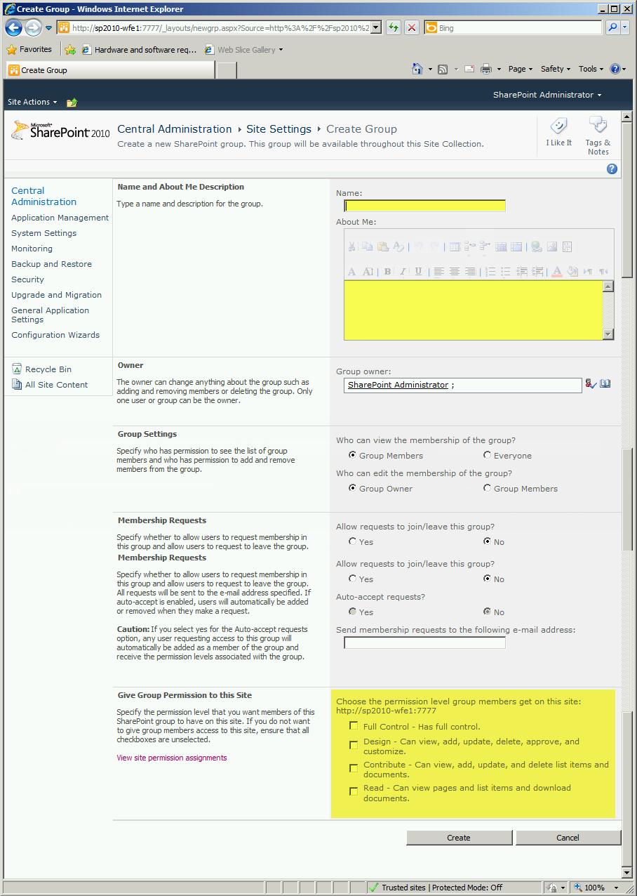

1. Once you have finished creating your groups, click the SharePoint Logo and return to the Central Administration page.

## Setting INitial Read Permission on Site

In order for users to access and read information on your site, we need to set the initial top site permissions. Follow these instructions:

1. Navigate to the SharePoint Top Level Home Page (Not the Central Administration Page, rather the actual site you created in the initial wizard.)

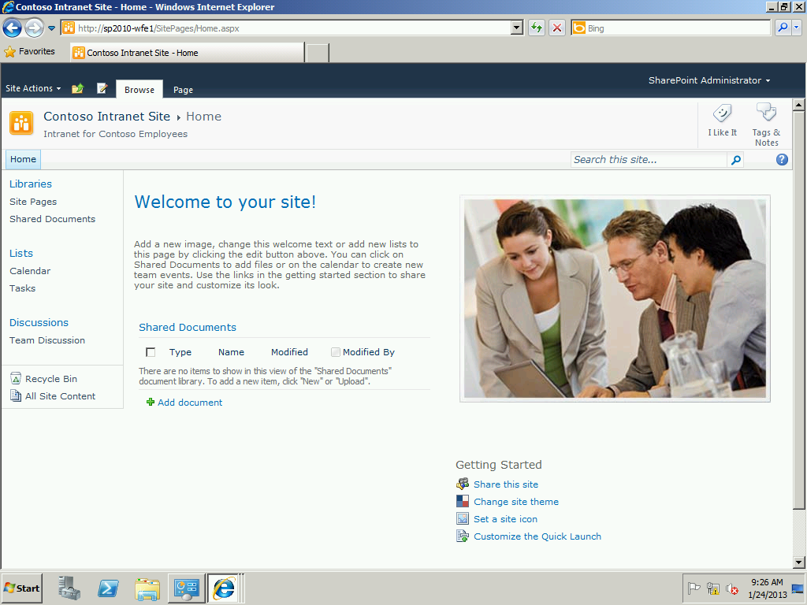

1. Click the top Site Actions pull down menu, and then select Site Permissions

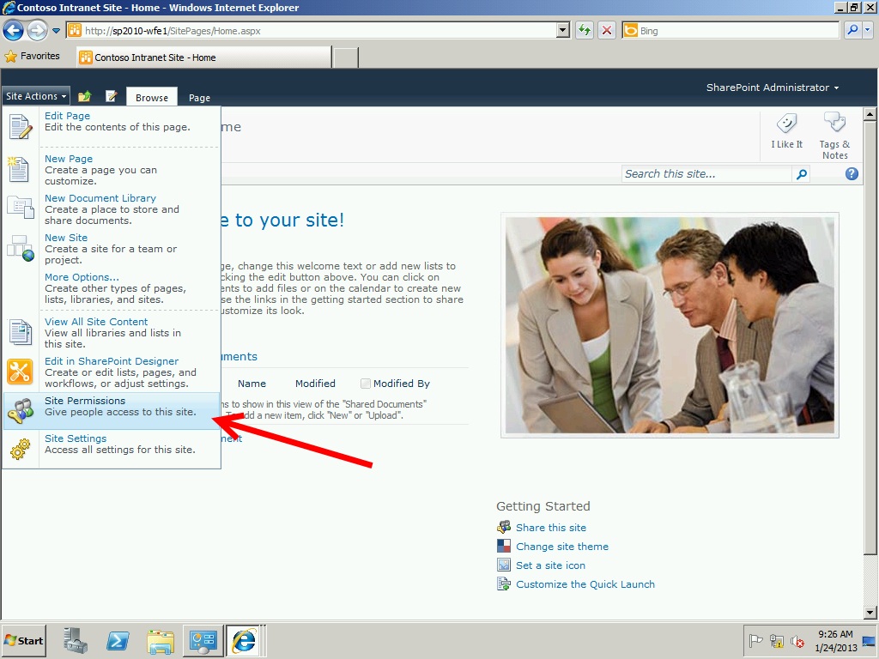

1. Click the Grant Permissions icon on the Ribbon toolbar

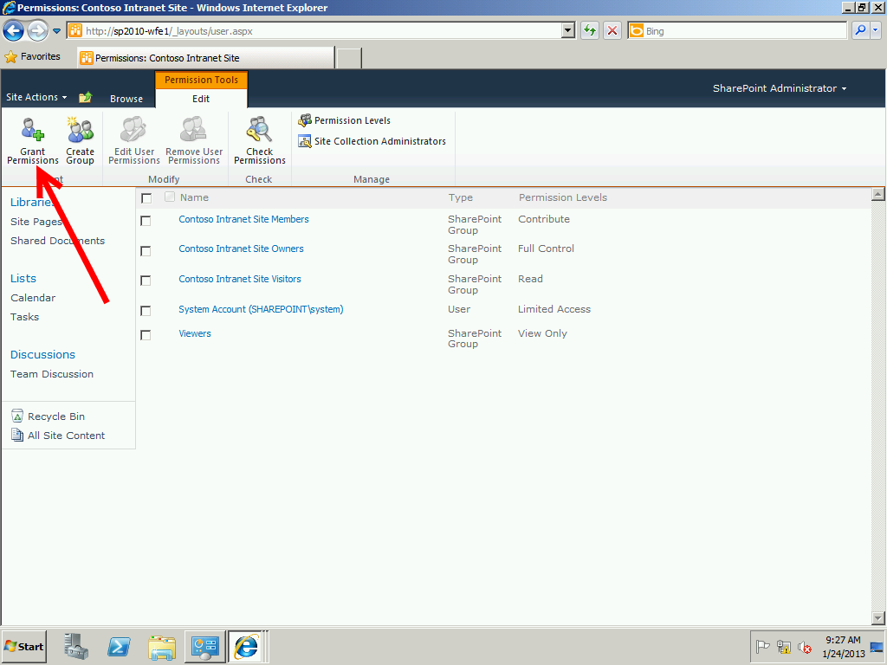

1. In the Grant Permissions Window, Users/Groups Window, type this without the quotation marks: “***NT AUTHORITY\authenticated users***” and then click the verification icon (head icon with a checkmark.) Your usernames should resolve with an underline showing they are validated. Choose your SharePoint for ProjectServer Visitors group that had read access you just created, and then click OK to save the settings

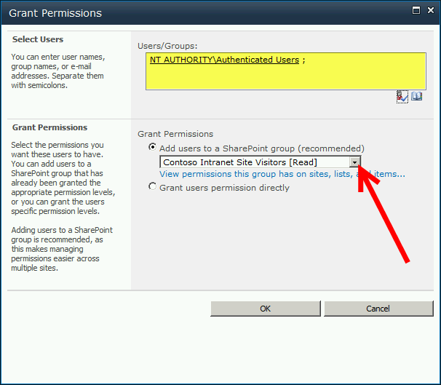

## Configure Object Cache Portal Super User Account and Portal Super Reader Accounts

There are user accounts that SharePoint uses for caching, reading and ACL (Access Control List) verification for user requests in the sites. These accounts need to be setup in SharePoint Central Administration.

Use this Table as a reference

|  |  |  |  |  |
| --- | --- | --- | --- | --- |
| **Account** | **Full Control** | **Full Read** | **Deny Write** | **Deny All** |
| SP_Farm | X |  |  |  |
| SP_ServiceApps | X | X |  |  |
| SP_Crawl | X | X |  |  |
| NT AUTHORITY\Local Service |  | X |  |  |

***NOTE****: These account names may differ dependent on your requirements gathering document. Refer to Table 4 for your specific account names.*

1. Click Manage web applications underneath the Application Management Menu

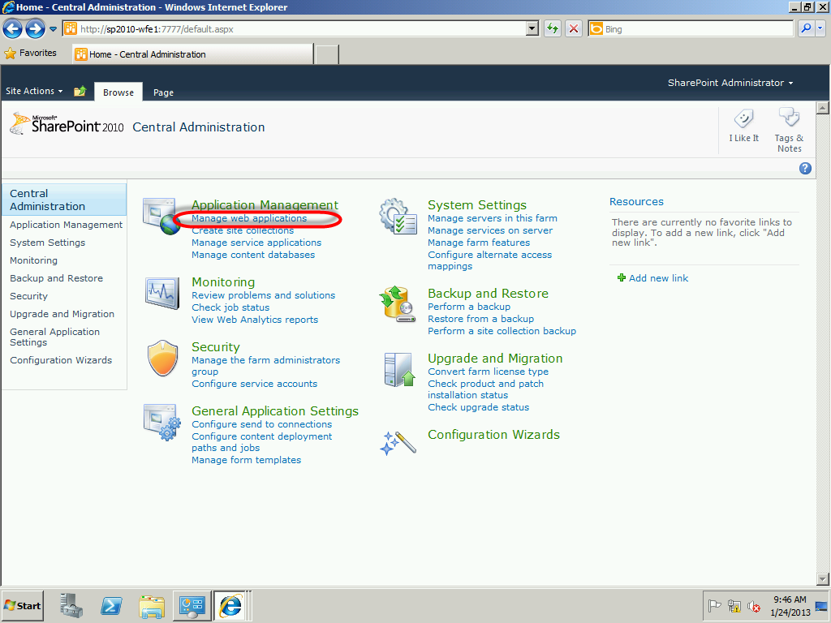

1. Highlight your top level SharePoint site (displays port 80). Once highlighted, click the User Policy ribbon bar icon.

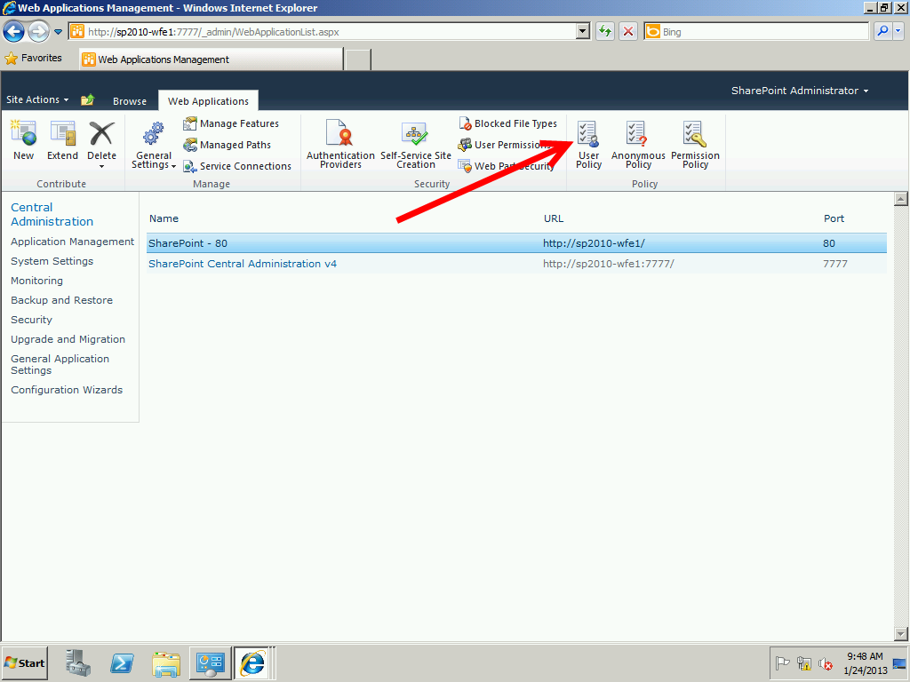

1. Click the Add Users hyperlink at the top

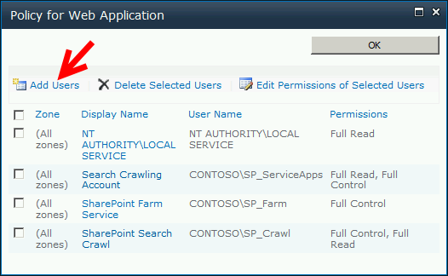

1. Make sure All zones is selected and then click Next to continue

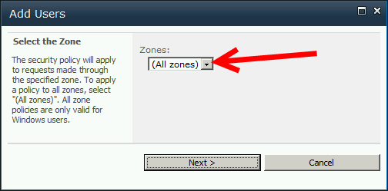

1. In the Add Users dialog window, type the names of the users in the table above, ensuring you set the permissions for each group appropriately.

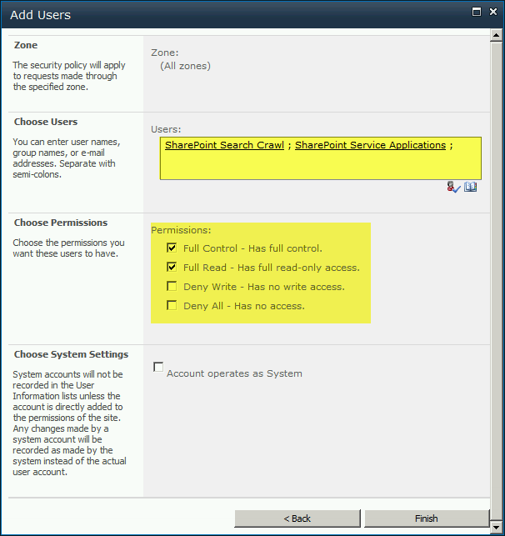

1. Click Finish when complete. Repeat as necessary for differing user group permissions.

## Provision First Instance of Project Server

**Quick Pre-Requisite Check**

* You are logged in as the SP_Admin domain account on the SharePoint Server
* You have Created your Security Groups in SharePoint
* You have the desired URL from Table 3 (Often set to PWA for Project Web App)

We are now ready to create our first instance of the Project Server Web Application.

1. Click Start > All Programs > Microsoft SharePoint 2010 Products > SharePoint 2010 Central Administration

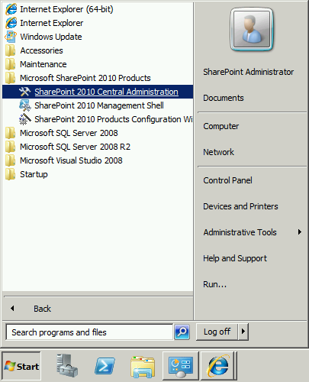

1. Internet Explorer will launch and bring you to the Central Administration Page. Select the Manage Service Applications from the Application Management Menu

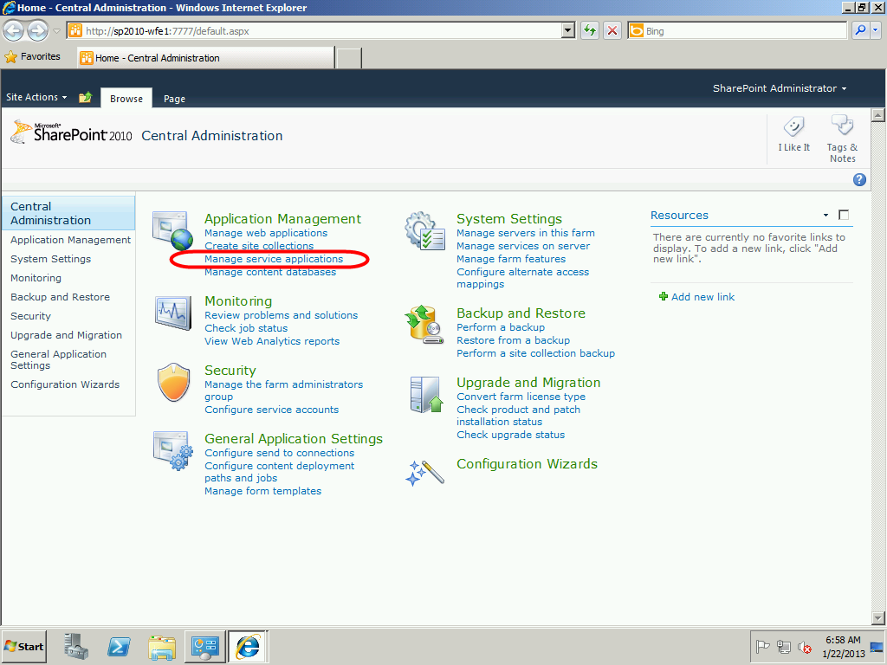

1. From the Manage Applications page, highlight the Project Server Service Application line item (Application and not the Proxy) and then click the Manage icon in the ribbon.

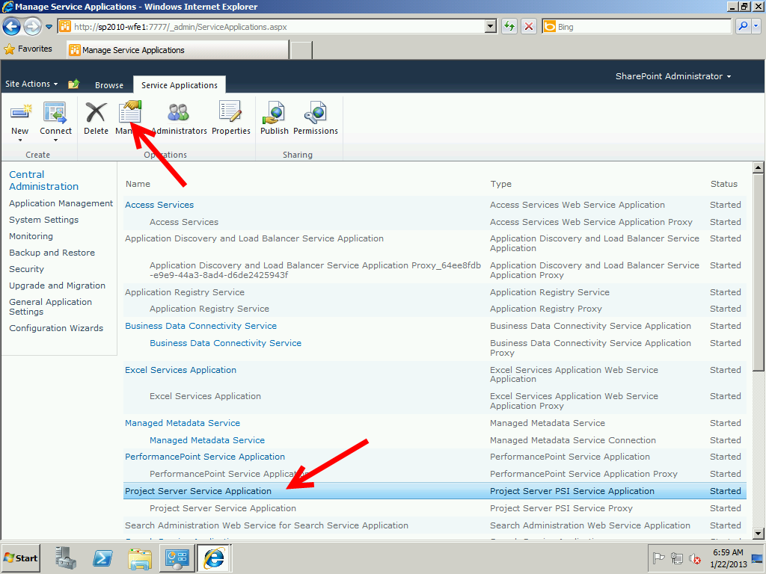

1. Click the Create Project Web App Site link at the top of the page

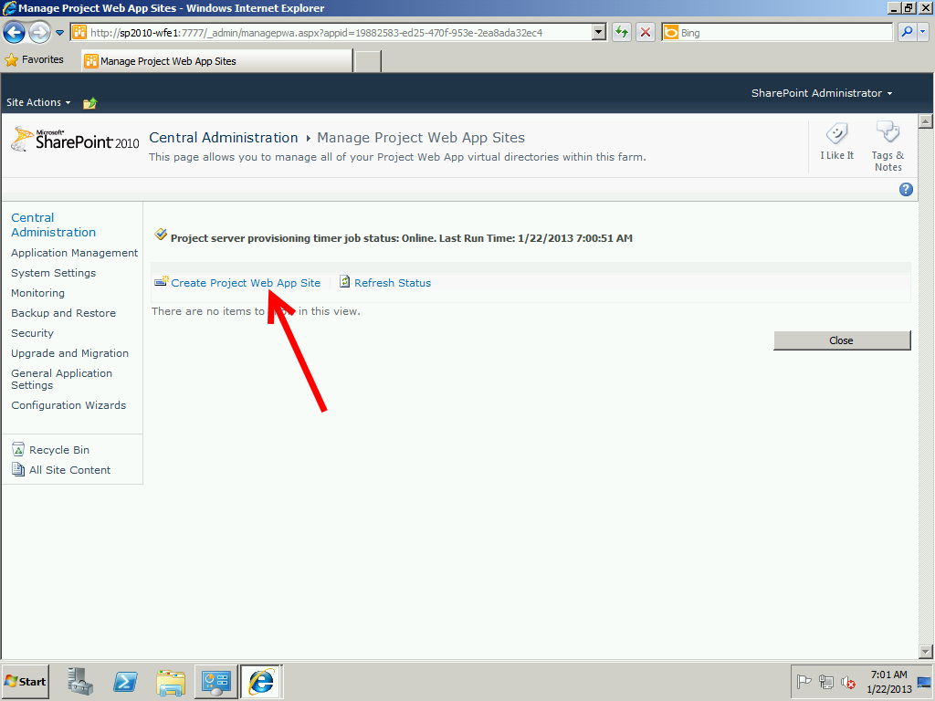

1. On the Project Web App path select the suffix name that will be used by the http://<SERVERNAME>>/PWA Project Server instance (PWA in the example image) or alternatively, select a full host header like <http://intranet.advisicon.demo/project> . If you select the host header option, you must check the box to Use Project Web App path as host header. Verify the Administrator account is accurate, the SQL Database information is accurate and then click OK to begin the provisioning process.

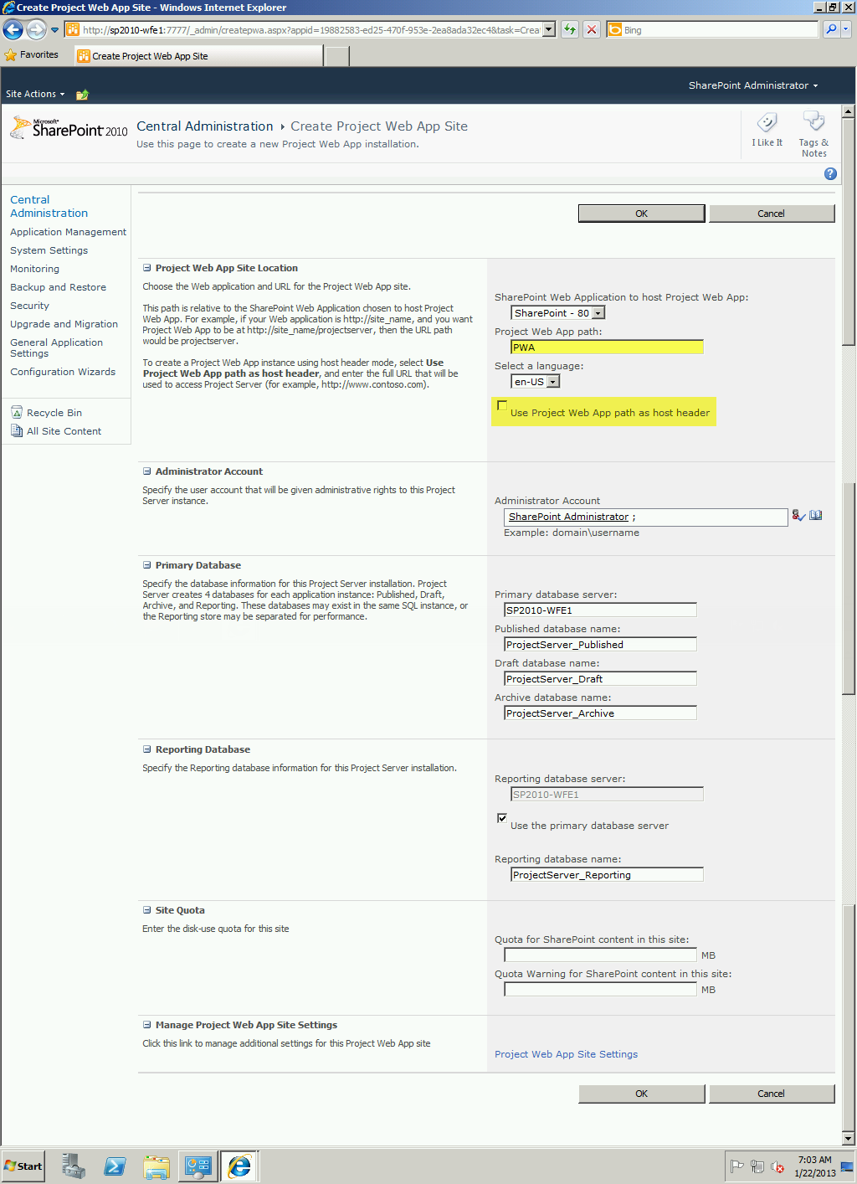

1. The provisioning process walks through five stages:
   1. Waiting for Resources
   2. Creating Project Web App Site
   3. Provisioning Databases
   4. Configuring the new Project Web App Site
   5. Provisioned
2. You can follow these five stage on the status section of the Provisioning screen. Once complete, you will see Provisioned as the status. Not the web URL for Project Server. Click Close to finish.

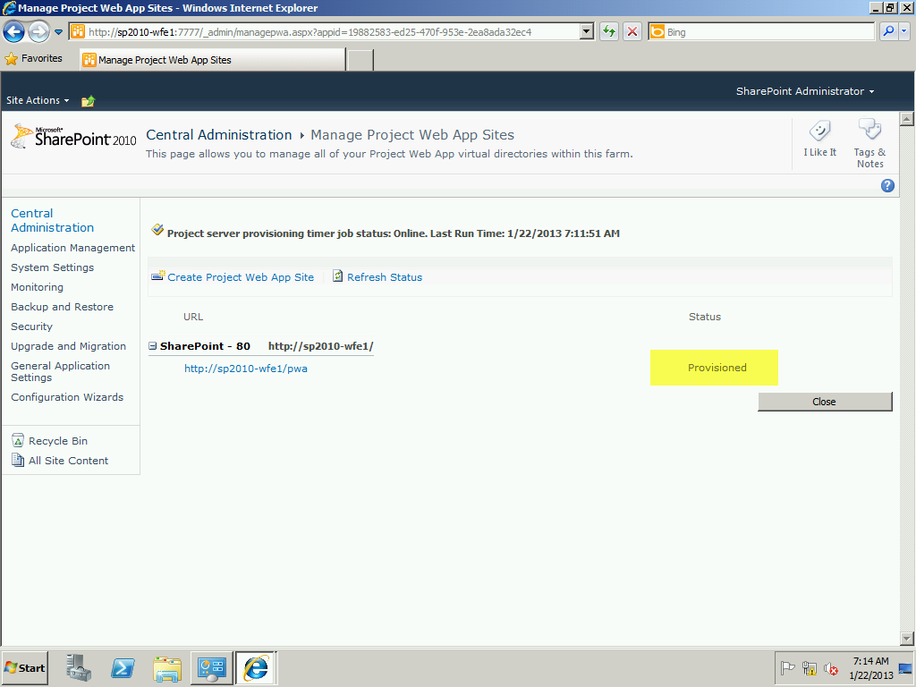

1. Your first instance of the Project Server is now installed. If you scroll to the URL you will see the Project Server instance. Note: Your first visit may take a few moments as the system sets up final information.

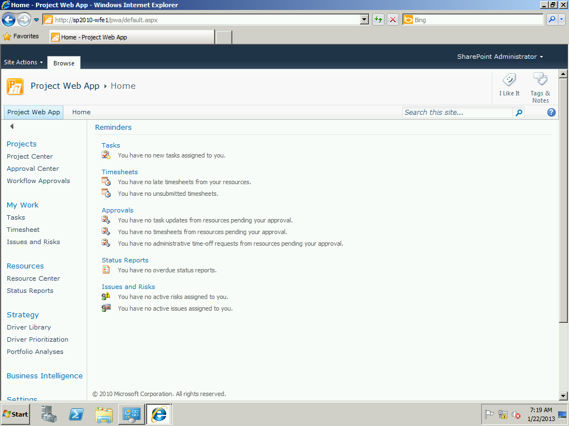

1. Congratulations. You’ve processed a lot of information so far. SharePoint is installed, ProjectServer is installed and now it is time to complete a few more configurations before we are ready to continue.

## Add Admin users to Project Server

Open the Project Server Web Application you created earlier. In this section we will add Users to the Project Server Web App, or any other Users/Groups you defined earlier in Table 8.

1. In the left Sidebar Menus, scroll down to Settings and click on Server Settings

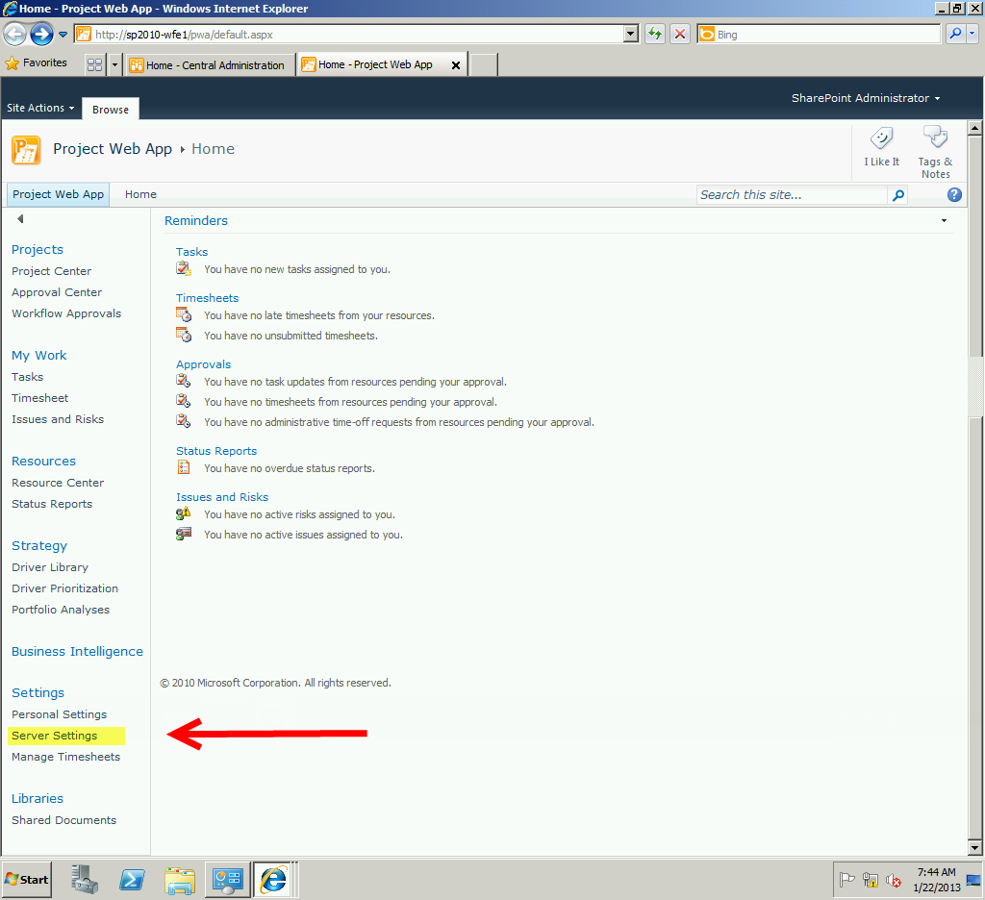

1. Click on Manage Groups

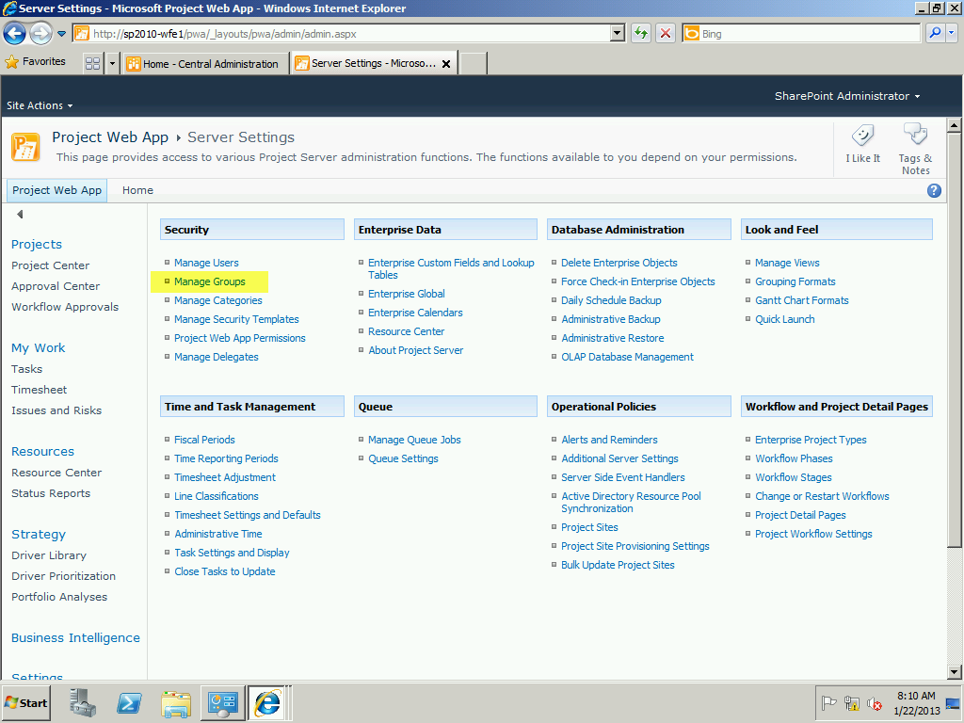

1. If your installation calls for other than the standard groups within Project Server, Click on New Group

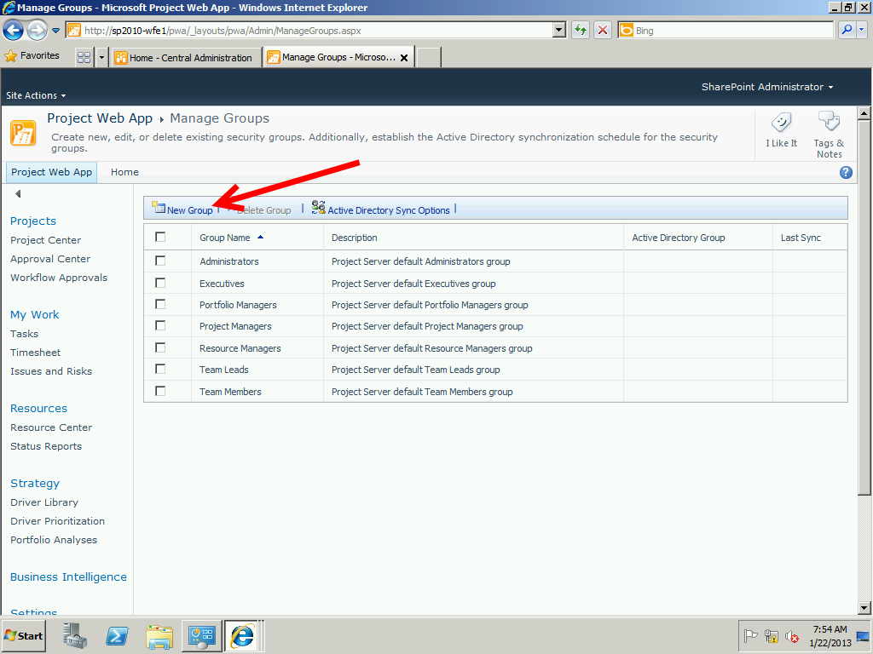

1. On the Add or Edit Group page, complete the details for this new group. Alter the security settings and select Users or Categories as required. Click Save to continue. Repeat as necessary.

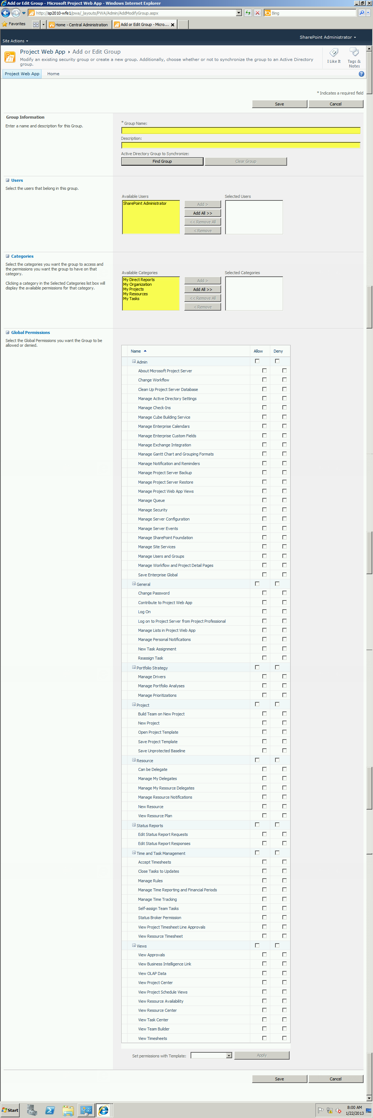

1. If your setup has synchronization that will occur with your Active Directory, you will need to define that cyclic rate of synchronization. Click on the Active Directory Sync Options in the Manage Groups Menu

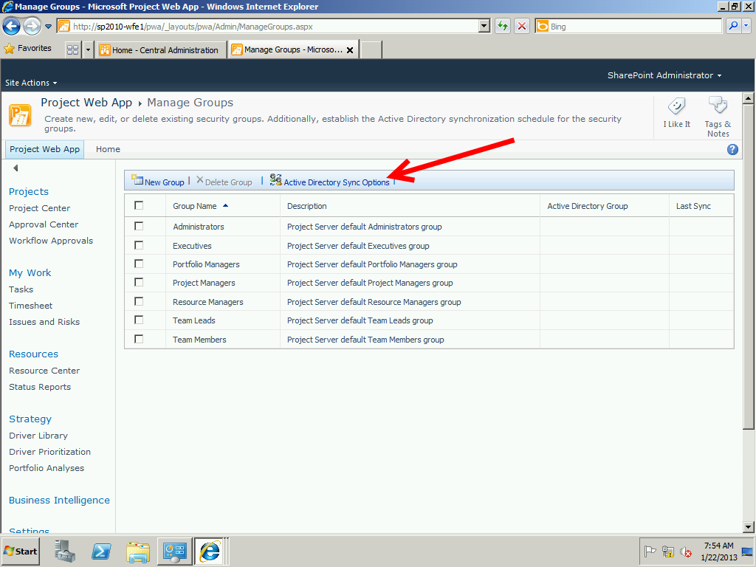

1. Make your selective choices based on the Client’s needs and either Save or Save and Synchronize Now. (Note: If you have a large Active Directory, this synch could take some time for the initial synch)

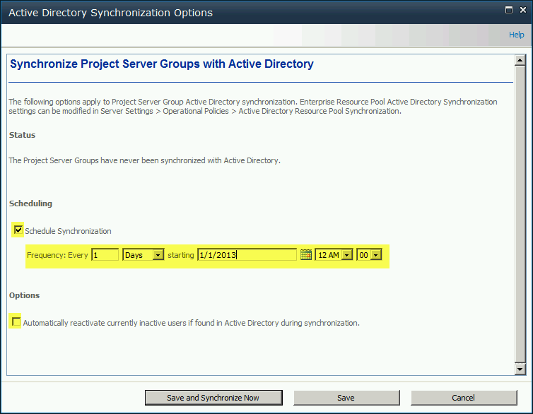

1. This completes the groups. Now let’s add a User to the Administrator’s Group. Return to the Project Web App > Server Settings page and select Manage Users.

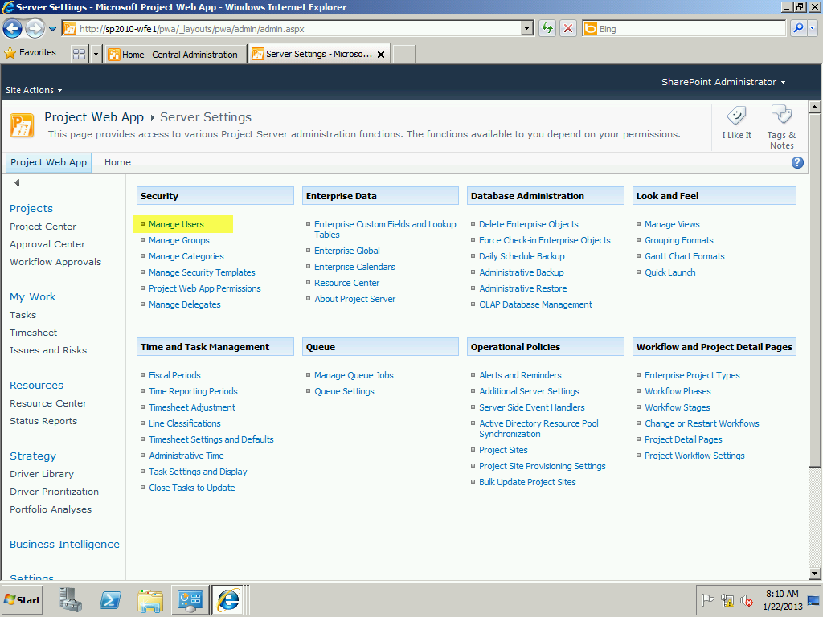

1. In this section you will manually add users for the client, or if in your demo and lab environment, it assumes you have already established user accounts in your Active Directory. If you have not already established these users, pause and establish them before continuing. Additionally, you should have already created the additional groups before you proceed with User additions, as you will need to place them within these groups as you create them. On the Manage Users screen click the New User option.

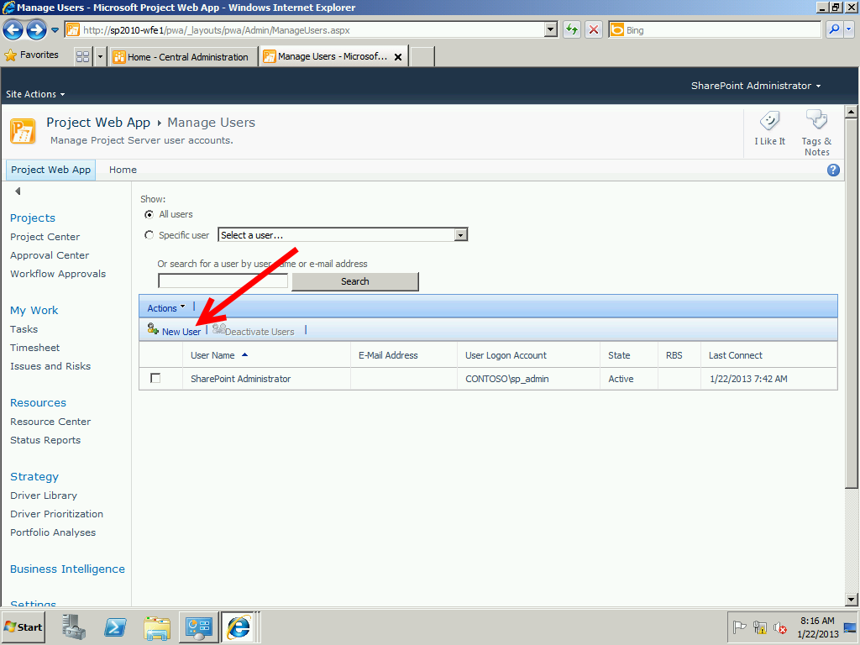

1. The User screen has numerous fields of information to add. Complete as necessary and click Save to continue.

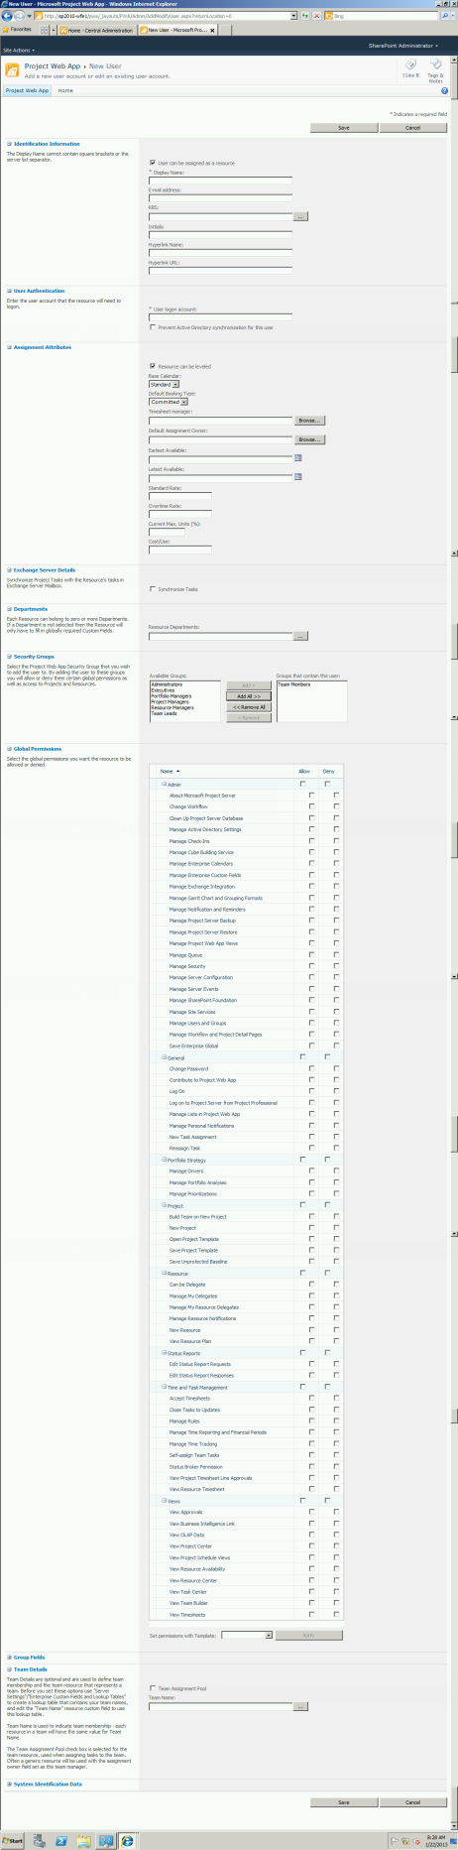

1. Repeat User setup as necessary.

## Internet Explorer Enhanced Security Control

To run effectively, SharePoint needs to have the Windows Internet Explorer Enhanced Security Control (IEESC) disabled. This can quickly be accomplished through the Server Manager.

1. Click the Server Manager Icon next to the Start button (alternatively click the Start > Administrative Tools > Server Manager

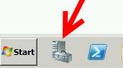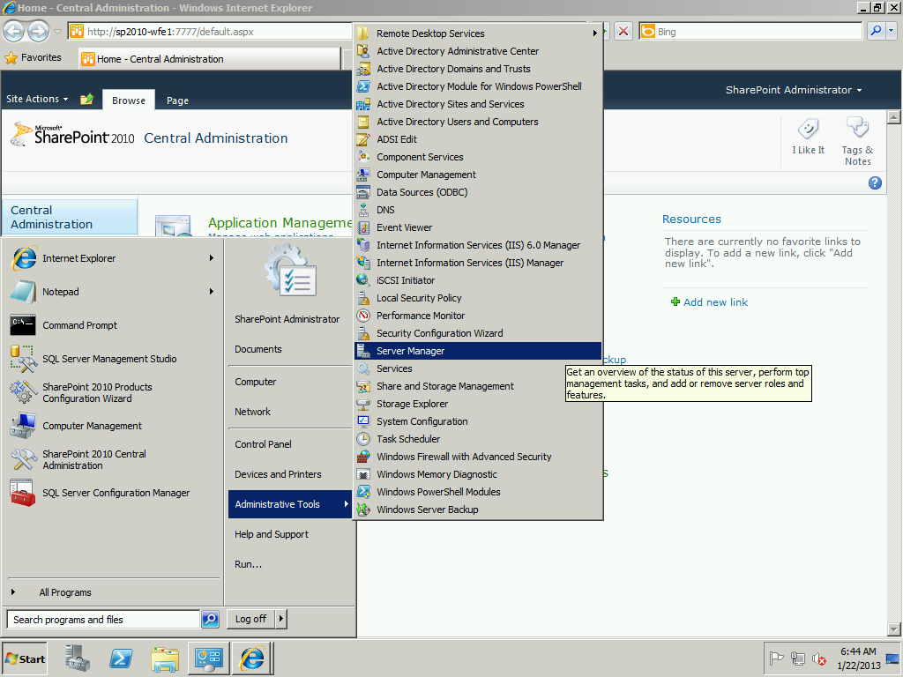

1. Scroll down to the Security Information Section and click the Configure IE ESC option on the right side of the screen

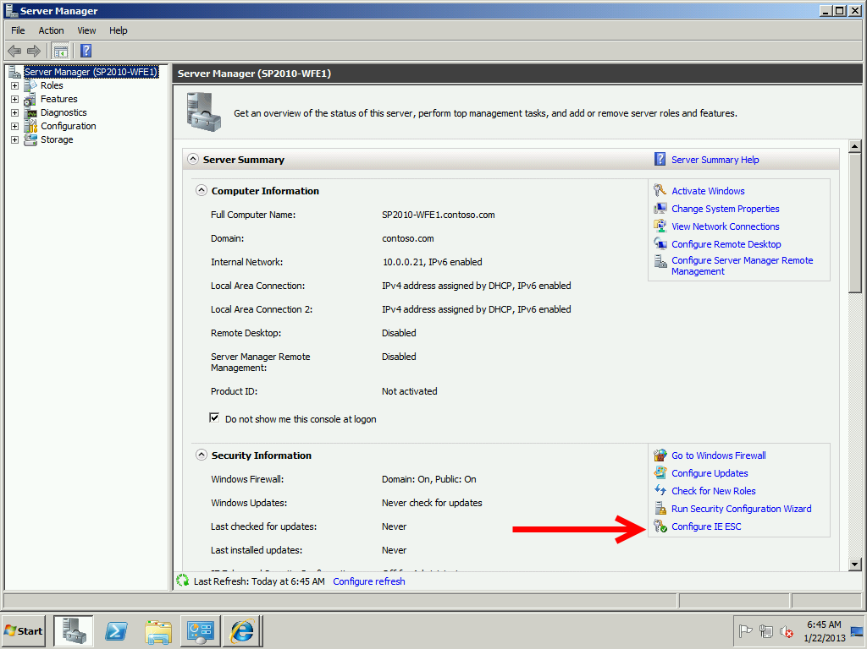

1. Ensure that both Administrators and Users are set to Off. Click OK then Close down Server Manager.

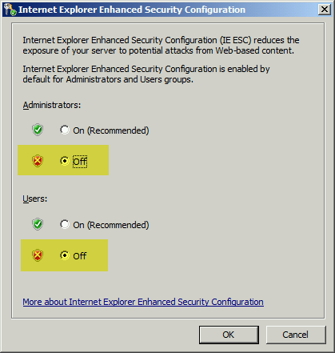

## Create a Performance Point Application

1. Return to the SharePoint Central Administration Page and Select Manage Service Applications



1. Click New in the Ribbon and from the pull-down menu select Performance Point Service Application

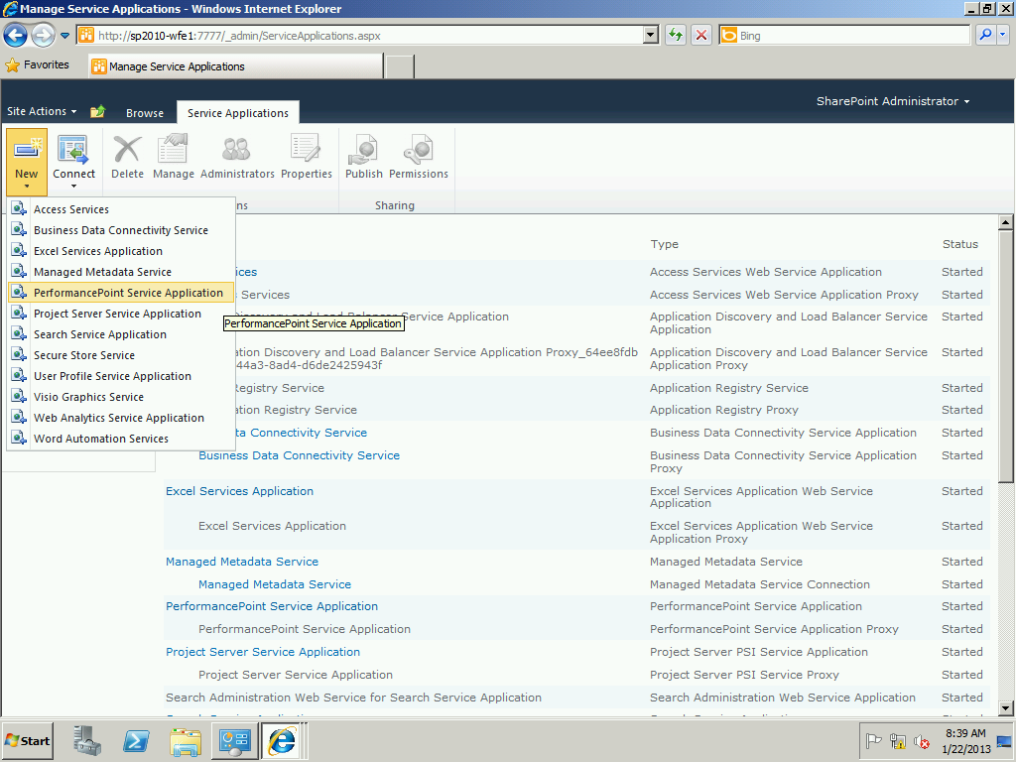

1. In the Name type the name of your application (i.e. PerformancePoint Application), scroll down and create a new application pool name and then select your Services account as the Configurable pull down. Click Create when you are finished.

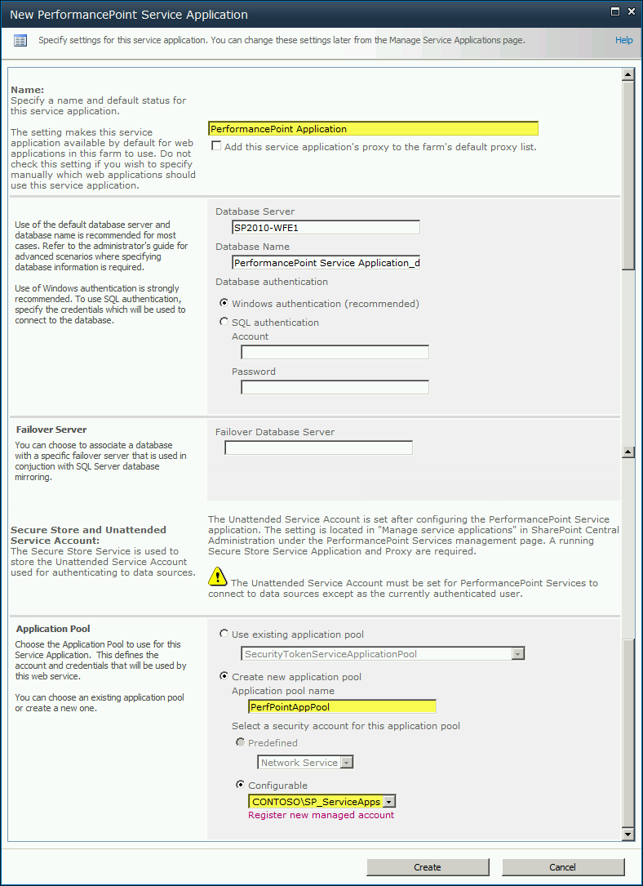

1. The system displays the confirmation screen when it has completed the service application setup.

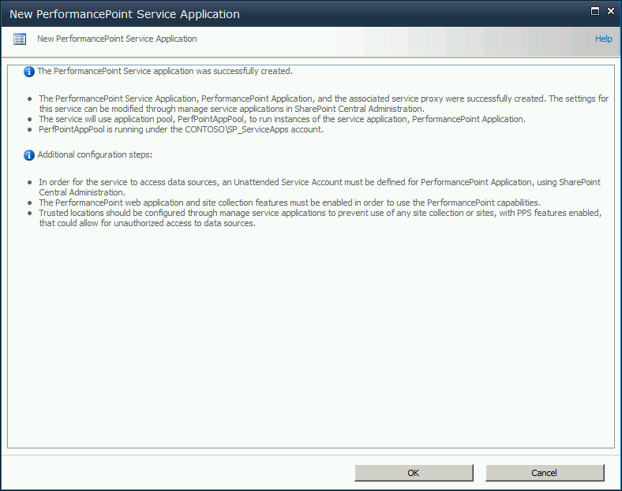

1. Click OK

## Configure Excel Services

In Table 4 we identified two user groups in Active Directory that need to be established in order for ProjectServer to use accurate reporting services, and for the organizational users to be assigned to access these reporting services.

### Create Reporting Services Active Directory Groups

If you did not create these groups, take a moment now to do so before continuing; if they are already created, skip to the next section

1. Launch the Active Directory Users and Groups on the Domain Controller. Right click on Groups, select New then Group to continue

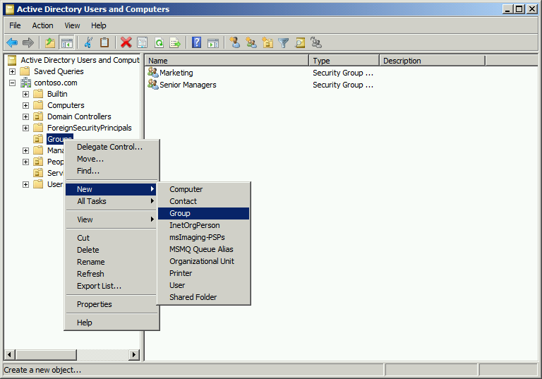

1. Using your name (or the one identified from the client) type the Group Name. Ensure that Global is checked, and Security is the type. Click OK to continue. Report this for both reporting groups. Once finished, close down Active Directory Users and Groups

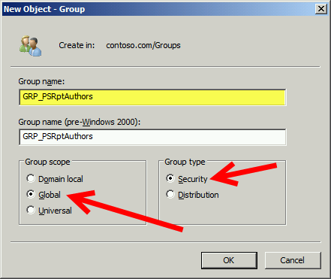

### Configure Excel Services

Log into the Computer that you have running SQL with your SQL_Admin account. Once logged into the server complete these steps:

1. Click Start > All Programs > Microsoft SQL Server 2008 (2012) > SQL Server Management Studio

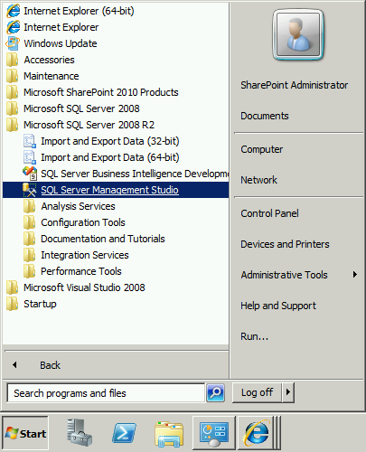

1. On the Connect to Server Options, click the Server Type pull-down and select Reporting Services

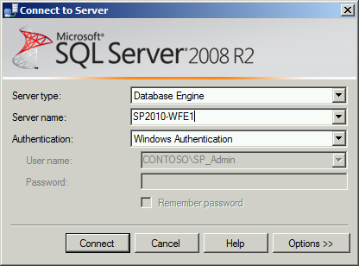

1. Make sure your Server is selected in the Server name, and then click Connect. Expand the plus symbol next to security, and then right click on Logins and select New Login…

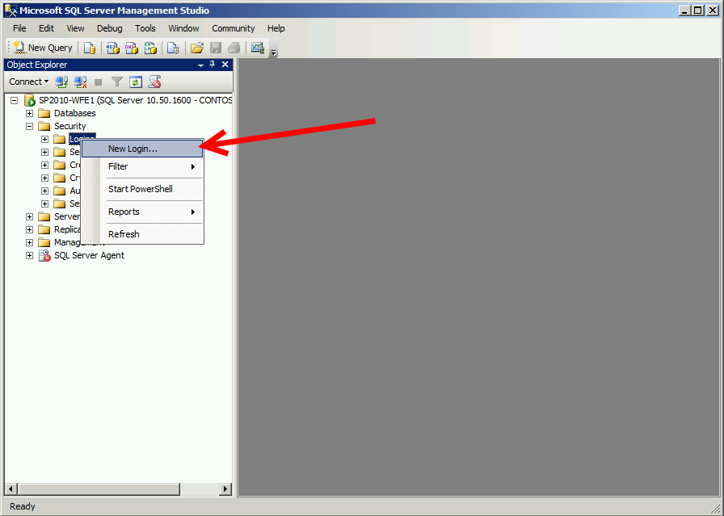

1. In the login name, using the DOMAIN\username convention, type in the name of the Report Authors group from Table 4. ONLY do this for the Report Authors group, not the Viewers Group.

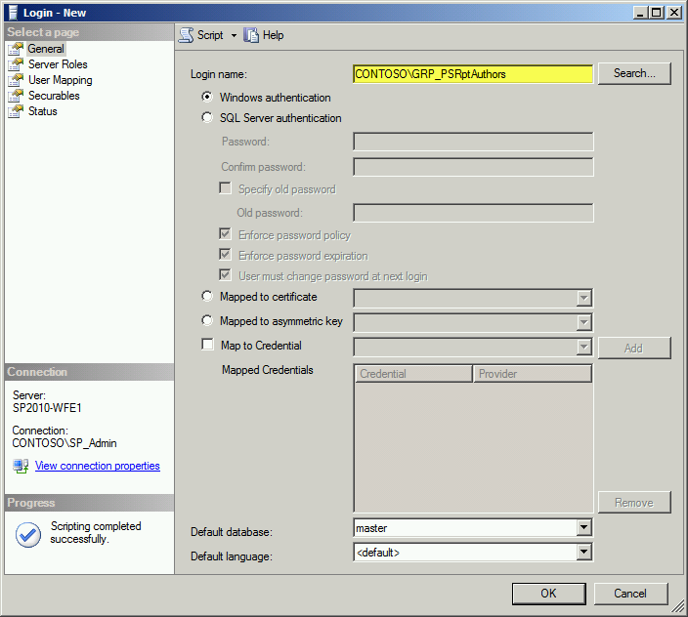

1. Before closing down, click the User Mapping page in the left window pane. Once selected, scroll to your Project Server Reporting Database in the upper right database window, and check the box for the database; once checked, in the lower role membership window ensure that *db_datareader* and *public* are checked. Click OK to continue.

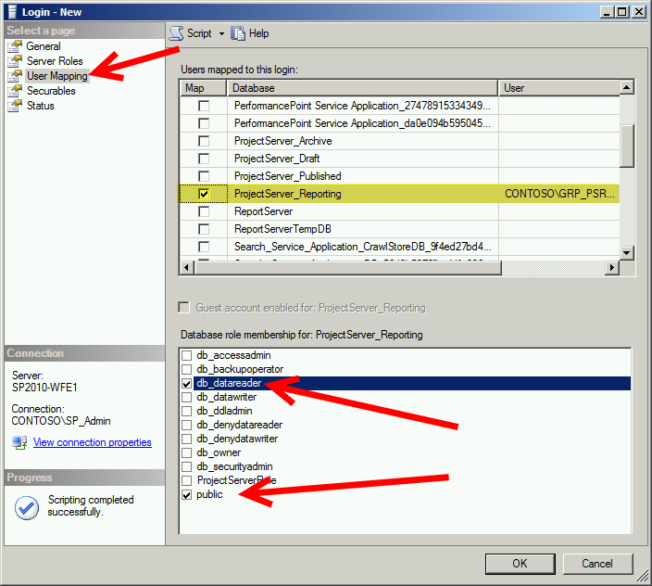

1. Exit from the SQL Management Studio. Return to your SharePoint/ProjectServer system. Open up Internet Explorer and browse to your Project Web Application instance you previously installed. In the left Sidebar menu, scroll down and click on Business Intelligence.

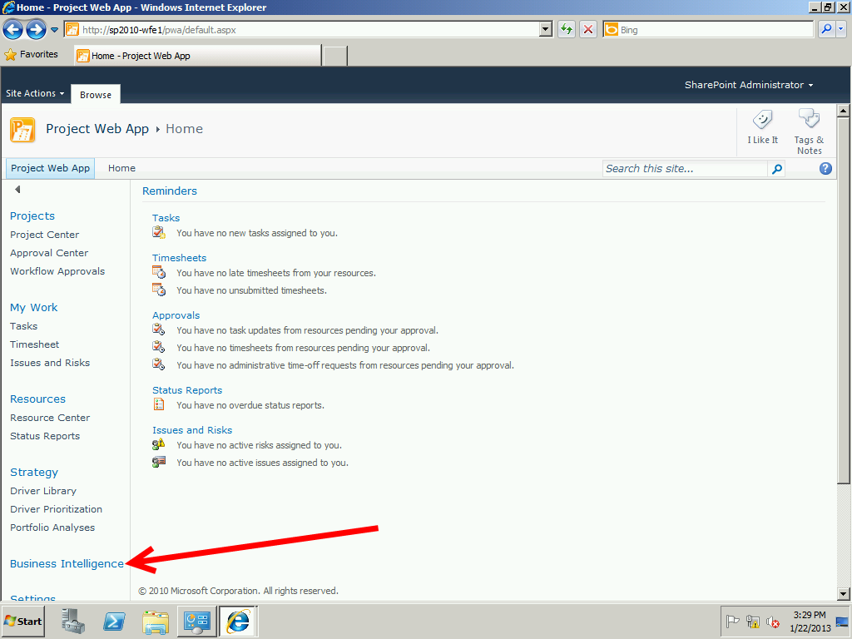

1. There are URLs we need to verify and identify as safe URLs to continue. On the Business Intelligence Center, click the Data Connections link in the left sidebar menu.

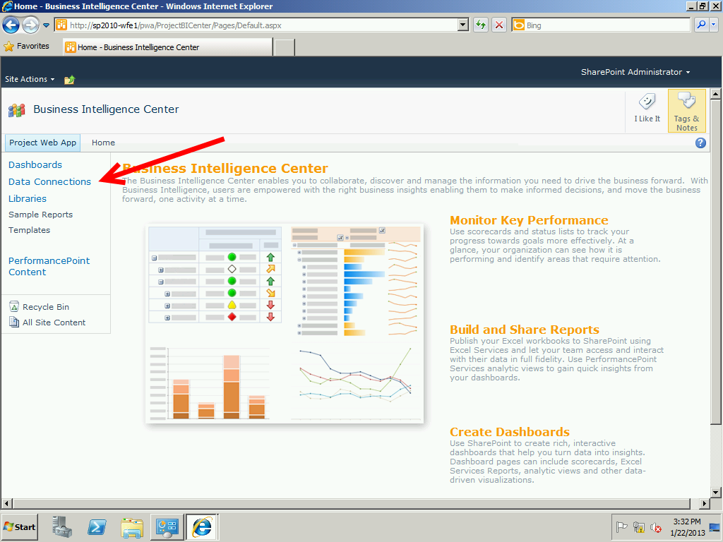

1. Check the box next to the English (United States) Folder icon in the center, and then click the View Properties ribbon menu icon.

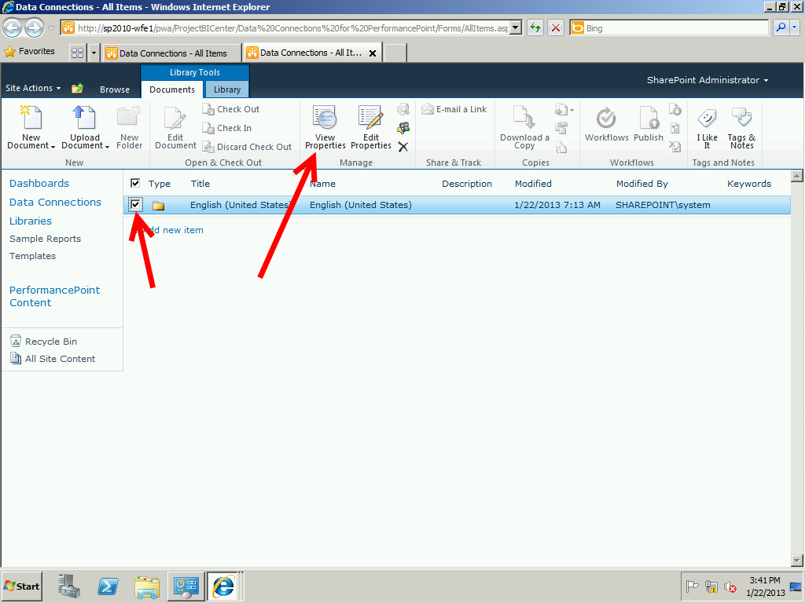

1. Right click on the English (United States) and then select Properties from the contextual menu.

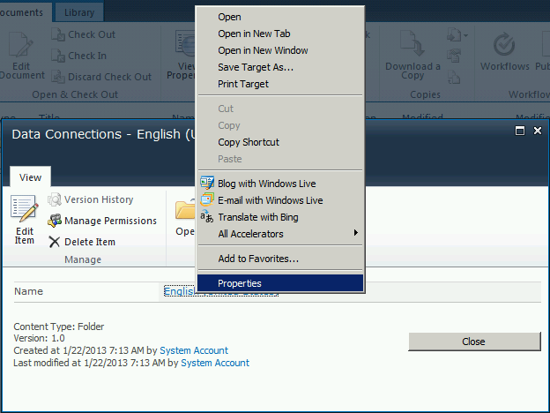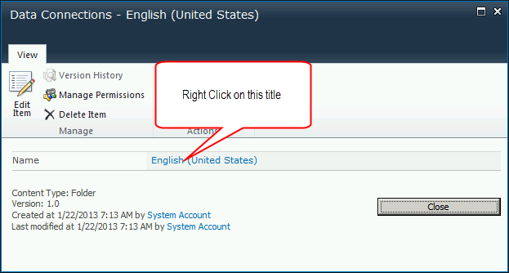

1. On the popup window, left click highlight the Adddress (URL) information which has more than can be seen, so be sure to capture it all by highlighting and right click selecting Copy or pressing Control-C to place it on your clipboard.

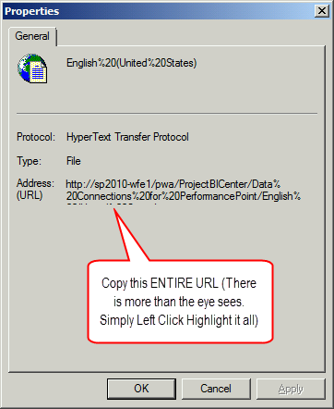

1. Open Notepad on the server by clicking Start and in the Search Programs and Files type notepad and press return. Paste the URL information into this notepad instance. ***REPEAT THIS FOR THE SAMPLE REPORTS MENU OPTION***. You will end up with two pasted links in your Notepad file.

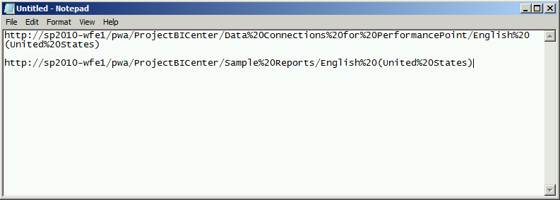

1. Return to the previous popup window and click close, then Close out of the Data Connections popup window.
2. We are now going to set this link URL up as a trusted location in Excel Services. Return to your SharePoint Central Administration screen and click the Manage Service Applications under the Application Management menu.

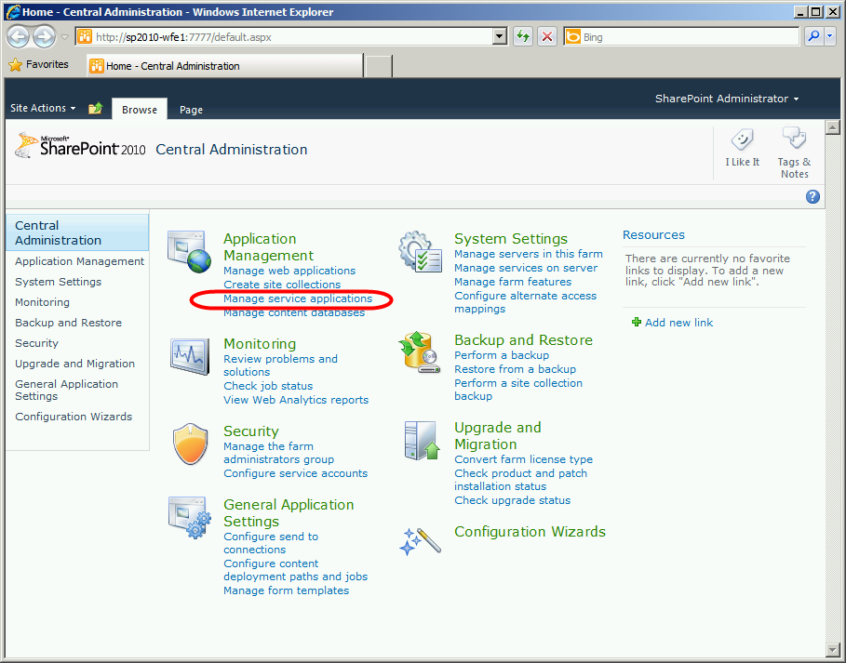

1. Highlight the Excel Services Application Row and then click Manage in the Ribbon toolbar.

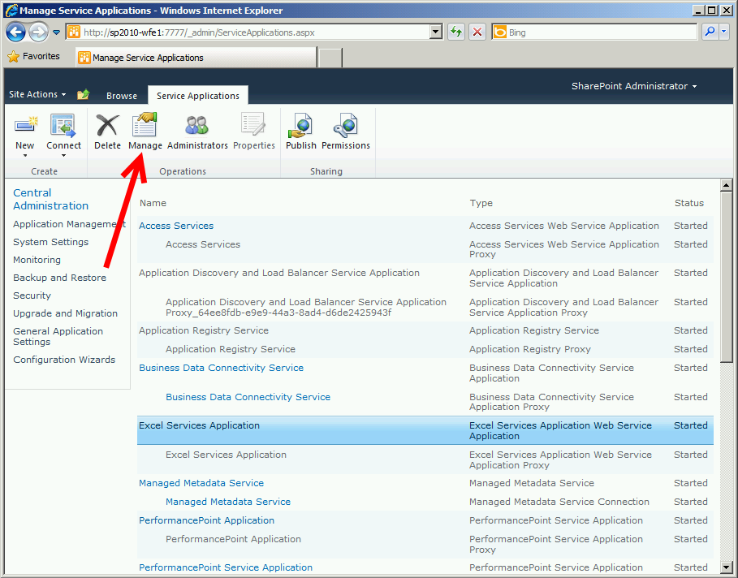

1. Click the Global Settings link

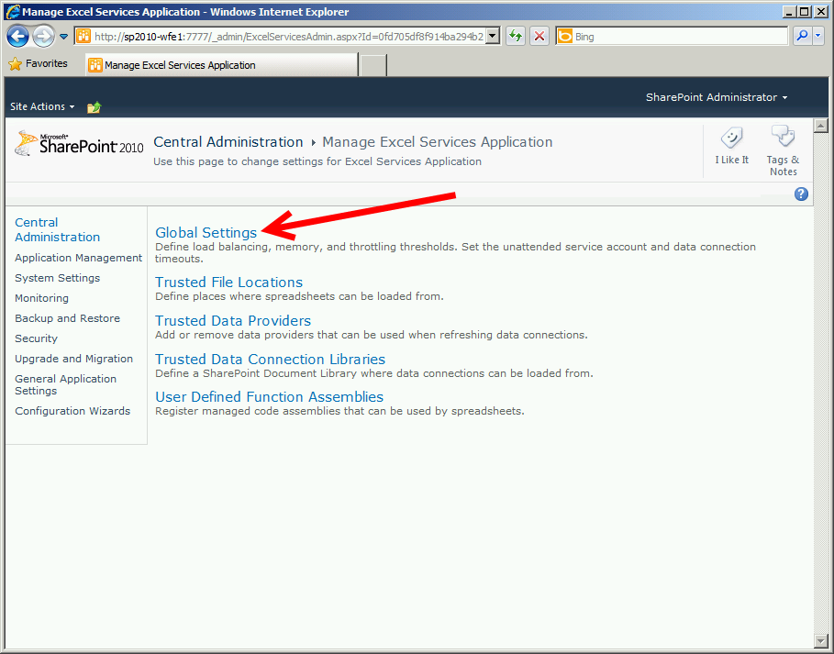

1. Scroll to the bottom of the page and in the External Data Section, under Application ID:, type ProjectServerApplication (NOTE: Case sensitive, must be typed exactly this way, no spaces, and with P,S,and A capitalized.) Click OK to return to the Manage Excel Services Application screen.

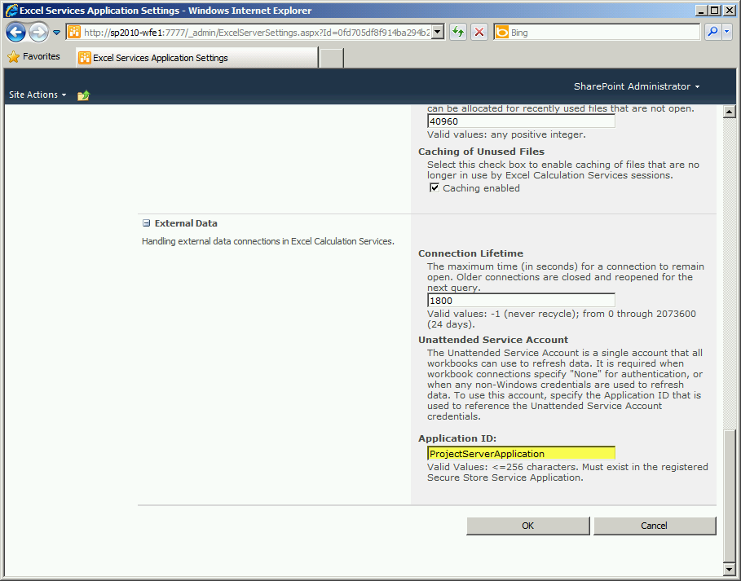

1. Click on the Trusted Data Connection Libraries link

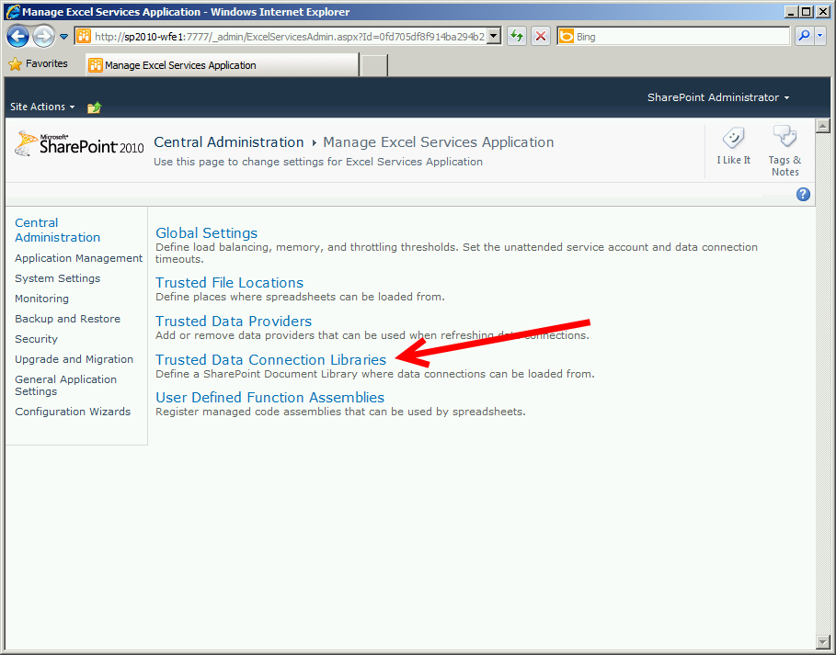

1. Click the Add Trusted Data Connection Library. 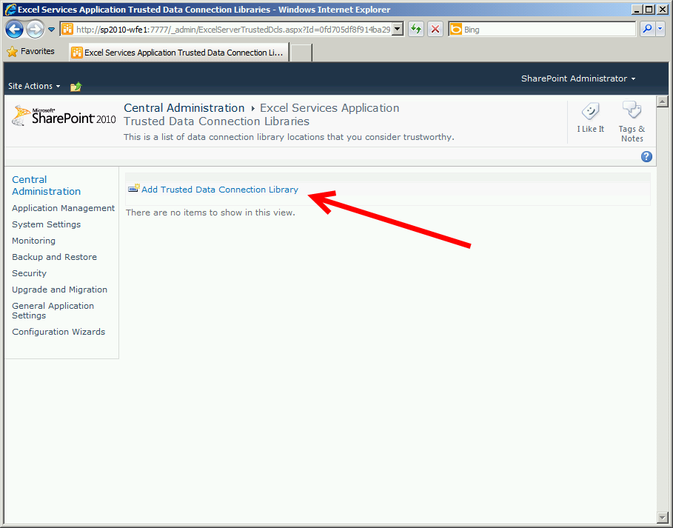
2. Return to your open Notepad application, copy the entire URL to your clipboard, and past it into the Address link you see on the screen.

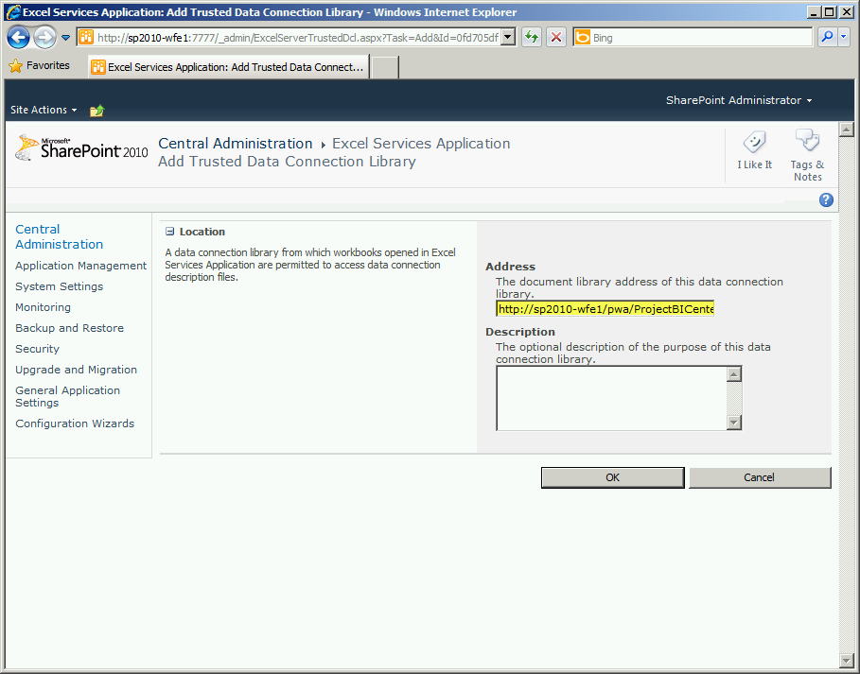

1. Click OK to save the location. Return to the Central Administration > Manage Excel Services Application menu in SharePoint Central Administration and click the Trusted File Locations link.

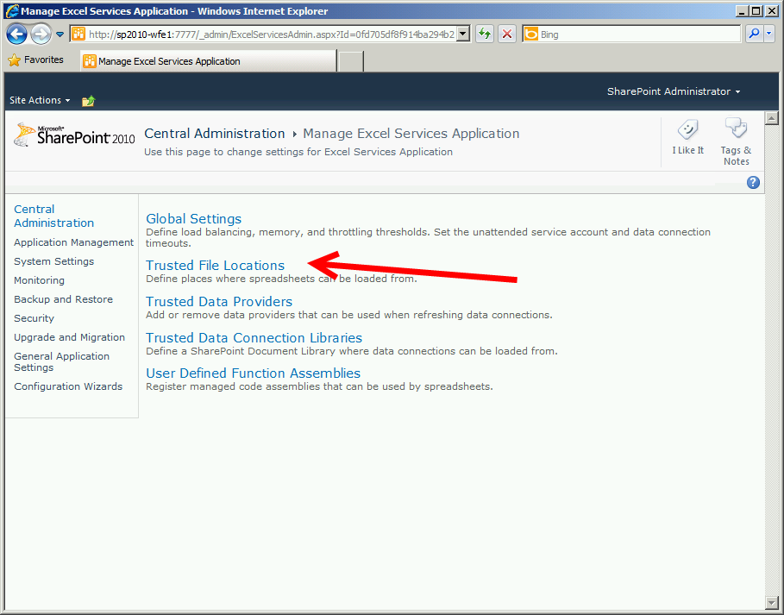

1. The display shows that all files located underneath http:// are presently trusted. Unless you have highly restricted sites, there is little need to change this. Click on the Add Trusted File Location link at the top.

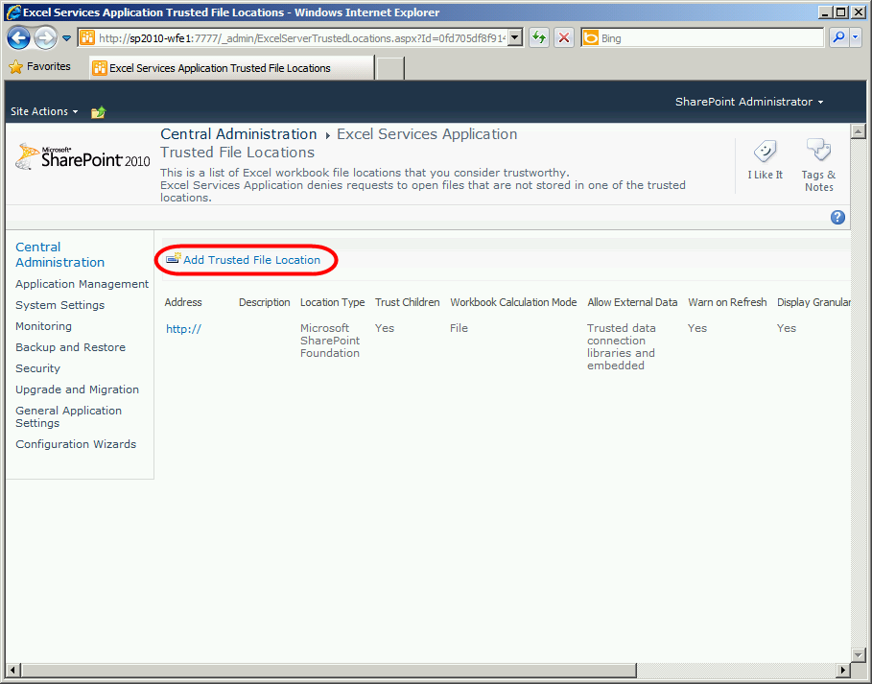

1. In the address line, copy and paste the second URL you saved in the notepad file earlier that belonged to the Sample Reports link.

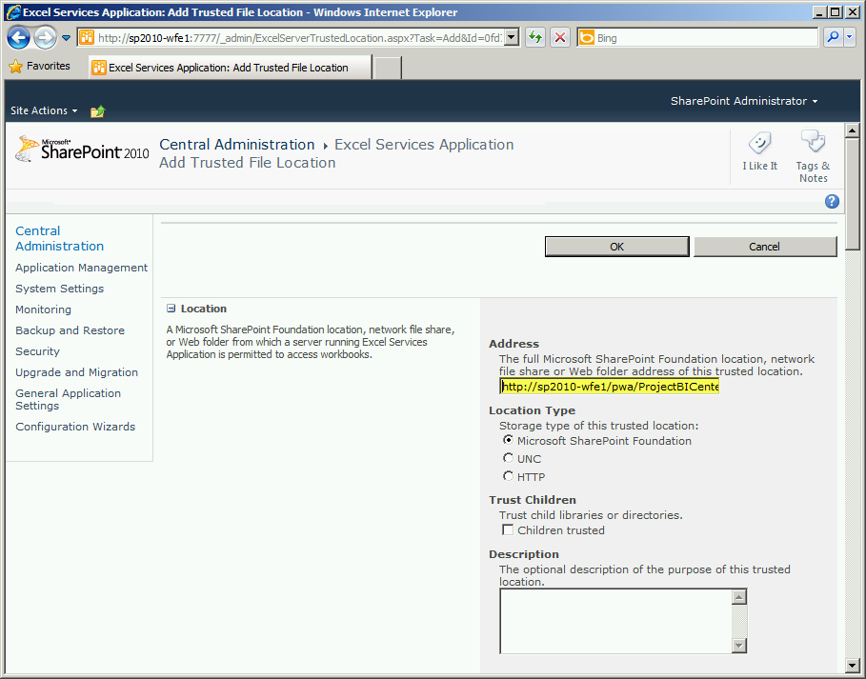

1. You can optionally leave this set to http:// . On this screen click the Children Trusted Checkbox, the Trusted Data connection libraries and embedded option under Allow External Data and clear the checkbox in Refresh warning enabled. Scroll down and click OK.

## Configuring the Secure Store Service Application

Before we create a new encryption key for the Secure Store service, we want to Backup the Secure Store Database. Follow these steps to create a backup. ANYTIME you change it, SharePoint will prompt you to make a backup.

1. On your Micrososft SQL Server computer, click Start > All Programs > Micrososft SQL Server 2008 R2 (2012) > SQL Server Management Studio. Once open, login to the Database Server. In the left window pane, click the plus adjacent to the server, then the plus adjacent to Databases to expand all databases underneath. Locate the Secure_Store_Service_DB database, right click on it, select Tasks then Backup.

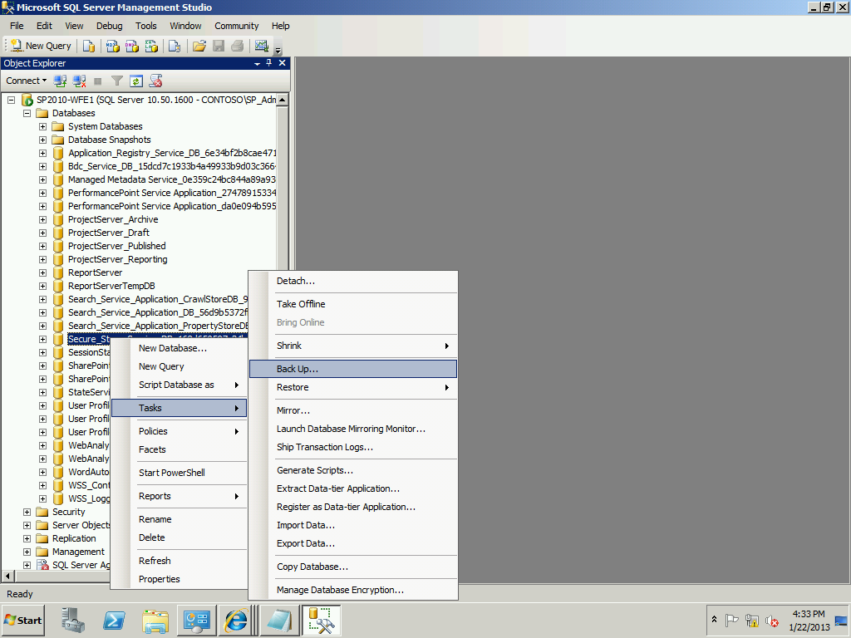

1. Accept the defaults shown and then click Ok. Once backed up you will receive a confirmation screen as shown.

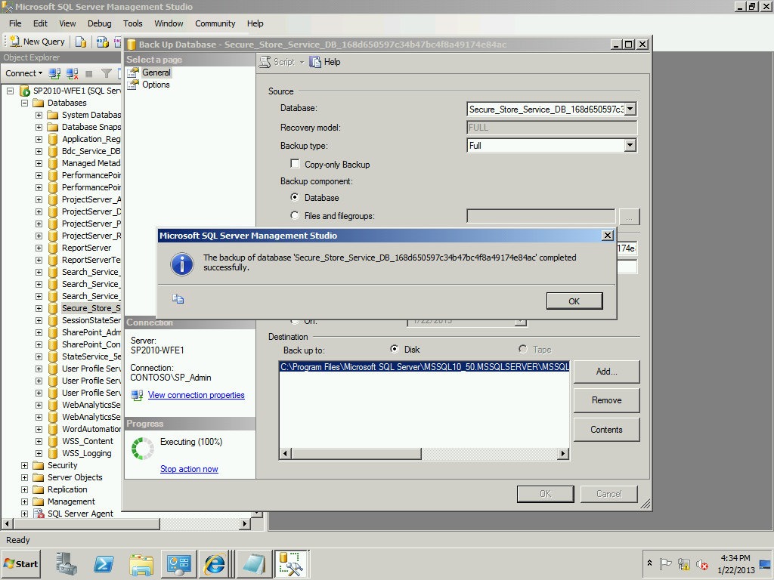

1. Return to your SharePoint Central Administration and select the Applications Management > Manage Service Applications link.



1. Scroll down and highlight the Secure Store Service application link, then click the Manage icon in the ribbon.

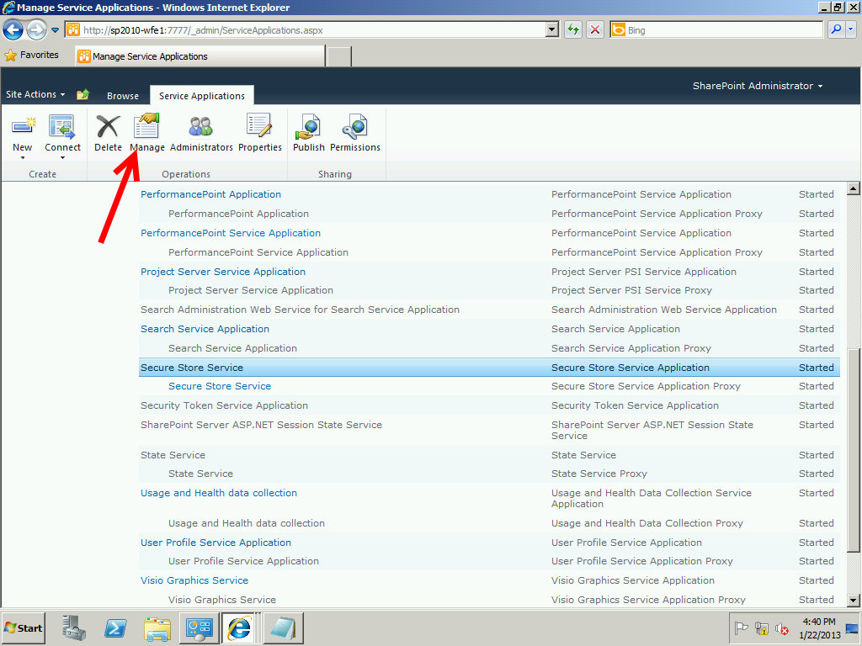

1. The system warns that you must generate a new key before creating a new Secure Store Target Application.

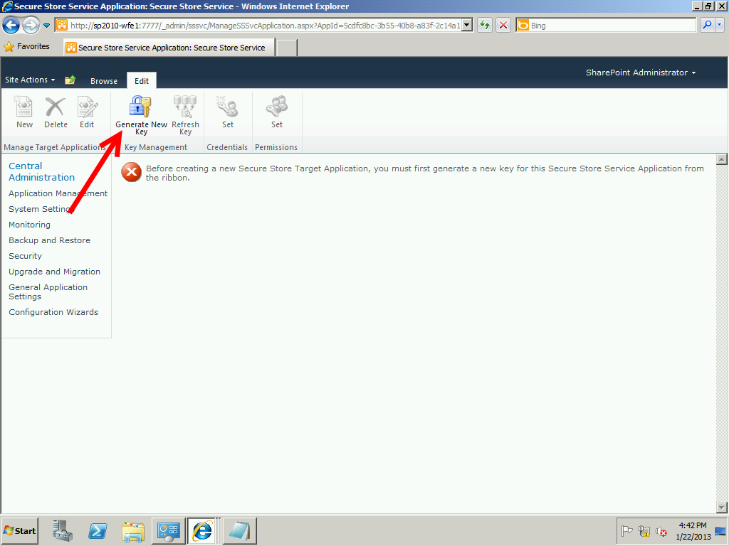

1. Click the Generate New Key icon in the ribbon. In the popup window, enter the Pass Phrase you collected in Table 6. Once entered, press Ok to continue.

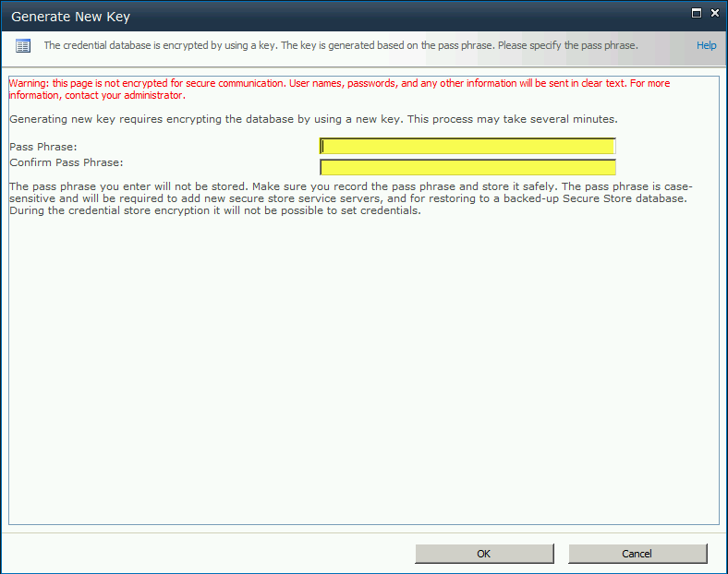

1. Click the New button in the ribbon to create a new Secure Store Target Application ID. In the Targe Application ID type: ProjectServerApplication as shown **(NOTE: Case sensitive; type it exactly as shown without spaces.)** Type your email address if you desire, or the notification email address the client desires. Choose Group in the Target Application Type and then click Next to continue.

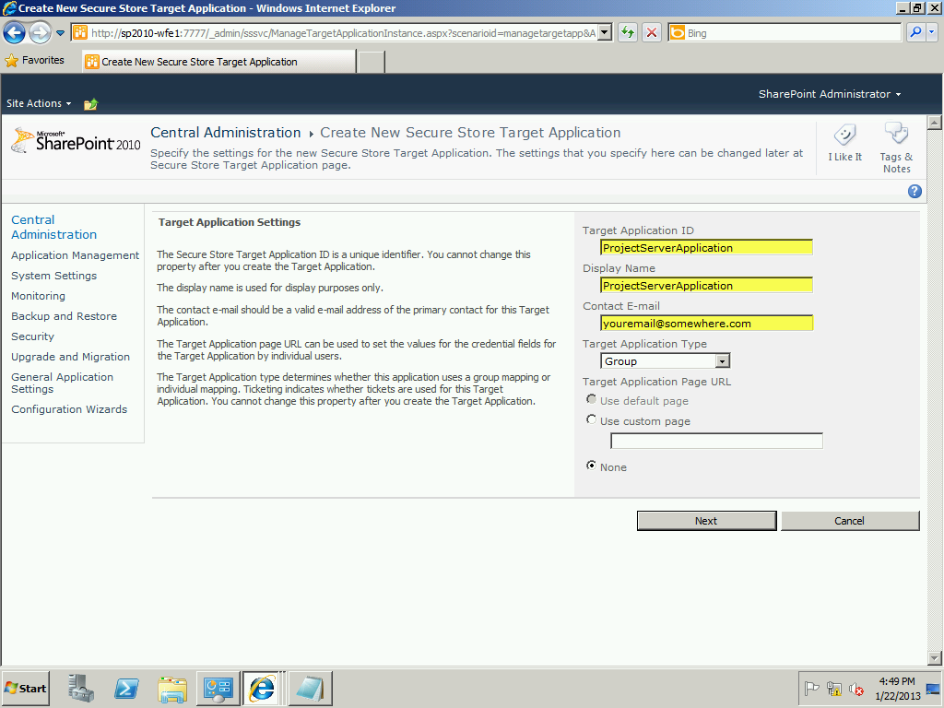

1. On the page that follows you can leave the default settings as they are which is sufficient for ProjectServer. Click Next to continue.

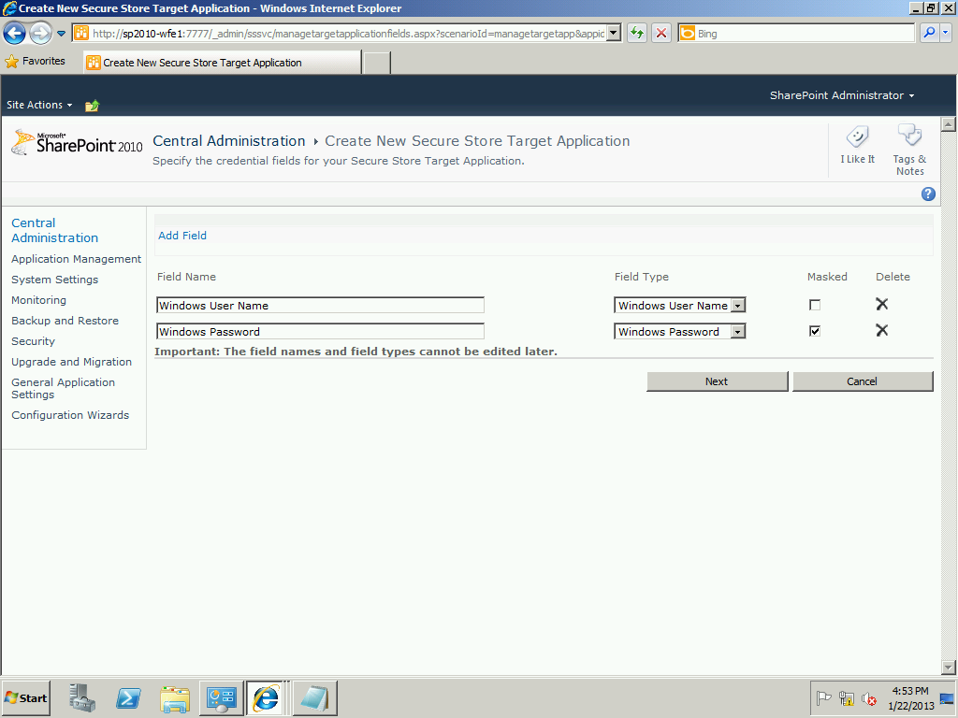

1. In the Specify membership settings page, in the Administrators window, add the Domain Administrators for your domain (Contoso shown in the example); also, add the group for Report Viewers you created earlier in the members window. Check each item using the small people icon, ensuring that each receives an underline to confirm them. Click OK to continue. The systems generates the new store service.

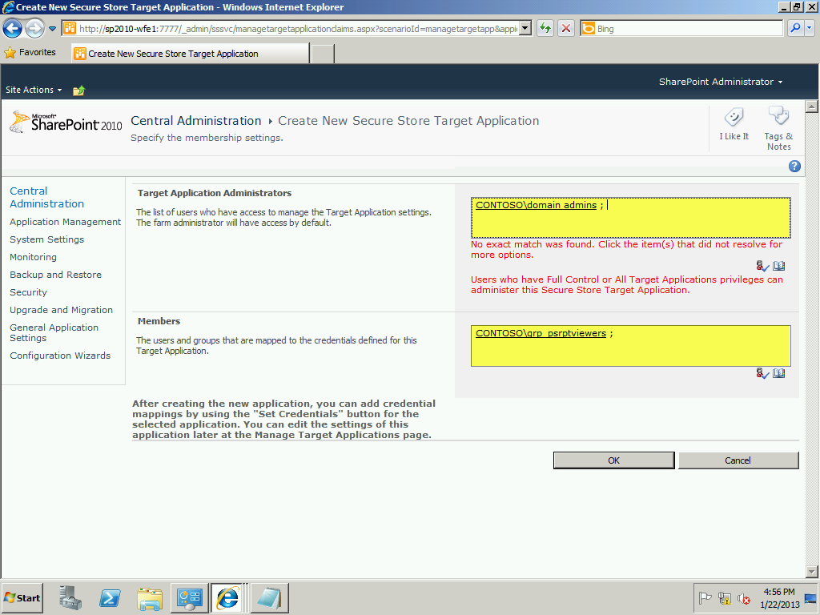

1. On the next screen, click the checkbox next to the Target Application ID you just created and then click the Set Credentials icon in the ribbon.

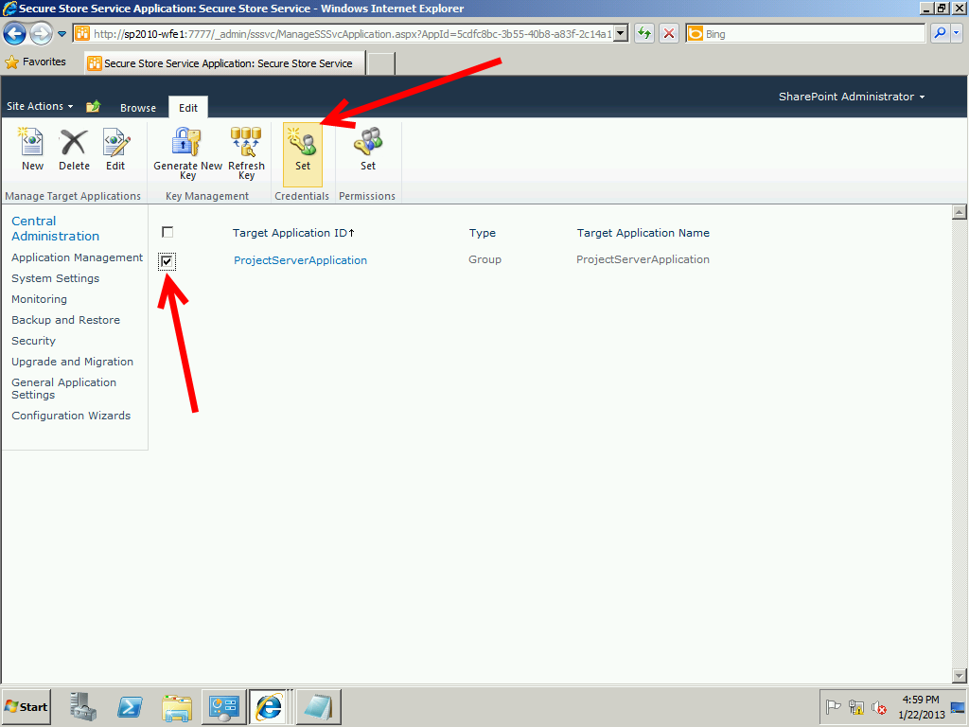

1. Enter the SharePoint Application Pool Account you created in Table 5 and the corresponding password. Click OK to continue

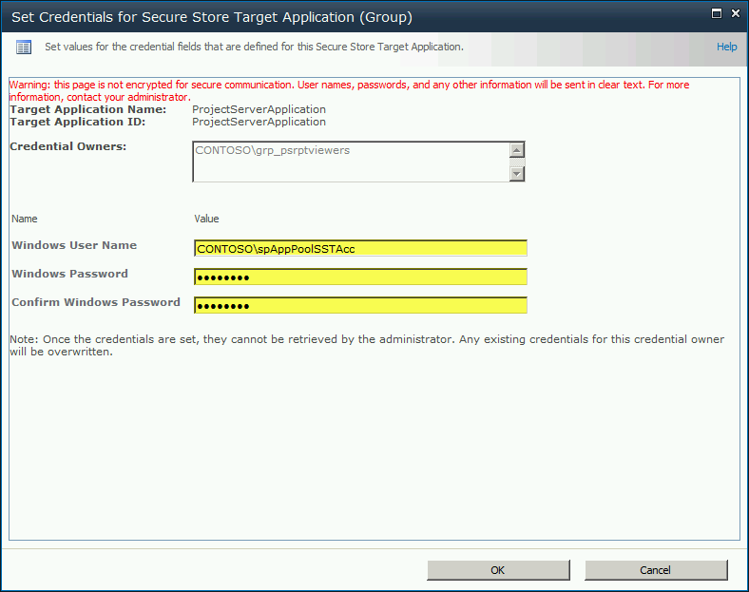

1. This completes the Secure Store Configuration Application settings. So can close down and discard the Notepad file.

## Configure OLAP CUBE Building Services

In order for the OLAP function to properly work, there are two pre-requisite applications that need to be installed as follows:

|  |  |
| --- | --- |
| Stand Alone Server | SQL Server / SharePoint/ProjectServer Setup |
| * Install the SQL Server 2008 Native Client * Install the SQL Server 2008 Analysis Management Objects | * Install the SQL Server 2008 Native Client ONLY on the SharePoint Server/Project Server System * Install the SQL Server 2008 Analysis Management Objects ONLY on the SharePoint Server/Project Server System |

**NOTE**: You previously installed these applications; this table is merely for review.

### Setting up the Analysis Service SQL Login Account

## Setting Server performance Enhancements

## Final Verification of Project Server Functionality

# GENERAL FUNCTIONAL SETUP FOR YOUR SERVERS

When you first install Windows Server 2008, there are some things that you want to shut down or configure just to operate. Not all of these will be useful in a client environment, but can be used in a demo or lab environment. Please note the environments at each section that you can apply this to.

## Windows Firewall

Applies to:

* Lab Machines
* Demo Machines

Turning off the Windows Firewall is a good idea to help avoid problems with machines talking to each other. Simply go to your Start > Control Panel > Windows Firewall. Turn off all instances of the Firewall as shows.

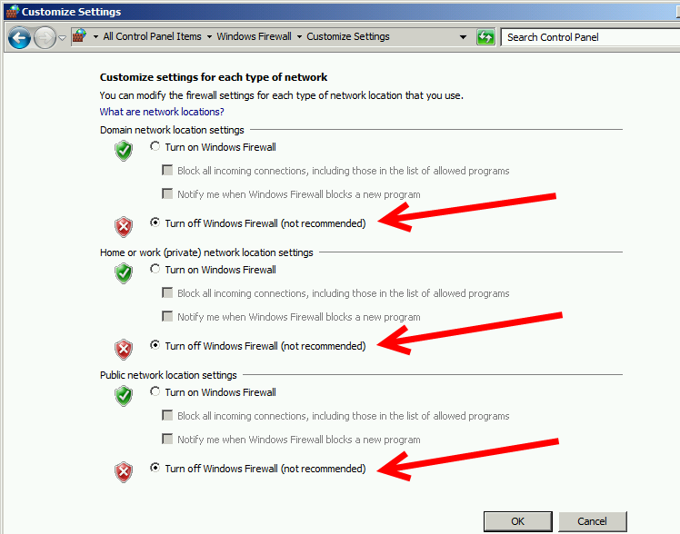

## Windows Shutdown Event Tracker

Applies to:

* Lab Machines
* Demo Machines
* Client’s Environment (Unless they otherwise note)

Turning off the pesky little screen that asks you why you shut down the server is a favorite to turn off. To turn it off click Start > Run > gpedit.msc and press enter.

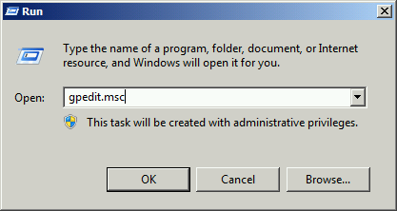

Windows opens the Local Group policy editor. In the left Window pane, expand the Administrative Templates and then click the System folder. In the right pane scroll down and double click the Display Shutdown Event Tracker options.

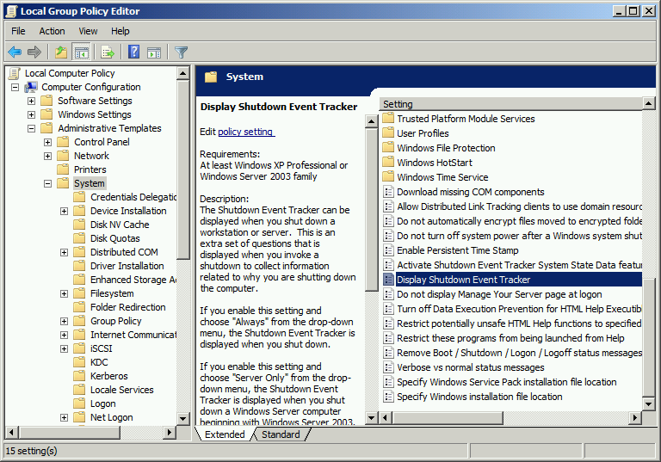

In the popup dialog, change the Enabled value to Disabled, then click OK and close down the Policy Editor.

